2026 FALL SEMESTER

Programming for Data Science Lab (MACSE502) Record

INDEX
Week No | Date | Sl.  No. | Type | Topic | Title with download Link for document | Problem Statement | Page No.
1 | 09-07-  2026 | 1 | PP | Pandas | Basic Data Manipulation with Pandas | Create a DataFrame with columns Name, Age, and City containing data for five individuals. Perform the following operations: select only the Name and Age columns, filter rows where Age is greater than 25, add a new column Country with a default value, and sort the DataFrame by Age in  descending order. Finally, calculate the average age of the individuals. | 1
1 | 09-07-  2026 | 2 | EP | Pandas | AI Model Performance Analysis Using Pandas | An AI company maintains model performance records containing:  - ModelID  - Accuracy  - Algorithm Perform:  - Select ModelID and Accuracy.  - Filter models with Accuracy greater than 90%.  - Add Status with default value "Production Ready".  - Sort models by Accuracy.  - Calculate average model accuracy. | 6
2 | 16-07-  2026 | 3 | PP | Pandas | Data Cleaning and Preprocessing with Pandas | Create a DataFrame with some missing values in columns Name, Age, and City. Perform the following operations: fill missing values in the Age column with the mean age, drop rows where Name or City is missing, and convert the Age column to integer type. Finally, normalize the Age column  using min-max scaling | 14
2 | 16-07-  2026 | 4 | EP | Pandas | Movie Rating Data Preprocessing Using Pandas | A streaming platform maintains movie records containing:  - MovieID  - Rating  - Genre Perform:  - Create a dataset with missing values.  - Fill missing Rating values using average rating.  - Remove rows with missing MovieID or Genre.  - Convert Rating into integer type.  Normalize rating values. | 19

3 | 23-07-  2026 | 5 | PP | NumPy | Creating and Manipulating Arrays  Using NumPy | Create a 2D array of shape (3, 4) with random integers between 0 and  10. Perform the following operations: calculate the mean and standard deviation of the entire array, slice the array to get the first two rows and last two columns, reshape the array to shape (4, 3), and perform element-wise multiplication with another array  of the same shape. | 30
3 | 23-07-  2026 | 6 | EP | NumPy | Warehouse Shipment and Logistic Analytics Using Numpy | A logistics company tracks shipments from 4 warehouses across 7 weeks. Create a 4 x 7 shipment matrix. Perform the following operations: (1) compute average shipments,  (2) compute standard deviation,  (3) slice the first two warehouses and last three weeks, (4) reshape the matrix into a 7 x 4 matrix, and (5) perform element-wise multiplication with a transportation-cost matrix of the same shape. As an extra | 35
4 | 30/7/20  26 | 7 | PP | Pandas,  Numpy, MatplotLib | Feature  Engineerin g and Explorator y Data Analysis | Create a DataFrame with columns  Feature1, Feature2, and Target containing random data. Perform the following operations: create a new feature that is the logarithm of Feature1, bin Feature2 into three categories (low, medium, high), and calculate the correlation matrix of the DataFrame. Finally, create a scatter plot of Feature1 vs.  Feature2 colored by Target,  and interpret any visible patterns. | 46

4 | 30/7/202  6 | 8 | EP | Pandas, NumPy, Matplotlib | Employee Attrition Prediction Using Workforce Indicators | A company wants to analyze workforce behavior and predict employee attrition. Create a DataFrame containing:  OvertimeHours JobSatisfactionScore SalaryLevel  TrainingHours WorkLifeBalance YearsAtCompany PromotionCount AttritionStatus  Perform:  - Create Log_OvertimeHours.  - Categorize JobSatisfactionScore into:  - Disengaged  - Satisfied  - Highly Engaged  - Generate correlation matrix.  - Create a Treemap Visualization of employee categories.  Analyze workforce trends. | 56
5 | 06/08/20  26 | 9 | PP | Web Scraping | requests, BeautifulS oup pandas json | Scrape data from a webpage and store it in a structured format like CSV or  JSON | 63
5 | 06/08/20  26 | 10 | EP | Web Scraping | Online Job Market Analytics | A recruitment agency wants to analyze job opportunities posted on a dynamic job portal. Develop a Python application using Selenium to scrape job listings, extract Job Title, Company Name, Location and Salary (if available), store the collected data in a Pandas DataFrame, save the dataset as a CSV file, and visualize job demand by location. | 70

PP: Practice Program; EP: Exercise Program; CP: Challenging Program

2026 FALL SEMESTER
Programming for Data Science Lab (MACSE502) Record Practice Program
Date: 09/07/2026 Week No.: 1 Program S. No. 1
Name | Age | City
Alice | 23 | New York
Bob | 30 | London
Charlie | 28 | Paris
David | 35 | Tokyo
Emma | 22 | Sydney

Title | Data Manipulation and Analysis using the Starwars Dataset in R
Problem Statement | Basic Data Manipulation with Pandas: Create a DataFrame with columns Name, Age, and City containing data for five individuals. Perform the following operations: select only the Name and Age columns, filter rows where Age is greater than 25, add a new column Country with a default  value, and sort the DataFrame by Age in descending order. Finally, calculate the average age of the individuals.
Objectives | - To understand how to create a Pandas DataFrame from a Python  - dictionary.  - To learn column selection techniques using Pandas.  - To apply filtering conditions on DataFrame rows.  - To create and populate new columns in a DataFrame.  - To sort data based on column values.  - To perform basic statistical analysis using Pandas aggregate functions.
Dataset URL Link
/ File
Functions Details | Sl.  No. | Function | Package | Description of function
Functions Details | 1 | DataFrame() | pandas | Creates a DataFrame
Functions Details | 2 | sort_values() | pandas | Sorts DataFrame rows
Functions Details | 3 | mean() | pandas | Calculates the average value
Functions Details | 4 | sort_values() | pandas | Sorts DataFrame rows
Steps/ Process/ Procedure/ Algorithm/ Flowchart/ Model | Step 1  Import the pandas library and create a dictionary containing Name, Age and City Data  Step 2  Convert the dictionary into a pandas DataFrame  Step 3  Select only the Name and Age columns from the DataFrame.  Step 4  Filter the DataFrame to display individuals whose age is greater than 25.

Student Reg. No: 26MML0031Name: Makada Hasnain Husainbhai
Faculty: Dr Rajasekhara Babu M, Professor, School of CSE, Vellore Institute of Technology (VIT), Vellore
- | P a g e

2026 FALL SEMESTER
Programming for Data Science Lab (MACSE502) Record Practice Program
Date: 09/07/2026 Week No.: 1 Program S. No. 1
Step 5
Add a new column named Country and assign a default value of India.
Step 6
Sort the DataFrame in descending order based on the Age column.
Step 7
Calculate the average age of all individuals using the mean() function.
Step 8
– Display all intermediate and final results.
Program | # Load Necessary Packages import pandas as pd  # Step 1: Create Dataset dataframe1 = {  "Name": ["Alice", "Bob", "Charlie", "David",  "Emma"], "Age": [23, 30, 28, 35, 22],  "City": ["New York", "London", "Paris", "Tokyo", "Sydney"]  }  # Step 2: Create DataFrame  df = pd.DataFrame(dataframe1)  print("Original DataFrame") print(df)  print()  # Step 3: Select Name and Age Columns name_age = df[["Name", "Age"]]  print("Name and Age") print(name_age) print()  # Step 4: Filter Rows where Age > 25 filtered_df = df[df["Age"] > 25]  print("Age > 25") print(filtered_df) print()
Student Reg. No: 26MML0031Name: Makada Hasnain Husainbhai
Faculty: Dr Rajasekhara Babu M, Professor, School of CSE, Vellore Institute of Technology (VIT), Vellore
- | P a g e

2026 FALL SEMESTER
Programming for Data Science Lab (MACSE502) Record Practice Program
Date: 09/07/2026 Week No.: 1 Program S. No. 1
# Step 5: Add Country
Column df["Country"] = "India"
print("Country Added") print(df) print()
# Step 6: Sort by Age in Descending Order
sorted_df = df.sort_values(by="Age", ascending=False)
print("Sorted Data") print(sorted_df) print()
# Step 7: Calculate Mean Age mean_df = df["Age"].mean()
print("Mean Age") print(mean_df)
Output Snapshots With Explanation/ Observations | Figure 1.1 displays the original DataFrame created from a Python dictionary containing information about five individuals. The DataFrame consists of three columns: Name, Age, and City, where each row represents a different individual and their corresponding  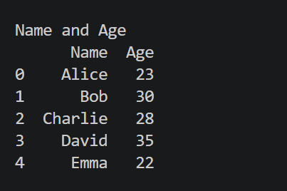  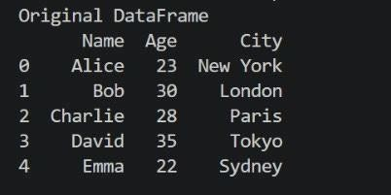  Figure 1.1 Original Dataframe details. The pd.DataFrame() function  converts  the dictionary data into a structured tabular format, making it easier to store, view, and manipulate data using Pandas. This DataFrame serves as the starting dataset for all subsequent operations such as column selection, filtering, adding new columns, sorting, and calculating statistical  measures.  Figure 1.2 shows the DataFrame after selecting only the Name and Age columns from the original dataset using Pandas column indexing. This operation extracts the required columns and creates a new DataFrame named name_age, removing the City column from the view. Such column  selection helps focus on relevant attributes Figure 1.2 Selected Nameand  for analysis and reduces unnecessary data Age Columns  processing.

Student Reg. No: 26MML0031Name: Makada Hasnain Husainbhai
Faculty: Dr Rajasekhara Babu M, Professor, School of CSE, Vellore Institute of Technology (VIT), Vellore
- | P a g e

2026 FALL SEMESTER
Programming for Data Science Lab (MACSE502) Record Practice Program
Date: 09/07/2026 Week No.: 1 Program S. No. 1
Figure 1.3 presents the filtered
DataFrame containing only those individuals whose Age is greater than 25. This filtering operation is performed using a conditional expression in Pandas, where the Age
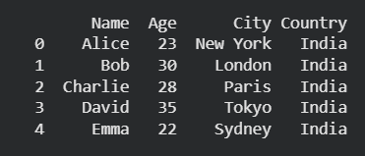
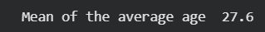
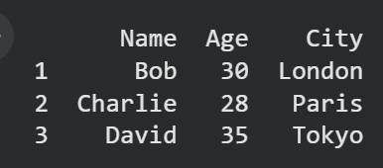
Figure 1.3: Filtered Data (Age > 25) column is checked against the
condition Age > 25. As a result, only
the rows
satisfying the condition are retained in the new DataFrame filtered_df. Figure 1.3 operation demonstrates how Pandas can be used to extract specific records based on user-defined criteria, which is a common requirement in data analysis and data preprocessing tasks.
Figure 1.4 displays the DataFrame after addinga
new column named Country with a default value of "India" for all records. This operation is performed using Pandas column assignment,
where the same value is assigned to Figure 1.4: DataFrame with Country Column
every row in the newly created column. Adding new columns is a common data transformation technique used to enrich datasets with additional information. Figure 1.4 output confirms that the Country column has been successfully added to the DataFrame, and each individual has been assigned the default value India. The enriched dataset is now ready for further operations such as sorting and statistical analysis.
Figure 1.5 illustrates the DataFrame after sorting the records based on the Age column in descending order using the Pandas sort_values() function. In this operation, individuals are arranged from
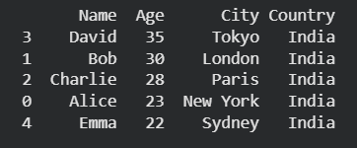
Figure 1.5 Sorted Data by Age the highest age to the lowest age.
(Descending Order) Sorting helps organize data
systematically and makes it easier to
identify records with
the largest or smallest values. Figure 1.5 output confirms that the DataFrame has been successfully sorted in descending order of Age, placing the oldest individual at the top and the youngest individual at the bottom. Such sorting operations are commonly used in data analysisFtiogurraen1k.,6 cAovmerpagaereA, gaenodf Ionrdgivaindiuzaels records efficiently.
Figure 1.6 presents the average age of all individuals in the dataset, calculated using the Pandas mean() function. The average (mean) age is obtained by summing all the age values and dividing the total by the
number of individuals in the DataFrame. This operation demonstrates the use of aggregate statistical functions in Pandas for summarizing numerical data. Figure 1.6 output confirms that the Pandas mean() function has successfully computed the average age of the five individuals as 27.6 years. Such aggregate functions are widely used in data analysis to summarize and interpret numerical information efficiently.
Student Reg. No: 26MML0031Name: Makada Hasnain Husainbhai
Faculty: Dr Rajasekhara Babu M, Professor, School of CSE, Vellore Institute of Technology (VIT), Vellore
- | P a g e

2026 FALL SEMESTER
Programming for Data Science Lab (MACSE502) Record Practice Program
Date: 09/07/2026 Week No.: 1 Program S. No. 1
Conclusions | This experiment successfully demonstrated the use of Pandas for basic data manipulation and analysis. A DataFrame containing the details of five individuals was created using the columns Name, Age, and City. Various DataFrame operations were then performed, including selecting specific columns, filtering rows based on a condition, adding a new column with default values, sorting records, and calculating statistical measures. These operations showcased the flexibility and efficiency of Pandas in handling tabular data.  The results showed that:  - The Name and Age columns could be extracted independently for focused analysis.  - Filtering enabled the identification of individuals whose Age was greater than 25 years.  - A new Country column was successfully added to enrich the dataset.  - Sorting arranged the records in descending order of age, making it easy to identify the oldest and youngest individuals.  - The average age of the individuals was calculated as 27.6 years, demonstrating the use of aggregate functions in data analysis.  Overall, this exercise provided a strong foundation in DataFrame creation, data selection, filtering, transformation, sorting, and statistical analysis using Pandas. These fundamental data manipulation techniques are widely used in Data Science, Machine Learning, Data Analytics, and Business Intelligence applications, making them essential skills for working with real-world datasets.
References | - Michael Freeman and Joel Ross, Programming Skills for Data Science: Start Writing Code to Wrangle, Analyze, and Visualize Data with R, Addison-Wesley, 2018  - Pandas Documentation: https://pandas.pydata.org/docs/  - Python Documentation: https://docs.python.org/3/  - Python Program (Google Colab link) https://colab.research.google.com/drive/1sjdIVacPTNg2JO_nGS8gic 99hGEtMuRe?usp=sharing  - Class lecture link https://drive.google.com/file/d/15diEukCtrPLimox63oa9ce1U-t4qVMUy/view

Student Reg. No: 26MML0031Name: Makada Hasnain Husainbhai
Faculty: Dr Rajasekhara Babu M, Professor, School of CSE, Vellore Institute of Technology (VIT), Vellore
- | P a g e

2025 WINTER SEMESTER

Programming for Data Science Lab (MACSE502) Record Exercise Program
Date: 09/07/2026 Week No.: 1 Program S. No. 2
Title | Data Manipulation and Analysis using the Starwars Dataset in R
Problem Statement | An AI company maintains model performance records containing:  - ModelID  - Accuracy  - Algorithm Perform:  - Select ModelID and Accuracy.  - Filter models with Accuracy greater than 90%.  - Add Status with default value "Production Ready".  - Sort models by Accuracy.  - Calculate average model accuracy.
Objectives | - Understand how AI model performance data is stored and represented in a Pandas DataFrame.  - Filter machine learning models based on conditions, such as accuracy greater than 90%.  - Learn how to select specific columns such as ModelID and Accuracy.  - Sort AI models according to their accuracy values.  - Calculate statistical values such as average, minimum, and maximum model accuracy.  - Rank machine learning models based on their performance.
 |  | ModelID |  | Algorithm |  |  | PreviousAccuracy | Accuracy
 |  | M101 |  | Logistic Regression |  |  | 84.5 | 87.2
 |  | M102 |  | Decision Tree |  |  | 87.0 | 89.5
 |  | M103 |  | Random Forest |  |  | 90.2 | 93.8
 |  | M104 |  | Support Vector Machine |  |  | 88.5 | 91.4
Dataset URL Link  / File |  | M105  M106 M107 M108 |  | K-Nearest Neighbors Random Forest Decision Tree  Neural Network |  |  | 82.5  91.0  85.5  92.0 | 85.6  94.5  88.3  96.1
 |  | M109 |  | Logistic Regression |  |  | 86.0 | 90.8
 |  | M110 |  | Neural Network |  |  | 93.1 | 95.4
 |  | M111 |  | Gradient Boosting |  |  | 89.4 | 92.7
 |  | M112 |  | Gradient Boosting |  |  | 91.8 | 94.1
Functions Details | Sl.  No. |  | Function |  | Package | Description of function
Functions Details | 1 |  | pd.DataFram  e() |  | Pandas | Creates a DataFrame from the AI model  data dictionary.
Functions Details | 2 |  | pd.read_csv() |  | Pandas | Reads AI model records from a CSV  file.
Functions Details | 3 |  | dropna() |  | Pandas | Removes rows containing missing or  invalid values
Functions Details | 4 |  | drop_duplicat  es() |  | Pandas | Removes duplicate records based on  ModelID.

Student Reg. No: 26MML0031 Name: Hasnain Makada
Faculty: Dr Rajasekhara Babu M, Professor, School of CSE, Vellore Institute of Technology (VIT), Vellore
- | P a g e

2025 WINTER SEMESTER

Programming for Data Science Lab (MACSE502) Record Exercise Program
Date: 09/07/2026 Week No.: 1 Program S. No. 2
 | 5 | sort_values() | Pandas | Sorts the models according to their  accuracy values.
 | 6 | mean() | Pandas | Calculates the average accuracy of all  AI models.
 | 7 | groupby()  and agg() | Pandas | Groups models by algorithm and  calculates performance statistics.
 | 8 | to_csv() | Pandas | Saves the analysed model results into  a CSV file.
Steps/ Process/ Procedure/ Algorithm/ Flowchart/ Model | - Import the Pandas package.  - Create the AI model dataset containing ModelID, Algorithm, PreviousAccuracy and Accuracy.  - Convert the dataset into a Pandas DataFrame.  - Clean the dataset byremoving missing values, duplicate ModelIDs and invalid accuracy values.  - Select only the ModelID and Accuracy columns.  - Filter the models whose Accuracy is greater than 90%.  - Add a Status column with the default value “Production Ready”.  - Change the status to “Needs Improvement” for models having Accuracy below 90%.  - Sort the models in descending order based on Accuracy.  - Assign ranks to the models, where the highest-accuracy model receives Rank 1.  - Calculate the improvement of each model using: Improvement = Accuracy − PreviousAccuracy  - Calculate the average accuracy of all models.  - Group the models by Algorithm and calculate minimum, maximum and average accuracy.  - Identify the best-performing, lowest-performing and most-improved models.  - Display all the analysis results in the console.  - Generate an automated model evaluation report.  - Save the analysed results in a CSV file and the report in a text file.
Program | import sys  from pathlib import Path import pandas as pd  from analysis_core import ( analyse_models, clean_data, create_algorithm_summary, create_report, create_sample_data, perform_basic_operations  )

Student Reg. No: 26MML0031 Name: Hasnain Makada
Faculty: Dr Rajasekhara Babu M, Professor, School of CSE, Vellore Institute of Technology (VIT), Vellore
- | P a g e

2025 WINTER SEMESTER

Programming for Data Science Lab (MACSE502) Record Exercise Program
Date: 09/07/2026 Week No.: 1 Program S. No. 2
#
====================================================
========
# HEADING FUNCTION
# This keeps console output neat and readable. #
====================================================
========
def print_heading(title): print("\n" + "=" * 72) print(title)
print("=" * 72)
#
====================================================
========
# MAIN CONSOLE PROGRAM #
# Run with sample data:
# python console_app.py #
# Run with CSV data:
# python console_app.py sample_ai_models.csv #
====================================================
========
def main():
print_heading("AI MODEL PERFORMANCE ANALYSIS
- CONSOLE MODE")
csv_file = None
# If the user gives a file path, use that CSV. if len(sys.argv) > 1:
csv_file = sys.argv[1]
if csv_file:
csv_path = Path(csv_file)
if not csv_path.exists(): print(f"Error: File not found:
{csv_path}") return
print(f"Using CSV file: {csv_path}") raw_data = pd.read_csv(csv_path)
else:
print("Using built-in sample data.")

Student Reg. No: 26MML0031 Name: Hasnain Makada
Faculty: Dr Rajasekhara Babu M, Professor, School of CSE, Vellore Institute of Technology (VIT), Vellore
- | P a g e

2025 WINTER SEMESTER

Programming for Data Science Lab (MACSE502) Record Exercise Program
Date: 09/07/2026 Week No.: 1 Program S. No. 2
raw_data = create_sample_data()
try:
cleaned_data = clean_data(raw_data) except ValueError as error:
print(f"Data error: {error}") return
analysed_data = analyse_models( cleaned_data
, production_threshold=90.0
)
results =
perform_basic_operations( analy sed_data
)
print_heading("ORIGINAL CLEANED DATA") print(
cleaned_data.to_string(index=False)
)
print_heading("1. SELECT MODELID AND ACCURACY") print(
results["selected_columns"]
.to_string(index=False)
)
print_heading(
"2. FILTER MODELS WITH ACCURACY GREATER THAN 90%"
)
print(
results["models_above_90"][ ["ModelID", "Algorithm", "Accuracy"]
].to_string(index=False)
)
print_heading(
'3. ADD STATUS WITH DEFAULT "PRODUCTION READY"'
)
print(
results["status_table"]
.to_string(index=False)
)
print_heading("4. SORT MODELS BY ACCURACY") print(

Student Reg. No: 26MML0031 Name: Hasnain Makada
Faculty: Dr Rajasekhara Babu M, Professor, School of CSE, Vellore Institute of Technology (VIT), Vellore
- | P a g e

2025 WINTER SEMESTER

Programming for Data Science Lab (MACSE502) Record Exercise Program
Date: 09/07/2026 Week No.: 1 Program S. No. 2
results["sorted_models"][
["ModelID", "Algorithm", "Accuracy"]
].to_string(index=False)
)
print_heading("5. CALCULATE AVERAGE MODEL ACCURACY")
print(
f'Average model accuracy: ' f'{results["average_accuracy"]:.2f}%'
)
print_heading("MODEL RANKING") print(
analysed_data[ [
"Rank", "ModelID", "Algorithm", "PreviousAccuracy", "Accuracy", "Improvement", "Status"
]
].to_string(index=False)
)
print_heading("ALGORITHM PERFORMANCE COMPARISON")
algorithm_summary = create_algorithm_summary( analysed_data
)
print(
algorithm_summary.to_string(index=False)
)
print_heading("ACCURACY IMPROVEMENT TRACKING")
print(
analysed_data[ [
"ModelID", "PreviousAccuracy", "Accuracy", "Improvement", "ImprovementStatus"
]
].to_string(index=False)
)

Student Reg. No: 26MML0031 Name: Hasnain Makada
Faculty: Dr Rajasekhara Babu M, Professor, School of CSE, Vellore Institute of Technology (VIT), Vellore
10 | P a g e

2025 WINTER SEMESTER

Programming for Data Science Lab (MACSE502) Record Exercise Program
Date: 09/07/2026 Week No.: 1 Program S. No. 2
report = create_report( analysed_data, production_threshold=90.0
)
print_heading("AUTOMATED EVALUATION REPORT") print(report)
# Save analysed data. analysed_data.to_csv(
"console_ai_model_results.csv", index=False
)
# Save the report. with open(
"console_ai_model_report.txt", "w",
encoding="utf-8"
) as report_file: report_file.write(report)
print_heading("FILES CREATED") print("console_ai_model_results.csv") print("console_ai_model_report.txt")
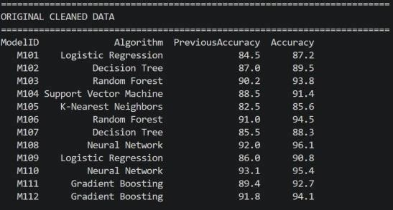
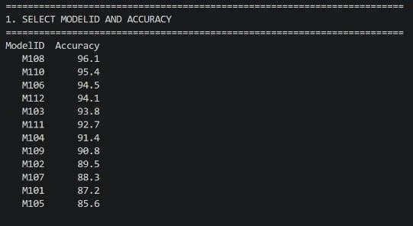
if name == " main ": main()
 |  | The program successfully loaded and cleaned the AI model performance dataset. The dataset contained ModelID, Algorithm, PreviousAccuracy and Accuracy.
Output Snapshots With Explanation/ Observations | Figure 2.1 Original Cleaned Dataset  The ModelID and Accuracy columns were selected successfully. Models having accuracy greater than 90% were filtered from the dataset.
 |  | Figure 1.2 Selected ModelID and Accuracy

Student Reg. No: 26MML0031 Name: Hasnain Makada
Faculty: Dr Rajasekhara Babu M, Professor, School of CSE, Vellore Institute of Technology (VIT), Vellore
11 | P a g e

2025 WINTER SEMESTER

Programming for Data Science Lab (MACSE502) Record Exercise Program
Date: 09/07/2026 Week No.: 1 Program S. No. 2
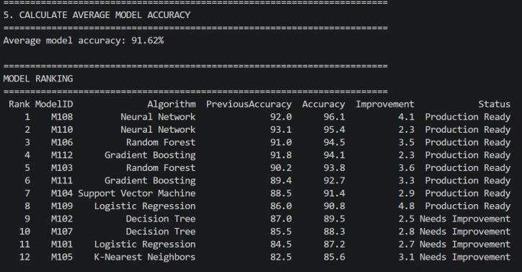
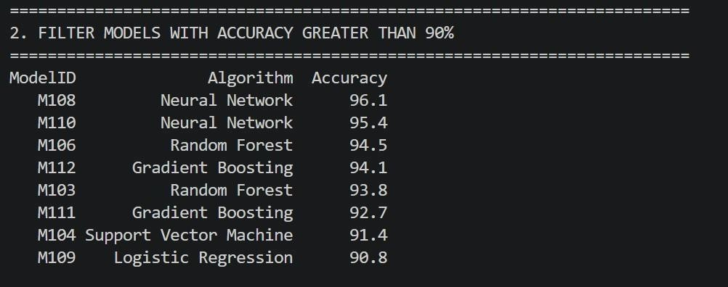
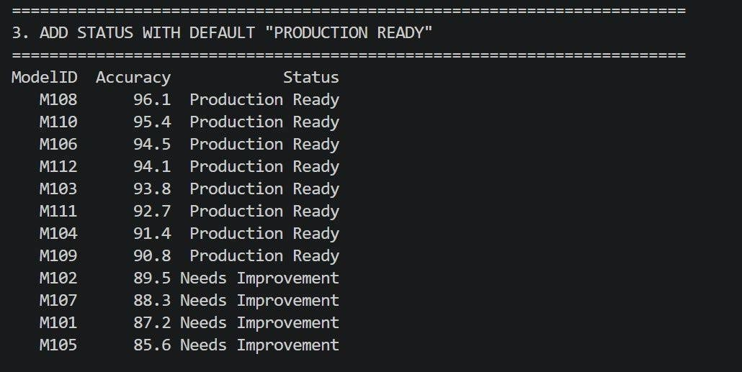
Figure 1.3 Models Accuracy Greater than 90%

A Status columnwas added.
Models with accuracy greater than or equal to 90% were marked as
“Production Figure 1.4 Status Column and Models sorted by accuracy
Ready”,
while the remaining
models were marked as “Needs The average
Improvement”. accuracyof all
models was calculated. Accuracy improvement was also calculated by subtracting PreviousAccuracy from the current Accuracy.
Figure 1.5 Average Model Accuracy

Student Reg. No: 26MML0031 Name: Hasnain Makada
Faculty: Dr Rajasekhara Babu M, Professor, School of CSE, Vellore Institute of Technology (VIT), Vellore
12 | P a g e

2025 WINTER SEMESTER

Programming for Data Science Lab (MACSE502) Record Exercise Program
Date: 09/07/2026 Week No.: 1 Program S. No. 2
 | 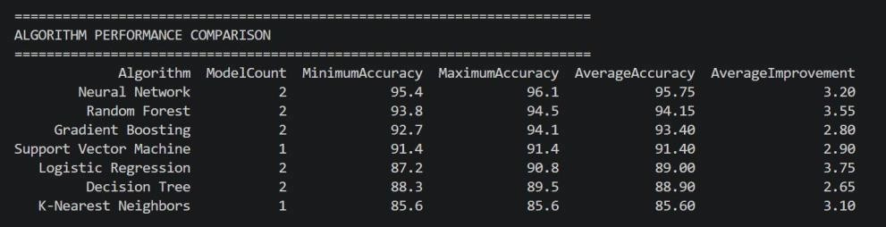
 | Figure 1.6 Models Grouped according to their algorithm and other metrics
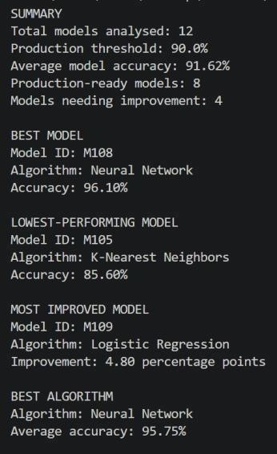
The models were grouped according to their algorithms, and minimum, maximum and average accuracy values were calculated for each
algorithm.

The program identified the best-performing model, lowest-performing model, most-improved model and best-performing algorithm.
 | Figure 1.7 Final Output
Conclusions | The exercise successfully demonstrated how Pandas can be used to analyse AI model performance data. The program selected, filtered, sorted and ranked the models, calculated average accuracy, compared algorithm performance and tracked accuracy improvement. It also generated an automated evaluation report and saved the final results in CSV and text formats.
References | - Michael Freeman and Joel Ross, Programming Skills for Data Science: Start Writing Code to Wrangle, Analyze, and Visualize Data with R, Addison-Wesley, 2018  - Python Program  (https://github.com/hasnainmakada-99/Data-Science-Codes/b lob/main/WEEK%201/Excercise_Program_Console.py)  - Class lecture link (https://drive.google.com/file/d/15diEukCtrPLimox63oa9ce1U  -t4qVMUy/view?usp=drive_link)

Student Reg. No: 26MML0031 Name: Hasnain Makada
Faculty: Dr Rajasekhara Babu M, Professor, School of CSE, Vellore Institute of Technology (VIT), Vellore
13 | P a g e

2026 FALL SEMESTER

Programming for Data Science Lab (MACSE502) Record Practice Program
Date: 16/07/2026 Week No.: 2 Program S. No. 3
Title | Student Marks Data Manipulation and Analysis using Pandas
Problem Statement | Data Cleaning and Preprocessing with Pandas: Create a DataFrame with some missing values in columns Name, Age, and City. Perform the following operations: fill missing values in the Age column with the mean age, drop rows where Name or City is missing, and convert the Age column to integer type. Finally, normalize the Age column using min-max scaling.
Objectives | - To understand how to create a Pandas DataFrame containing missing values.  - To learn how to identify and handle missing data using the fillna()  function.  - To remove incomplete records using the dropna() function.  - To convert a DataFrame column to the required data type using the  astype() function.  - To normalize numerical data using the Min-Max Scaling technique.  To understand the importance of data preprocessing before performing data analysis and machine learning tasks.
Dataset URL Link
/ File
Dataset URL Link  / File |  |  | Name |  | Age |  | City
Dataset URL Link  / File |  |  | Arjun |  | np.nan |  | np.nan
Dataset URL Link  / File |  |  | Priya |  | 28 |  | Mumbai
Dataset URL Link  / File |  |  | Rohan |  | 35 |  | Delhi
Dataset URL Link  / File |  |  | Sneha |  | np.nan |  | np.nan
Dataset URL Link  / File |  |  | Amit |  | 40 |  | Bangalore
Dataset URL Link  / File |  |  | Deepa |  | 30 |  | Chennai
Dataset URL Link  / File |  |  | Rahul |  | np.nan |  | np.nan
Dataset URL Link  / File |  |  | np.nan |  | 33 |  | Kolkata
Dataset URL Link  / File |  |  | np.nan |  | 29 |  | Ahmedabad
Functions Details | Sl.  No. | Function |  | Package |  | Description of function
Functions Details | 1 | DataFrame() |  | pandas |  | Creates a DataFrame from structured  data
Functions Details | 2 | Mean() |  | pandas |  | Calculates the average value
Functions Details | 3 | fillna() |  | pandas |  | Replaces missing values with  a specified value.
Functions Details | 4 | dropna() |  | pandas |  | Removes rows containing missing  values.

Student Reg. No: 26MML0031 Name: Makada Hasnain Husainbhai
Faculty: Dr Rajasekhara Babu M, Professor, School of CSE, Vellore Institute of Technology (VIT), Vellore
14 | P a g e

2026 FALL SEMESTER

Programming for Data Science Lab (MACSE502) Record Practice Program
Date: 16/07/2026 Week No.: 2 Program S. No. 3
Step 1
Import the pandas library.
Step 2
Create a Python dictionary containing StudentID, Name, and Marks for five students.
Steps/ Process/ Procedure/ Algorithm/ Flowchart/ Model | Step 3  Convert the dictionary into a Pandas DataFrame and display the original dataset.  Step 4  Select and display only the Name and Marks columns.  Step 5  Filter and display students whose Marks are greater than 70.  Step 6  Add a Grade column by assigning grades A to E according to the marks obtained.
Step 7
Display the updated DataFrame containing the Grade column.
Step 8
Sort the DataFrame by Marks in ascending order and display the result.
Step 9
Calculate and display the average marks using the mean() function.
 | # Import the Pandas library import pandas as pd
# Create a dictionary containing student details dictionary_1 = {
"StudentID": [10, 11, 12, 13, 14],
"Name": ["Hasnain", "John", "Alice", "Sahil", "Cook"], "Marks": [45, 86, 90, 67, 97]
}
 | # Convert the dictionary into a Pandas DataFrame dataFrame = pd.DataFrame(dictionary_1)
 | # Display the original dataset print("Diplaying the Original Dataset\ n") print(dataFrame, "\n")
Program | # Select and display only the Name and Marks columns only_name_colum = pd.DataFrame(  dataFrame, columns=["Name", "Marks"]  )  print("Displaying only name and marks columns\n") print(only_name_colum, "\n")
# Filter students whose marks are greater than 70 marks_greater_than_70 = pd.DataFrame(
dataFrame[dataFrame["Marks"] > 70]
)
print("Displaying students with marks greater than 70\n") print(marks_greater_than_70, "\n")
# Assign grades based on the marks obtained dataFrame["Grade"] = [
"A" if marks >= 90 else "B" if marks >= 80 else "C" if marks >= 70 else "D" if marks >= 60 else "E"
for marks in dataFrame["Marks"]

Student Reg. No: 26MML0031 Name: Makada Hasnain Husainbhai
Faculty: Dr Rajasekhara Babu M, Professor, School of CSE, Vellore Institute of Technology (VIT), Vellore
15 | P a g e

2026 FALL SEMESTER

Programming for Data Science Lab (MACSE502) Record Practice Program
Date: 16/07/2026 Week No.: 2 Program S. No. 3
]

# Display the updated dataset with the Grade column print("Displaying the updated dataset\n") print(dataFrame, "\n")

# Sort the dataset by Marks in ascending order sort_by_marks = dataFrame.sort_values(
by="Marks", ascending=True
)
print("Displaying the sorted dataset\n") print(sort_by_marks, "\n")

# Calculate and display the average marks average = dataFrame["Marks"].mean() print("Average Marks \n") print(average)
Figure 2.1 displays the original DataFrame created fr student dictionary. It contains the columns Stud Name, and Marks for five students. The pd.DataF function converts the dictionary into a structured format that can be analysed using Pandas.
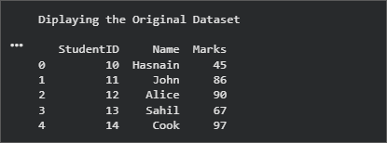
Figure 2.1 Original Student Dataset
2.2 shows onlythe Name and Marks columns selected the original DataFrame. This demonstrates column selection and allows the analysis to focus on the student names and their corresponding marks without Displaying StudentID.
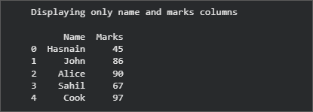
Figure 2.2 Selected Name and Marks Columns
Output Snapshots With Explanation/ Observations | 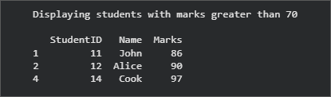  Figure 2.3 presents the filtered records for students Marks are greater than 70. The Boolean condition dataFrame["Marks"] > 70 retains John,  Alice, and Cook because their marks satisfythe specified condition.
Output Snapshots With Explanation/ Observations | Figure 2.3 Filtering student with marks  > 70
 | 2.4 displays the updated DataFrame after the Grade column. Grades are assigned conditional logic: A for marks of 90 or B for 80-89, C for 70-79, D for 60-69, and marks below 60. |  | 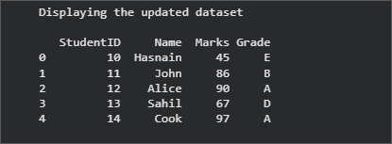  Figure 2.4 Dataset after Adding the Grade Column
 | 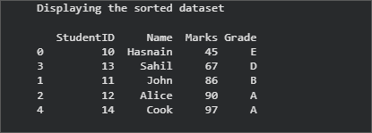  2.5 Dataset Sorted by Marks in Ascending Order |  | Figure 2.5 shows the records sorted from the lowest to the highest marks using sort_values(). Hasnain appears first with 45 marks, while Cook appears last with 97 marks. The original row indexes are retained by Pandas.

Student Reg. No: 26MML0031 Name: Makada Hasnain Husainbhai
Faculty: Dr Rajasekhara Babu M, Professor, School of CSE, Vellore Institute of Technology (VIT), Vellore
16 | P a g e

2026 FALL SEMESTER

Programming for Data Science Lab (MACSE502) Record Practice Program
Date: 16/07/2026 Week No.: 2 Program S. No. 3
Figure using five of | 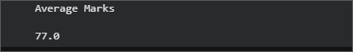  2.6 displays the average marks calculated the mean() function. The total marks of all students divided by five gives an average  77.0. Figure 2.6 Average Marks
Conclusions | This exercise successfully demonstrated basic student-data manipulation and analysis using Pandas. A DataFrame containing StudentID, Name, and Marks was created from a Python dictionary, and multiple operations were performed on the dataset.  The results showed that:  - The Name and Marks columns were selected successfully for focused analysis.  - Students with marks greater than 70 were identified using Boolean filtering.  - A Grade column was generated using conditional logic based on each student's marks.  - The records were arranged in ascending order of marks using sort_values().  - The average marks of the five students were calculated as 77.0 using mean(). Overall, the exercise provided practical experience in DataFrame creation, column selection, row filtering, conditional transformation, sorting, and statistical aggregation. These operations are fundamental for data preprocessing and exploratory data analysis in Data Science and Machine Learning applications.
References | - Wes McKinney, Python for Data Analysis: Data Wrangling with pandas, NumPy,  and Jupyter, 3rd Edition, O’Reilly Media, 2022.  - Pandas Documentation: https://pandas.pydata.org/docs/  - Python Documentation: https://docs.python.org/3/  - Python Program (Google Colab Link) https://colab.research.google.com/drive/1qBzvtH6ZEis8Jv20WDiYXKI4PXGS XcWJ?usp=sharing  - Pandas DataFrame API Reference: https://pandas.pydata.org/docs/reference/api/pandas.DataFrame.html  - Class lecture link: https://drive.google.com/file/d/15diEukCtrPLimox63oa9ce1U-t4qVMUy/view

Student Reg. No: 26MML0031 Name: Makada Hasnain Husainbhai
Faculty: Dr Rajasekhara Babu M, Professor, School of CSE, Vellore Institute of Technology (VIT), Vellore
17 | P a g e

2025 WINTER SEMESTER

Programming for Data Science Lab (MACSE502) Record Exercise Program
Date: 16/07/2026 Week No.: 2 Program S. No. 4
Title | Data Manipulation and Analysis using the Starwars Dataset in R
Problem Statement | A streaming platform maintains movie records containing:  - MovieID  - Rating  - Genre Perform:  - Create a dataset with missing values.  - Fill missing Rating values using average rating.  - Remove rows with missing MovieID or Genre.  - Convert Rating into integer type.  - Normalize rating values.
Objectives | - To understand movie data preprocessing using the Pandas library.  - To create a dataset containing missing values.  - To identify and handle missing values in a dataset.  - To fill missing Rating values using the average rating.  - To remove records with missing MovieID or Genre.  - To convert the Rating column into integer data type.  - To normalize movie rating values using Min-Max normalization.  - To identify top-rated movies based on ratings.
Dataset URL Link  / File |  | MovieID | MovieTit  le | Rating | Genre | ViewCou  nt | Likes
Dataset URL Link  / File |  | MV101 | The Last  Horizon | 8.5 | Science  Fiction | 125000 | 11200
Dataset URL Link  / File |  | MV102 | City  Lights |  | Comedy | 98000 | 7500
Dataset URL Link  / File |  | MV103 | Hidden  Truth | 7.8 | Thriller | 110000 | 8900
Dataset URL Link  / File |  | None | Lost  Kingdom | 9.1 | Fantasy | 150000 | 13500
Dataset URL Link  / File |  | MV105 | Digital  Dreams | 8.9 | Science  Fiction | 175000 | 16000
Dataset URL Link  / File |  | MV106 | Silent River |  | Drama | 87000 | 6100
Dataset URL Link  / File |  | MV107 | Future  Code | 9.3 | Science  Fiction | 210000 | 19800
Dataset URL Link  / File |  | MV108 | Broken  Compass | 6.7 |  | 65000 | 4200
Dataset URL Link  / File |  | MV109 | Midnight  Journey | 8.1 | Adventur  e | 132000 | 10400
Dataset URL Link  / File |  | MV110 | Laugh  Again | 7.5 | Comedy | 105000 | 8100
Dataset URL Link  / File |  | MV111 | Ocean  Mystery | 8.8 | Mystery | 143000 | 12100
Dataset URL Link  / File |  | MV112 | Final  Mission |  | Action | 190000 | 17400

Student Reg. No: 26MML0031 Name: Makada Hasnain H
Faculty: Dr Rajasekhara Babu M, Professor, School of CSE, Vellore Institute of Technology (VIT), Vellore
18 | P a g e

2025 WINTER SEMESTER

Programming for Data Science Lab (MACSE502) Record Exercise Program
Date: 16/07/2026 Week No.: 2 Program S. No. 4
 |  | MV113 |  | Parallel  Lives |  | 8.4 |  | Drama | 118000 | 9600
 |  | MV114 |  | Wild Trails |  | 7.2 |  | Adventur e | 99000 | 7200
 |  | MV115 |  | The Great Escape |  | 9.0 |  | Action | 205000 | 18800
Functions Details | Sl.  No. |  | Function |  | Package |  | Description of function
Functions Details | 1 |  | pd.DataFram  e() |  | Pandas |  | Creates a DataFrame from the movie  dataset stored in dictionary format.
Functions Details | 2 |  | isnull() |  | Pandas |  | Identifies missing values present in the  movie dataset.
Functions Details | 3 |  | mean() |  | Pandas |  | Fills missing Rating values using the  calculated average rating.
Functions Details | 4 |  | dropna() |  | Pandas |  | Removes rows containing missing MovieID or Genre values.
Functions Details | 5 |  | pd.to_numeri  c() |  | Pandas |  | Converts Rating values into numeric  format and handles invalid entries.
Functions Details | 6 |  | round() |  | Pandas |  | Rounds decimal Rating values before  converting them into integers.
Functions Details | 7 |  | astype() |  | Pandas |  | Converts the Rating column into integer  data type.
Functions Details | 8 |  | min() |  | Pandas |  | Finds the minimum Rating value  required for normalization.
Functions Details | 9 |  | max() |  | Pandas |  | Finds the maximum Rating value  required for normalization.
Functions Details | 10 |  | groupby() |  | Pandas |  | Groups movie records according to Genre for genre-wise analysis.
Functions Details | 11 |  | sort_values() |  | Pandas |  | Sorts movies based on rating, popularity  score or number of views.
Functions Details | 12 |  | fillna() |  | Pandas |  | Fills missing Rating values using the calculated average rating.
Steps/ Process/ Procedure/ Algorithm/ Flowchart/ Model | Step 1: Import the Pandas library and create the movie dataset in dictionary format.  Step 2: Convert the dictionary into a Pandas DataFrame using pd.DataFrame().  Step 3: Display the original dataset containing missing values.  Step 4: Calculate the average value of the Rating column using the mean() function.  Step 5: Fill the missing Rating values using fillna() with the calculated average rating.

Student Reg. No: 26MML0031 Name: Makada Hasnain H
Faculty: Dr Rajasekhara Babu M, Professor, School of CSE, Vellore Institute of Technology (VIT), Vellore
19 | P a g e

2025 WINTER SEMESTER

Programming for Data Science Lab (MACSE502) Record Exercise Program
Date: 16/07/2026 Week No.: 2 Program S. No. 4
Step 6: Remove rows containing missing MovieID or Genre using the dropna() function.
Step 7: Convert the Rating column into numeric format using pd.to_numeric() and then convert it into integer type using round() and astype(int).
Step 8: Normalize the Rating values using the Min-Max Normalization formula:
Normalized Rating = (Rating − Minimum Rating) / (Maximum Rating − Minimum Rating)
Step 9: Calculate the Engagement Rate and Popularity Score for each movie based on views, likes and ratings.
Step 10: Sort the movies according to Popularity Score and Rating using sort_values() and assign popularity ranks.
Step 11: Generate a genre-wise report using the groupby() function to compare movie performance across different genres.
Step 12: Recommend the top movies based on selected genre and minimum rating, generate the automated analytics report, and save the processed results for future analysis.
 | import pandas as pd
 | #
 | # 1. CREATE MOVIE DATASET IN DICTIONARY FORMAT
 | #
 | movie_data = {
 | "MovieID": [
 | "MV101", "MV102", "MV103", None, "MV105",
 | "MV106", "MV107", "MV108", "MV109", "MV110",
 | "MV111", "MV112", "MV113", "MV114", "MV115"
 | ],
Program | "MovieTitle": [
 | "The Last Horizon",
 | "City Lights",
 | "Hidden Truth",
 | "Lost Kingdom",
 | "Digital Dreams",
 | "Silent River",
 | "Future Code",
 | "Broken Compass",
 | "Midnight Journey",

Student Reg. No: 26MML0031 Name: Makada Hasnain H
Faculty: Dr Rajasekhara Babu M, Professor, School of CSE, Vellore Institute of Technology (VIT), Vellore
20 | P a g e

2025 WINTER SEMESTER

Programming for Data Science Lab (MACSE502) Record Exercise Program
Date: 16/07/2026 Week No.: 2 Program S. No. 4
"Laugh Again", "Ocean Mystery", "Final Mission", "Parallel Lives", "Wild Trails", "The Great Escape"
],
"Rating": [
8.5, None, 7.8, 9.1, 8.9,
None, 9.3, 6.7, 8.1, 7.5,
8.8, None, 8.4, 7.2, 9.0
],
"Genre": [ "Science Fiction", "Comedy", "Thriller", "Fantasy", "Science Fiction", "Drama", "Science Fiction", None, "Adventure", "Comedy", "Mystery", "Action",
"Drama", "Adventure", "Action"
],
"ViewCount": [
125000, 98000, 110000, 150000, 175000,
87000, 210000, 65000, 132000, 105000,
143000, 190000, 118000, 99000, 205000
],
"Likes": [
11200, 7500, 8900, 13500, 16000,
6100, 19800, 4200, 10400, 8100,
12100, 17400, 9600, 7200, 18800
]
}
# 2. CONVERT DICTIONARY INTO DATAFRAME

Student Reg. No: 26MML0031 Name: Makada Hasnain H
Faculty: Dr Rajasekhara Babu M, Professor, School of CSE, Vellore Institute of Technology (VIT), Vellore
21 | P a g e

2025 WINTER SEMESTER

Programming for Data Science Lab (MACSE502) Record Exercise Program
Date: 16/07/2026 Week No.: 2 Program S. No. 4
#
movies = pd.DataFrame(movie_data)
print("\nORIGINAL MOVIE DATASET")
print("=" * 90) print(movies.to_string(index=False))

#
# 3. CALCULATE AVERAGE RATING #
average_rating = movies["Rating"].mean()
print("\nAVERAGE RATING")
print("=" * 90)
print("Average Rating:", round(average_rating, 2))

#
# 4. FILL MISSING RATING VALUES #
movies["Rating"] = movies["Rating"].fillna(average_rating)
print("\nDATASET AFTER FILLING MISSING RATING VALUES")
print("=" * 90) print(
movies[
["MovieID", "MovieTitle", "Rating", "Genre"]
].to_string(index=False)
)

#
# 5. REMOVE ROWS WITH MISSING MOVIEID OR GENRE #
movies = movies.dropna(subset=["MovieID", "Genre"])
print("\nDATASET AFTER REMOVING MISSING MOVIEID OR GENRE")
print("=" * 90) print(
movies[
["MovieID", "MovieTitle", "Rating", "Genre"]
].to_string(index=False)
)

#

Student Reg. No: 26MML0031 Name: Makada Hasnain H
Faculty: Dr Rajasekhara Babu M, Professor, School of CSE, Vellore Institute of Technology (VIT), Vellore
22 | P a g e

2025 WINTER SEMESTER

Programming for Data Science Lab (MACSE502) Record Exercise Program
Date: 16/07/2026 Week No.: 2 Program S. No. 4
# 6. CONVERT RATING INTO INTEGER TYPE #
movies["Rating"] = movies["Rating"].round().astype(int)
print("\nRATING CONVERTED INTO INTEGER TYPE")
print("=" * 90) print(
movies[
["MovieID", "MovieTitle", "Rating"]
].to_string(index=False)
)
print("\nRating Data Type:", movies["Rating"].dtype)

#
# 7. NORMALIZE RATING VALUES
# Min-Max
Normalization # minimum_rating = movies["Rating"].min() maximum_rating = movies["Rating"].max()
movies["NormalizedRating"] = ( (movies["Rating"] - minimum_rating)
/ (maximum_rating - minimum_rating)
).round(3)
print("\nNORMALIZED RATING VALUES")
print("=" * 90) print(
movies[ [
"MovieID", "MovieTitle", "Rating", "NormalizedRating"
]
].to_string(index=False)
)

#
# 8. CALCULATE ENGAGEMENT RATE #
movies["EngagementRate"] = (
movies["Likes"] / movies["ViewCount"] * 100
).round(2)

Student Reg. No: 26MML0031 Name: Makada Hasnain H
Faculty: Dr Rajasekhara Babu M, Professor, School of CSE, Vellore Institute of Technology (VIT), Vellore
23 | P a g e

2025 WINTER SEMESTER

Programming for Data Science Lab (MACSE502) Record Exercise Program
Date: 16/07/2026 Week No.: 2 Program S. No. 4
print("\nVIEWER ENGAGEMENT")
print("=" * 90) print(
movies[ [
"MovieTitle", "ViewCount", "Likes", "EngagementRate"
]
].to_string(index=False)
)

#
# 9. CALCULATE POPULARITY SCORE #
maximum_engagement = movies["EngagementRate"].max()
movies["NormalizedEngagement"] = ( movies["EngagementRate"] / maximum_engagement
).round(3)
movies["PopularityScore"] = ( movies["NormalizedRating"] * 0.60
+ movies["NormalizedEngagement"] * 0.40
).round(3)

#
# 10. SORT AND RANK MOVIES #
movies = movies.sort_values( by=["PopularityScore", "Rating"], ascending=[False, False]
).reset_index(drop=True) movies["PopularityRank"] = range(1, len(movies) +
1) print("\nTOP-RATED AND POPULAMOVIES")
print("=" * 90) print(
movies[ [
"PopularityRank", "MovieID", "MovieTitle", "Genre",

Student Reg. No: 26MML0031 Name: Makada Hasnain H
Faculty: Dr Rajasekhara Babu M, Professor, School of CSE, Vellore Institute of Technology (VIT), Vellore
24 | P a g e

2025 WINTER SEMESTER

Programming for Data Science Lab (MACSE502) Record Exercise Program
Date: 16/07/2026 Week No.: 2 Program S. No. 4
"Rating", "ViewCount", "PopularityScore"
]
].to_string(index=False)
)

#
# 11. GENERATE GENRE-WISE REPORT #
genre_report = movies.groupby( "Genre", as_index=False
).agg(
MovieCount=("MovieID", "count"), AverageRating=("Rating", "mean"), HighestRating=("Rating", "max"), TotalViews=("ViewCount", "sum"), TotalLikes=("Likes", "sum")
)
genre_report["AverageRating"] = ( genre_report["AverageRating"].round(2)
)
genre_report = genre_report.sort_values( by="Avera geRating", ascending=False
)
print("\nGENRE-WISE MOVIE REPORT")
print("=" * 90) print(genre_report.to_string(index=False))

#
# 12. SIMPLE MOVIE RECOMMENDATION #
preferred_genre = "Science Fiction" minimum_required_rating = 7
recommended_movies = movies[ (movies["Genre"] == preferred_genre)
& (movies["Rating"] >= minimum_required_rating)
].sort_values( by="PopularityScor e", ascending=False

Student Reg. No: 26MML0031 Name: Makada Hasnain H
Faculty: Dr Rajasekhara Babu M, Professor, School of CSE, Vellore Institute of Technology (VIT), Vellore
25 | P a g e

2025 WINTER SEMESTER

Programming for Data Science Lab (MACSE502) Record Exercise Program
Date: 16/07/2026 Week No.: 2 Program S. No. 4
)
print("\nMOVIE RECOMMENDATIONS")
print("=" * 90)
print("Preferred Genre:", preferred_genre) print("Minimum Rating:", minimum_required_rating)
print(
recommended_movies[ [
"MovieID", "MovieTitle", "Genre",
"Rating", "PopularityScore"
]
].to_string(index=False)
)

#
# 13. AUTOMATED ANALYTICS REPORT #
top_movie = movies.iloc[0]
most_viewed_movie =
movies.loc[ movies["ViewCount"].idxmax()
]
best_genre = genre_report.iloc[0]
print("\nAUTOMATED MOVIE ANALYTICS REPORT")
print("=" * 90)
print("Total Movies Analysed:", len(movies))
print("Average Movie Rating:", round(movies["Rating"].mean(), 2)) print("Total Genres:", movies["Genre"].nunique())
print("\nTop-Rated and Most Popular Movie") print("Movie Title:", top_movie["MovieTitle"]) print("Genre:", top_movie["Genre"]) print("Rating:", top_movie["Rating"])
print("Popularity Score:", top_movie["PopularityScore"])
print("\nMost Viewed Movie") print("Movie Title:",
most_viewed_movie["MovieTitle"]) print("Views:", most_viewed_movie["ViewCount"])

Student Reg. No: 26MML0031 Name: Makada Hasnain H
Faculty: Dr Rajasekhara Babu M, Professor, School of CSE, Vellore Institute of Technology (VIT), Vellore
26 | P a g e

2025 WINTER SEMESTER

Programming for Data Science Lab (MACSE502) Record Exercise Program
Date: 16/07/2026 Week No.: 2 Program S. No. 4
print("\nBest Performing Genre") print("Genre:", best_genre["Genre"])
print("Average Rating:", best_genre["AverageRating"])

#
# 14. SAVE RESULTS #
movies.to_csv( "processed_movie
_data.csv", index=False
)
genre_report.to_csv( "genre_wise
_report.csv", index=False
)
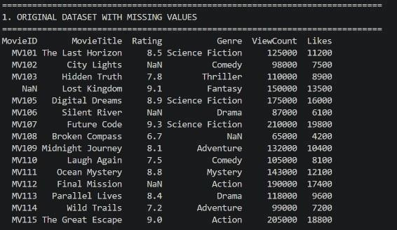
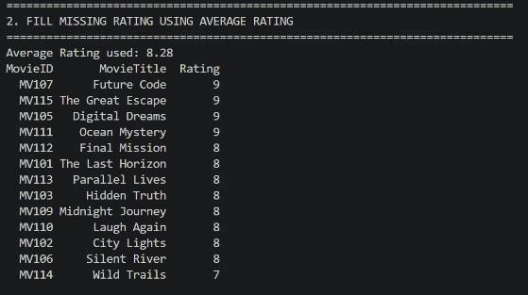
print("\nFILES CREATED") print("=" * 90) print("processed_movie_data.csv") print("genre_wise_report.csv")
Output Snapshots With Explanation/ Observations | The movie dataset was
Output Snapshots With Explanation/ Observations | successfully created in DataFrame format with missing values in the MovieID, Rating, and Genre columns.  Figure 1.1 Original dataset printed after creating the DataFrame (containing missing values).  The average rating was calculated successfully and was used to replace all missing Rating values.  Figure 1.2 Output showing the calculated average rating.
Student Reg. No | : 26MML0031 Name: Makada Hasnain H
Faculty: Dr Rajasekhara Babu M, Professor, School of CSE, Vellore Institute of Technology (VIT), Vellore
27 | P a g e

2025 WINTER SEMESTER

Programming for Data Science Lab (MACSE502) Record Exercise Program
Date: 16/07/2026 Week No.: 2 Program S. No. 4
Missing Rating values were replaced with the calculated average rating while preserving all other records.

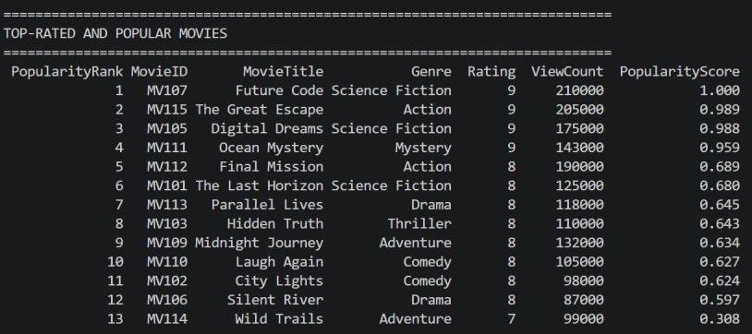
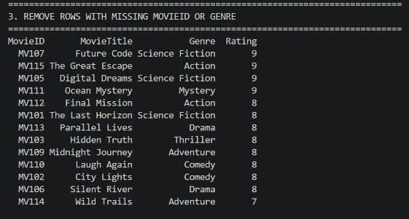
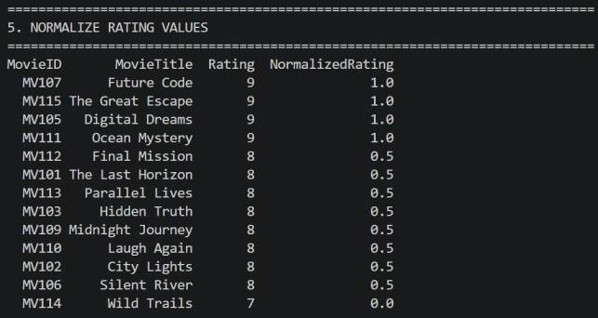
Figure 1.3 Dataset after fillna() operation.

Rating values were converted into integer type and normalized using the Min-Max Normalization technique.

Figure 1.4 Integer Rating output along with the NormalizedRating column.

Figure 1.5 Sorted movie list showing Popularity Rank.

Movies were ranked successfully based on their popularity score, allowing easy identification of top-performing movies.
Conclusions | The Movie Rating Data Preprocessing project was successfully implemented using the Pandas library. The dataset was created with missing values, and the missing Rating values were replaced using the average rating. Records with missing MovieID or Genre were removed to improve data quality. The Rating column was converted into integer type, and the values were normalized using the Min-Max normalization technique. The project also identified top-rated movies, generated genre-wise reports, analysed viewer preferences, recommended

Student Reg. No: 26MML0031 Name: Makada Hasnain H
Faculty: Dr Rajasekhara Babu M, Professor, School of CSE, Vellore Institute of Technology (VIT), Vellore
28 | P a g e

2026 WINTER SEMESTER

Programming for Data Science Lab (MACSE502) Record Exercise Program
Date: 16/07/2026 Week No.: 2 Program S. No. 4
 | movies based on genre and rating, and visualized movie popularity trends. This exercise provided practical knowledge of data preprocessing, data analysis, and dashboard development using Python, Pandas, and Streamlit.
References | - Michael Freeman and Joel Ross, Programming Skills for Data Science: Start Writing Code to Wrangle, Analyze, and Visualize Data with R, Addison-Wesley, 2018  - Python Program (https://github.com/hasnainmakada-99/Data-Science-Codes/blob/main/WEEK%202/ EXERCISE_PROGRAM.py)  - Class lecture link (https://drive.google.com/file/d/15diEukCtrPLimox63oa9ce1U-t4qVMUy/view)

Student Reg. No: 26MML0031 Name: Makada Hasnain H
Faculty: Dr Rajasekhara Babu M, Professor, School of CSE, Vellore Institute of Technology (VIT), Vellore
29 | P a g e

2026 FALL SEMESTER

Programming for Data Science (MACSE502) Lab Record Practice Program
Date: 23/07/2026 Week No.: 3 Program S. No. 5
Title | Creating and Manipulating Arrays Using NumPy
Problem Statement | Create a 2D array of shape (3, 4) with random integers between 0 and 10. Perform the following operations: calculate the mean and standard deviation of the entire array, slice the array to get the first two rows and  last two columns, reshape the array to shape (4, 3), and perform element-wise multiplication with another array of the same shape
Objectives | - To create and manipulate two-dimensional NumPy arrays.  - To represent predefined array values using a Python dictionary.  - To calculate the mean and standard deviation of the entire array.  - To slice the array and extract selected rows and columns.  - To reshape an array from shape (3, 4) to shape (4, 3).  - To perform element-wise multiplication between arrays of the same shape.  - To understand array shape, slicing, reshaping and numerical operations using NumPy.
Dataset URL Link  / File | Predefined dictionary dataset used directly inside the Python  program:
Dataset URL Link  / File | Array |  | Row 1 |  | Row 2 |  | Row 3 | Row 4
Dataset URL Link  / File | Array1 (3 x  4) |  | 2, 5, 7, 1 |  | 8, 3, 6, 4 |  | 9, 0, 5, 2 | —
Dataset URL Link  / File | Array2 (4 x  3) |  | 1, 2, 3 |  | 4, 5, 6 |  | 7, 8, 9 | 2, 3, 4
Dataset URL Link  / File | No external dataset file or URL is required.
Functions Details | Sl.  No. | Function |  | Package |  | Description of function
Functions Details | 1 | np.array() |  | NumPy |  | Converts dictionary values into  NumPy arrays.
Functions Details | 2 | shape |  | NumPy |  | Returns the dimensions of an array as  rows and columns.
Functions Details | 3 | np.mean() |  | NumPy |  | Calculates the mean of all elements in the array.
Functions Details | 4 | np.std() |  | NumPy |  | Calculates the standard deviation of all  array elements.
Functions Details | 5 | Array slicing |  | NumPy |  | Extracts the first two rows and last two columns.
Functions Details | 6 | reshape() |  | NumPy |  | Changes the array shape from (3, 4) to (4, 3).
Functions Details | 7 | round() |  | Python |  | Rounds numerical output to  the specified decimal places.
Functions Details | 8 | print() |  | Python |  | Displays arrays, calculations and  headings in the console.
Functions Details | 9 | range() |  | Python |  | Creates a sequence of integer values  when required.
Functions Details | 10 | len() |  | Python |  | Returns the number of items in an object.
Functions Details | 11 | dtype |  | NumPy |  | Shows the data type of array elements.

Student Reg. No: 26MML0031 Name: Makada Hasnain
Faculty: Dr Rajasekhara Babu M, Professor, School of CSE, Vellore Institute of Technology (VIT), Vellore
- | P a g e

2026 FALL SEMESTER

Programming for Data Science (MACSE502) Lab Record Practice Program
Date: 23/07/2026 Week No.: 3 Program S. No. 5
 | 12 | Element-wise  * | NumPy | Multiplies corresponding elements of equal-shaped arrays.
 | Step 1: Import NumPy using import numpy as np.
 | Step 2: Create a predefined dictionary containing Array1 and Array2.
 | Step 3: Convert the dictionary values into NumPy arrays using np.array().
 | Step 4: Display Array1 and verify its shape as (3, 4).
Steps/ | Step 5: Calculate the mean using np.mean().
Process/ | Step 6: Calculate the standard deviation using np.std().
Procedure/ | Step 7: Slice Array1 using array1[:2, -2:] to get the first two rows and last
Algorithm/ | two columns.
Flowchart/ | Step 8: Reshape Array1 to (4, 3) using reshape(4, 3).
Model | Step 9: Display Array2 and verify its shape as (4, 3).
 | Step 10: Perform element-wise multiplication using reshaped_array *
 | array2.
 | Step 11: Display all results and their respective shapes.
 | Step 12: Verify that all requested NumPy operations are completed
 | successfully.
 | import numpy as np
array_data = { "Array1": [[2, 5, 7,
1],
[8, 3, 6, 4],
[9, 0, 5, 2]],
"Array2": [[1, 2, 3],
[4, 5, 6],
[7, 8, 9],
[2, 3, 4]]
}
 | array1 = np.array(array_data["Array1"]) array2 = np.array(array_data["Array2"])
Program | print("ORIGINAL 2D ARRAY")  print(array1)  print("Shape:", array1.shape)
mean_value = np.mean(array1) standard_deviation = np.std(array1) print("\ nMean:", round(mean_value, 2))
print("Standard Deviation:", round(standard_deviation, 2))
sliced_array = array1[:2, -2:]
print("\nFIRST TWO ROWS AND LAST TWO COLUMNS")
print(sliced_array)
print("Shape:", sliced_array.shape)
 | reshaped_array = array1.reshape(4, 3) print("\ nRESHAPED ARRAY")

Student Reg. No: 26MML0031 Name: Makada Hasnain
Faculty: Dr Rajasekhara Babu M, Professor, School of CSE, Vellore Institute of Technology (VIT), Vellore
- | P a g e

2026 FALL SEMESTER

Programming for Data Science (MACSE502) Lab Record Practice Program
Date: 23/07/2026 Week No.: 3 Program S. No. 5
print(reshaped_array)
print("Shape:", reshaped_array.shape)

print("\nSECOND ARRAY") print(array2)
multiplied_array = reshaped_array * array2 print("\nELEMENT-WISE MULTIPLICATION")
print(multiplied_array)
print("Shape:", multiplied_array.shape)

print("\nFINAL SUMMARY") print("Original Shape:", array1.shape) print("Mean:", round(mean_value, 2))
print("Standard Deviation:", round(standard_deviation, 2)) print("Sliced Shape:", sliced_array.shape)
print("Reshaped Shape:", reshaped_array.shape) print("Multiplied Shape:", multiplied_array.shape)
Output Snapshots With Explanation/ Observations | 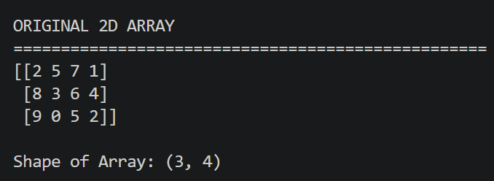  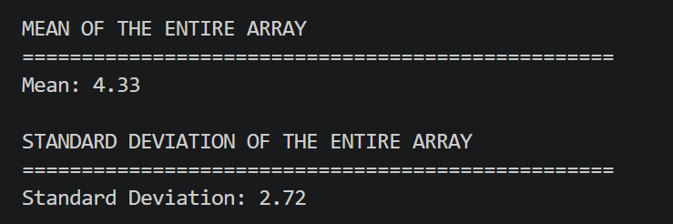  Screenshot 1: Original Array and Shape  Figure 1.1 Original 2D Array  The predefined dictionary values were converted into a NumPy array. The output confirms that the array contains 3 rows and 4 columns.  Screenshot 2: Mean and Standard Deviation  Figure 1.2 Mean & Standard Deviation of the Array  The mean represents the average of all elements in the array, while the standard deviation shows how widely the values are distributed around the mean.

Student Reg. No: 26MML0031 Name: Makada Hasnain
Faculty: Dr Rajasekhara Babu M, Professor, School of CSE, Vellore Institute of Technology (VIT), Vellore
- | P a g e

2026 FALL SEMESTER

Programming for Data Science (MACSE502) Lab Record Practice Program
Date: 23/07/2026 Week No.: 3 Program S. No.
5 Screenshot 3: Array Slicing
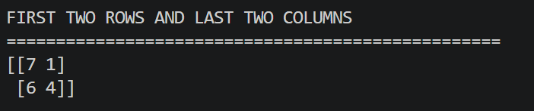
Figure 1.3 Sliced Array

Array slicing was performed using array1[:2, -2:]. The resulting sliced array has a shape of 2 × 2.

Screenshot 4: Reshaped Array
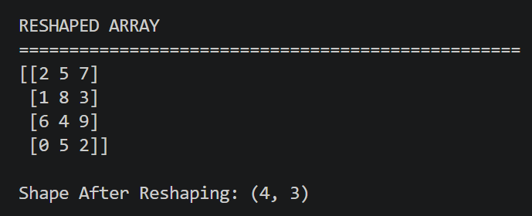
Figure 1.4 Reshaped Array

The reshape() function changed the arrangement of the 12 elements without changing their values or total count.
Screenshot 5: Element-wise Multiplication
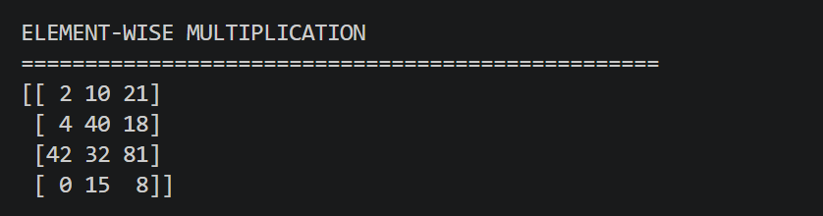
Figure 1.5 Element Wise Multiplication

Corresponding elements of the two arrays with shape (4, 3) were multiplied using the * operator.

Student Reg. No: 26MML0031 Name: Makada Hasnain
Faculty: Dr Rajasekhara Babu M, Professor, School of CSE, Vellore Institute of Technology (VIT), Vellore
- | P a g e

2026 FALL SEMESTER

Programming for Data Science (MACSE502) Lab Record Practice Program
Date: 23/07/2026 Week No.: 3 Program S. No. 5
Screenshot 6: Final Summary

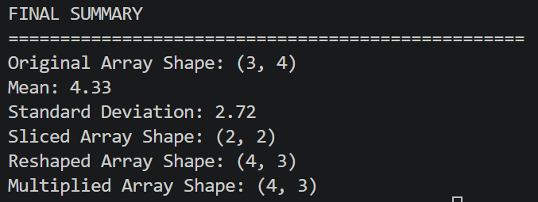
Figure 1.6 Final Summary

The final output verifies that all statistical, slicing, reshaping and multiplication operations were completed successfully.
Conclusions | The NumPy array manipulation exercise was completed successfully. A two-dimensional array of shape (3, 4) was created using predefined dictionary data. The mean and standard deviation were calculated, the first two rows and last two columns were extracted through slicing, and the array was reshaped to (4, 3). Element-wise multiplication was performed with another array of the same shape. The exercise provided  practical understanding of NumPy array creation, statistical calculations, slicing, reshaping and element-wise operations.
References | - Michael Freeman and Joel Ross, Programming Skills for Data Science: Start Writing Code to Wrangle, Analyze, and Visualize Data with R, Addison-Wesley, 2018.  - NumPy documentation for array creation, statistics, slicing, reshaping and mathematical operations.  - Python program link (https://github.com/hasnainmakada-99/Data-  Science-Codes/blob/main/WEEK%203/PRACTICE_PROGRAM.py)  - Programming for Data Science (MACSE502) class lecture notes.

Student Reg. No: 26MML0031 Name: Makada Hasnain
Faculty: Dr Rajasekhara Babu M, Professor, School of CSE, Vellore Institute of Technology (VIT), Vellore
- | P a g e

2026 FALL SEMESTER

Programming for Data Science (MACSE502) Lab Record Exercise Program
Date: 23/07/2026 Week No.: 3 Program S. No.: 6
Title | Warehouse Shipment and Logistics Analytics Using NumPy
Problem Statement | A logistics company tracks shipments from 4 warehouses across 7 weeks. Create a 4 x 7 shipment matrix. Perform the following operations: (1) compute average shipments, (2) compute standard deviation, (3) slice the first two warehouses and last three weeks, (4) reshape the matrix into a 7 x  4 matrix, and (5) perform element-wise multiplication with a transportation-cost matrix of the same shape. As an extra practice mini project, develop a Supply Chain Analytics Dashboard that tracks inventory movement, optimizes transportation costs, identifies logistics bottlenecks, generates warehouse performance reports, and supports supply-chain planning.
Objectives | - To create a 4 x 7 warehouse shipment matrix using NumPy.  - To store shipment, transportation-cost, and capacity data locally using predefined Python dictionaries.  - To calculate the mean and standard deviation of the complete shipment matrix.  - To extract the first two warehouses and last three weeks using NumPy slicing.  - To reshape the shipment matrix from 4 x 7 into 7 x 4 without changing its elements.  - To calculate warehouse-week transportation expenditure using element-wise multiplication.  - To track warehouse totals, weekly inventory movement, transportation cost, and capacity utilization.  - To identify high-performing warehouses, cost-efficient warehouses, peak weeks, and logistics bottlenecks.  - To develop an additional Streamlit dashboard for warehouse reporting and supply-chain planning.  - Learning Outcome: Students understand numerical analytics in logistics management.
Dataset URL Link  / File | The dataset is stored locally inside the console and dashboard programs using predefined dictionaries. No external CSV file, URL, or database is required.  A. Shipment Matrix (units shipped)
Dataset URL Link  / File |  | Warehouse 1 | 120 | 135 | 128
Dataset URL Link  / File |  | Warehouse 2 | 98 | 105 | 110
Dataset URL Link  / File |  | Warehouse 3 | 140 | 145 | 150
Dataset URL Link  / File |  | Warehouse 4 | 80 | 85 | 90

Student Reg. No.: 26MML0031 Name: Makada Hasnain Husainbhai
Faculty: Dr Rajasekhara Babu M, Professor, School of CSE, Vellore Institute of Technology (VIT), Vellore
- | P a g e

2026 FALL SEMESTER

Programming for Data Science (MACSE502) Lab Record Exercise Program
Date: 23/07/2026 Week No.: 3 Program S. No.: 6
Warehouse 1 | 12 | 12 | 13 | 13 | 14 | 14 | 15
Warehouse 2 | 10 | 11 | 11 | 12 | 12 | 13 | 13
Warehouse 3 | 14 | 14 | 15 | 15 | 16 | 16 | 17
Warehouse 4 | 9 | 9 | 10 | 10 | 11 | 11 | 12

Warehouse | Weekly Capacity
Warehouse 1 | 175
Warehouse 2 | 145
Warehouse 3 | 180
Warehouse 4 | 120

B. Transportation Cost Matrix (cost per shipment unit)

C. Weekly Capacity Dictionary
Functions Details | Sl.  No. | Function | Package | Description of function
Functions Details | 1 | np.array() | NumPy | Converts dictionary values into two-dimensional NumPy matrices.
Functions Details | 2 | np.mean() | NumPy | Calculates average shipments for the full matrix or a selected axis.
Functions Details | 3 | np.std() | NumPy | Measures the variation of shipment values around the mean.
Functions Details | 4 | Array slicing | NumPy | Extracts the first two warehouses and last three weeks.
Functions Details | 5 | reshape() | NumPy | Reorganizes the 4 x 7 matrix into a 7 x 4 matrix.
Functions Details | 6 | np.multiply() | NumPy | Performs element-wise multiplication of shipments and unit costs.
Functions Details | 7 | np.sum() | NumPy | Calculates warehouse totals, weekly totals, and total transportation cost.
Functions Details | 8 | np.argmax() | NumPy | Returns the index of the maximum shipment or utilization value.

Student Reg. No.: 26MML0031 Name: Makada Hasnain Husainbhai
Faculty: Dr Rajasekhara Babu M, Professor, School of CSE, Vellore Institute of Technology (VIT), Vellore
- | P a g e

2026 FALL SEMESTER

Programming for Data Science (MACSE502) Lab Record Exercise Program
Date: 23/07/2026 Week No.: 3 Program S. No.: 6
 | 9 | np.where() | NumPy | Identifies warehouse-week combinations that cross the bottleneck threshold.
 | 10 | pd.DataFrame () | Pandas | Creates labeled warehouse and weekly reports for dashboard display.
 | 11 | st.metric() | Streamlit | Displays important supply-chain key performance indicators.
 | 12 | st.line_chart()/ bar_chart() | Streamlit | Visualizes inventory movement, cost,  utilization, and warehouse performance.
Steps/ Process/ Procedure/ Algorithm/ Flowchart/ Model | Step 1: Import NumPy for numerical operations.  Step 2: Create local dictionaries containing warehouse names, week names, shipment data, transportation costs, and weekly capacities.  Step 3: Convert dictionary values into NumPy arrays.  Step 4: Display the original 4 x 7 shipment and transportation-cost matrices. Step 5: Calculate the mean of the entire shipment matrix using np.mean(). Step 6: Calculate the standard deviation using np.std().  Step 7: Slice shipments[:2, -3:] to obtain the first two warehouses and last three weeks.  Step 8: Reshape the 4 x 7 shipment matrix into a 7 x 4 matrix.  Step 9: Use np.multiply() to multiply each shipment value by its corresponding transportation cost.  Step 10: Calculate warehouse-wise shipments, week-wise shipments, total costs, average costs, and capacity utilization.  Step 11: Identify the highest-performing warehouse and peak shipment week using np.argmax().  Step 12: Identify logistics bottlenecks where utilization is at least 90 percent of weekly capacity.  Step 13: Generate a warehouse performance report for console output. Step 14: Create a Streamlit dashboard for inventory movement, transportation-cost analysis, bottleneck reporting, and planning.  Step 15: Execute the console program and dashboard, then capture each required output screenshot.
Program | A. Console Program  import numpy as np  # Local dataset stored using predefined dictionaries shipment_data = {  "Warehouse 1": [120, 135, 128, 142, 150, 160, 155],  "Warehouse 2": [98, 105, 110, 115, 120, 118, 125],  "Warehouse 3": [140, 145, 150, 155, 165, 170, 175],  "Warehouse 4": [80, 85, 90, 95, 100, 105, 110]  }  transport_cost_data = {  "Warehouse 1": [12, 12, 13, 13, 14, 14, 15],  "Warehouse 2": [10, 11, 11, 12, 12, 13, 13],

Student Reg. No.: 26MML0031 Name: Makada Hasnain Husainbhai
Faculty: Dr Rajasekhara Babu M, Professor, School of CSE, Vellore Institute of Technology (VIT), Vellore
- | P a g e

2026 FALL SEMESTER

Programming for Data Science (MACSE502) Lab Record Exercise Program
Date: 23/07/2026 Week No.: 3 Program S. No.: 6
"Warehouse 3": [14, 14, 15, 15, 16, 16, 17],
"Warehouse 4": [9, 9, 10, 10, 11, 11, 12]
}

capacity_data =
{ "Warehouse 1":
175,
"Warehouse 2": 145,
"Warehouse 3": 180,
"Warehouse 4": 120
}

warehouses = np.array(list(shipment_data.keys()))
weeks = np.array(["Week 1", "Week 2", "Week 3", "Week 4",
"Week 5", "Week 6", "Week 7"]) shipments = np.array(list(shipment_data.values())) transport_cost = np.array(list(transport_cost_data.values())) capacity = np.array(list(capacity_data.values()))
print("WAREHOUSE SHIPMENT MATRIX")
print(shipments)
print("Shape:", shipments.shape)
print("\nTRANSPORTATION COST MATRIX")
print(transport_cost)
print("Shape:", transport_cost.shape)

average_shipments = np.mean(shipments) shipment_std = np.std(shipments)
print("\nAVERAGE AND STANDARD DEVIATION")
print("Average shipments:", round(average_shipments, 2)) print("Standard deviation:", round(shipment_std, 2))

sliced_shipments = shipments[:2, -3:]
print("\nFIRST TWO WAREHOUSES AND LAST THREE WEEKS")
print(sliced_shipments)
print("Sliced shape:", sliced_shipments.shape)
reshaped_shipments = shipments.reshape(7, 4) print("\nRESHAPED SHIPMENT MATRIX")
print(reshaped_shipments)
print("Reshaped shape:", reshaped_shipments.shape) transportation_expense = np.multiply(shipments, transport_cost) print("\nELEMENT-WISE TRANSPORTATION EXPENSE")
print(transportation_expense)
warehouse_totals = np.sum(shipments, axis=1)

Student Reg. No.: 26MML0031 Name: Makada Hasnain Husainbhai
Faculty: Dr Rajasekhara Babu M, Professor, School of CSE, Vellore Institute of Technology (VIT), Vellore
- | P a g e

2026 FALL SEMESTER

Programming for Data Science (MACSE502) Lab Record Exercise Program
Date: 23/07/2026 Week No.: 3 Program S. No.: 6
weekly_totals = np.sum(shipments, axis=0) warehouse_costs = np.sum(transportation_expense, axis=1) average_unit_cost = warehouse_costs / warehouse_totals utilization = shipments / capacity[:, None] * 100 maximum_utilization = np.max(utilization, axis=1)
best_warehouse_index = np.argmax(warehouse_totals) peak_week_index = np.argmax(weekly_totals) efficient_warehouse_index = np.argmin(average_unit_cost) bottleneck_index = np.argmax(maximum_utilization) bottleneck_points = np.where(utilization >= 90)
print("\nWAREHOUSE PERFORMANCE REPORT")
for i in range(len(warehouses)): print(warehouses[i])
print(" Total shipments:", warehouse_totals[i])
print(" Average weekly shipments:", round(np.mean(shipments[i]), 2)) print(" Transportation expense:", warehouse_costs[i])
print(" Average cost per shipment:", round(average_unit_cost[i], 2)) print(" Maximum capacity utilization:",
round(maximum_utilization[i], 2), "%")
print("\nWEEKLY INVENTORY MOVEMENT")
for i in range(len(weeks)): print(weeks[i], ":", weekly_totals[i])
print("\nLOGISTICS BOTTLENECK POINTS")
for warehouse_i, week_i in zip(*bottleneck_points): print(warehouses[warehouse_i], weeks[week_i],
"Utilization:", round(utilization[warehouse_i, week_i], 2), "%")

print("\nSUPPLY CHAIN PLANNING SUMMARY")
print("Highest-performing warehouse:", warehouses[best_warehouse_index])
print("Peak shipment week:", weeks[peak_week_index]) print("Most cost-efficient warehouse:",
warehouses[efficient_warehouse_index])
print("Highest bottleneck risk:", warehouses[bottleneck_index]) print("Total shipments:", np.sum(shipments))
print("Total transportation expense:", np.sum(transportation_expense))
B. Extra Practice: Streamlit Supply Chain Analytics Dashboard
import numpy as np import pandas as pd import streamlit as st

st.set_page_config(
page_title="Supply Chain Analytics Dashboard", layout="wide"

Student Reg. No.: 26MML0031 Name: Makada Hasnain Husainbhai
Faculty: Dr Rajasekhara Babu M, Professor, School of CSE, Vellore Institute of Technology (VIT), Vellore
- | P a g e

2026 FALL SEMESTER

Programming for Data Science (MACSE502) Lab Record Exercise Program
Date: 23/07/2026 Week No.: 3 Program S. No.: 6
)
st.title("Warehouse Shipment and Supply Chain Analytics")
# The dashboard uses the same local dictionary dataset shipment_data = {
"Warehouse 1": [120, 135, 128, 142, 150, 160, 155],
"Warehouse 2": [98, 105, 110, 115, 120, 118, 125],
"Warehouse 3": [140, 145, 150, 155, 165, 170, 175],
"Warehouse 4": [80, 85, 90, 95, 100, 105, 110]
}

transport_cost_data = {
"Warehouse 1": [12, 12, 13, 13, 14, 14, 15],
"Warehouse 2": [10, 11, 11, 12, 12, 13, 13],
"Warehouse 3": [14, 14, 15, 15, 16, 16, 17],
"Warehouse 4": [9, 9, 10, 10, 11, 11, 12]
}

capacity_data =
{ "Warehouse 1":
175,
"Warehouse 2": 145,
"Warehouse 3": 180,
"Warehouse 4": 120
}
weeks = ["Week 1", "Week 2", "Week 3", "Week 4",
"Week 5", "Week 6", "Week 7"]
shipment_df = pd.DataFrame.from_dict( shipment_data, orient="index", columns=weeks
)
cost_rate_df = pd.DataFrame.from_dict( transport_cost_data, orient="index", columns=weeks
)
expense_df = shipment_df * cost_rate_df capacity_series = pd.Series(capacity_data)
utilization_df = shipment_df.div(capacity_series, axis=0) * 100

warehouse_totals = shipment_df.sum(axis=1) weekly_totals = shipment_df.sum(axis=0) warehouse_expense = expense_df.sum(axis=1) average_cost = warehouse_expense / warehouse_totals maximum_utilization = utilization_df.max(axis=1)

performance_report = pd.DataFrame({ "Total Shipments": warehouse_totals,
"Average Weekly Shipments": shipment_df.mean(axis=1).round(2),

Student Reg. No.: 26MML0031 Name: Makada Hasnain Husainbhai
Faculty: Dr Rajasekhara Babu M, Professor, School of CSE, Vellore Institute of Technology (VIT), Vellore
- | P a g e

2026 FALL SEMESTER

Programming for Data Science (MACSE502) Lab Record Exercise Program
Date: 23/07/2026 Week No.: 3 Program S. No.: 6
"Transportation Expense": warehouse_expense, "Average Cost per Shipment": average_cost.round(2),
"Maximum Utilization (%)": maximum_utilization.round(2)
})
best_warehouse = warehouse_totals.idxmax() peak_week = weekly_totals.idxmax() cost_efficient = average_cost.idxmin() bottleneck = maximum_utilization.idxmax()
selected_warehouse = st.sidebar.selectbox( "Select warehouse", shipment_df.index
)
threshold = st.sidebar.slider(
"Bottleneck threshold (%)", 70, 100, 90
)
c1, c2, c3, c4 = st.columns(4)
c1.metric("Total Shipments", f"{int(shipment_df.values.sum()):,}") c2.metric("Top Warehouse", best_warehouse)
c3.metric("Peak Week", peak_week) c4.metric("Bottleneck Risk", bottleneck)
movement_tab, cost_tab, bottleneck_tab, report_tab, planning_tab
= st.tabs([
"Inventory Movement", "Transportation Costs", "Logistics Bottlenecks", "Warehouse Reports", "Supply Chain Planning"
])

with movement_tab:
st.subheader("Weekly Inventory Movement") st.line_chart(shipment_df.T) st.bar_chart(weekly_totals)
st.dataframe(shipment_df, use_container_width=True)

with cost_tab:
st.subheader("Transportation Expense by Warehouse") st.bar_chart(warehouse_expense)
st.write("Most cost-efficient warehouse:", cost_efficient) st.dataframe(expense_df, use_container_width=True)
with bottleneck_tab: st.subheader("Capacity Utilization") st.line_chart(utilization_df.T)
bottleneck_table = utilization_df[utilization_df >= threshold]
st.dataframe(bottleneck_table, use_container_width=True) if bottleneck_table.notna().any().any():

Student Reg. No.: 26MML0031 Name: Makada Hasnain Husainbhai
Faculty: Dr Rajasekhara Babu M, Professor, School of CSE, Vellore Institute of Technology (VIT), Vellore
- | P a g e

2026 FALL SEMESTER

Programming for Data Science (MACSE502) Lab Record Exercise Program
Date: 23/07/2026 Week No.: 3 Program S. No.: 6
st.warning("High-utilization warehouse-week combinations detected.")
else:
st.success("No bottlenecks detected at the selected threshold.")
with report_tab:
st.subheader("Warehouse Performance Report") st.dataframe(performance_report, use_container_width=True) st.bar_chart(performance_report[["Total Shipments"]])
with planning_tab:
st.subheader("Supply Chain Planning Summary") st.write("Selected warehouse:", selected_warehouse) st.write("Highest-performing warehouse:", best_warehouse) st.write("Peak shipment week:", peak_week) st.write("Most cost-efficient warehouse:", cost_efficient) st.write("Highest bottleneck risk:", bottleneck)
st.write(
"Planning action: Review vehicle allocation, dispatch frequency, " "capacity, and route cost for high-utilization warehouses."
)

# Run using: python -m streamlit run dashboard.py
Output Snapshots With Explanation/ Observations | 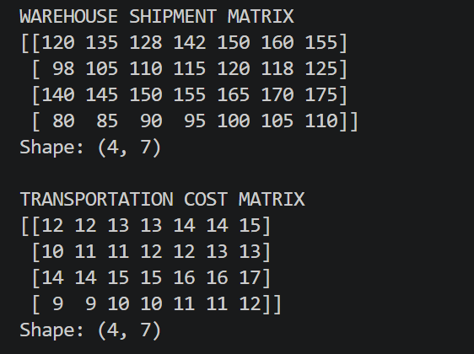  Screenshot 1: Original Shipment and Transportation-Cost Matrices  Figure 1.1 Original Shipment & Transportation Cost Matrix  Explanation/Observation: The local dictionary data was converted into two NumPy matrices of shape (4, 7), representing four warehouses across seven weeks.

Student Reg. No.: 26MML0031 Name: Makada Hasnain Husainbhai
Faculty: Dr Rajasekhara Babu M, Professor, School of CSE, Vellore Institute of Technology (VIT), Vellore
- | P a g e

2026 FALL SEMESTER

Programming for Data Science (MACSE502) Lab Record Exercise Program
Date: 23/07/2026 Week No.: 3 Program S. No.: 6
Screenshot 2: Average Shipment and Standard Deviation
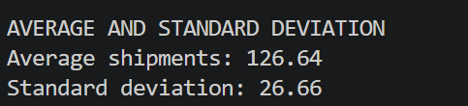
Figure 1.2 Average & Standard Deviation

Explanation/Observation: The mean represents the average shipment volume across all warehouse-week observations, while the standard deviation measures shipment variation.
Screenshot 3: Sliced Shipment Matrix
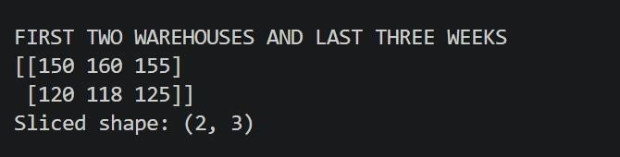
Figure 1.3 Sliced Shipment Matrix

Explanation/Observation: The expression shipments[:2, -3:] selected the first two warehouses and the last three weeks, producing a matrix of shape (2, 3).
Screenshot 4: Reshaped 7 x 4 Shipment Matrix
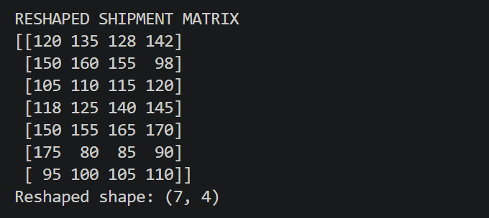
Figure 1.4 Reshaped Matrix

Explanation/Observation: The reshape operation reorganized all 28 shipment values into seven rows and four columns without adding or removing data.

Student Reg. No.: 26MML0031 Name: Makada Hasnain Husainbhai
Faculty: Dr Rajasekhara Babu M, Professor, School of CSE, Vellore Institute of Technology (VIT), Vellore
- | P a g e

2026 FALL SEMESTER

Programming for Data Science (MACSE502) Lab Record Exercise Program
Date: 23/07/2026 Week No.: 3 Program S. No.: 6
Screenshot 5: Element-wise Transportation Expense Matrix
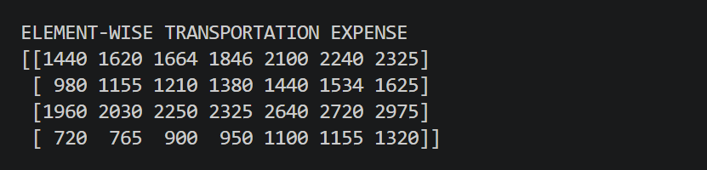
Figure 1.5 Element Wise Matrix

Explanation/Observation: Each shipment quantity was multiplied by its corresponding transportation cost to estimate warehouse-week transportation expenditure.
Screenshot 6: Warehouse Performance and Bottleneck Report
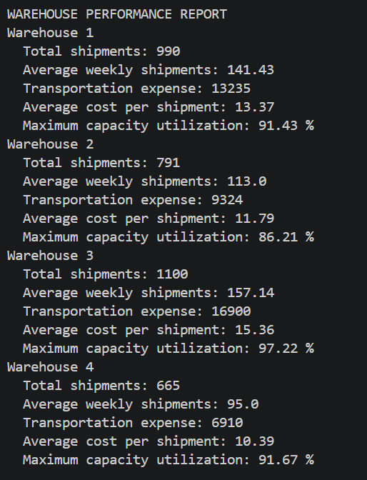
Figure 1.6 Warehouse Performance Report

Explanation/Observation: The console report compared total shipments, average shipments, transportation expense, cost efficiency, and maximum capacity utilization for every warehouse.

Student Reg. No.: 26MML0031 Name: Makada Hasnain Husainbhai
Faculty: Dr Rajasekhara Babu M, Professor, School of CSE, Vellore Institute of Technology (VIT), Vellore
- | P a g e

2026 FALL SEMESTER

Programming for Data Science (MACSE502) Lab Record Exercise Program
Date: 23/07/2026 Week No.: 3 Program S. No.: 6
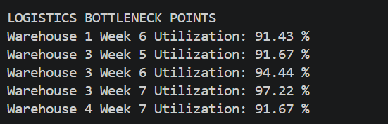
Screenshot 7: Cost, Bottleneck, and Planning Views

Figure 1.7 Logistics Bottleneck Points

Explanation/Observation: We visualized transportation expenses and capacity utilization, identified high-utilization periods, and generated planning recommendations.
Conclusions | The Warehouse Shipment and Logistics Analytics exercise was completed successfully using NumPy. Shipment, transportation-cost, and capacity data were stored locally using predefined dictionaries and converted into structured arrays. The mean and standard deviation of the shipment matrix were calculated, the first two warehouses and last three weeks were extracted through slicing, and the matrix was reshaped from 4 x 7 to 7 x 4. Element-wise multiplication was used to calculate transportation expenditure. Additional warehouse-wise and week-wise calculations identified the highest-performing warehouse, peak shipment week, most cost-efficient warehouse, and high-utilization bottlenecks.
References | - NumPy documentation for array creation, descriptive statistics, slicing, reshaping, aggregation, and element-wise operations.  - Pandas documentation for DataFrame creation and warehouse performance reporting.  - Python Program Link  (https://github.com/hasnainmakada-99/Data-Science-Codes/blob/mai n/WEEK%203/EXERCISE_PROGRAM.py)

Student Reg. No.: 26MML0031 Name: Makada Hasnain Husainbhai
Faculty: Dr Rajasekhara Babu M, Professor, School of CSE, Vellore Institute of Technology (VIT), Vellore
- | P a g e

2026 FALL SEMESTER

Programming for Data Science (MACSE502) Lab Record Practice Program
Date: 30/07/2026 Week No.: 4 Program S. No. 7
Featur Feature1 Feature2 Target
F 5 10 0
2 8 18 0
3 12 15 1
4 15 25 0

5 18 30 1
6 22 28 1
7 25 35 0
8 30 40 1
9 35 38 1
10 40 45 0
11 45 50 1
12 50 55 1
13 55 60 0
14 60 65 1
15 70 75 1
Title | Feature Engineering and Correlation Analysis Using Pandas
Problem Statement | Create a DataFrame with columns Feature1, Feature2, and Target containing predefined sample data stored in a Python dictionary. Create a new feature that is the logarithm of Feature1, bin Feature2 into three categories (Low, Medium, and High), and calculate the correlation matrix  of the DataFrame. Finally, create a scatter plot of Feature1 versus Feature2 distinguished by Target and interpret the visible patterns.
Objectives | - To create a Pandas DataFrame using a predefined Python dictionary.  - To understand feature engineering using logarithmic transformation.  - To transform Feature1 using the natural logarithm function.  - To divide Feature2 into Low, Medium, and High categories.  - To calculate and interpret correlations among numerical variables.  - To visualize the relationship between Feature1 and Feature2 using a scatter plot.  - To distinguish Target classes using a black-and-white plotting format.  - To interpret visible trends, class overlap, and feature relationships.
Dataset URL Link / File | Predefined dictionary dataset used directly inside the Python program:  Feature1 Feature2 Target  5 10 0  8 18 0  12 15 1  15 25 0  18 30 1  22 28 1  25 35 0  30 40 1  35 38 1  40 45 0  45 50 1  50 55 1  55 60 0  60 65 1  70 75 1  No external CSV file, URL, database, or online dataset is required.
Functions Details | Sl.  No. | Function | Package | Description of function
Functions Details | 1 | pd.DataFram  e() | Pandas | Creates a DataFrame from the  predefined dictionary data.
Functions Details | 2 | np.log() | NumPy | Calculates the natural logarithm of each  Feature1 value.
Functions Details | 3 | pd.cut() | Pandas | Bins Feature2 into Low, Medium, and  High categories.

Student Reg. No: 26MML0031 Name: Makada Hasnain
Faculty: Dr Rajasekhara Babu M, Professor, School of CSE, Vellore Institute of Technology (VIT), Vellore
- | P a g e

2026 FALL SEMESTER

Programming for Data Science (MACSE502) Lab Record Practice Program
Date: 30/07/2026 Week No.: 4 Program S. No. 7
 | 4 | corr() | Pandas | Calculates pairwise correlations between numerical columns.
 | 5 | value_counts  () | Pandas | Counts the number of records in each  Feature2 category.
 | 6 | sort_index() | Pandas | Displays category counts in their  defined category order.
 | 7 | round() | Python/ Pandas | Rounds logarithmic and correlation values for readable output.
 | 8 | plt.figure() | Matplotl  ib | Creates a plotting area with the  specified dimensions.
 | 9 | plt.scatter() | Matplotl ib | Creates the Feature1 versus Feature2 scatter plot.
 | 10 | plt.xlabel()/yl abel() | Matplotl ib | Adds descriptive labels to the plot axes.
 | 11 | plt.legend() | Matplotl  ib | Identifies the symbols used for each  Target class.
 | 12 | plt.show() | Matplotl ib | Displays the completed scatter plot on the screen.
 | Step 1: Import Pandas, NumPy, and Matplotlib.
 | Step 2: Define Feature1, Feature2, and Target values inside a Python
 | dictionary.
 | Step 3: Convert the dictionary into a DataFrame using pd.DataFrame().
Steps/ | Step 4: Display the original DataFrame and confirm the available
Process/ | columns.
Procedure/ | Step 5: Create Log_Feature1 by applying np.log() to Feature1.
Algorithm/ | Step 6: Bin Feature2 into three equal-width categories using pd.cut().
Flowchart/ | Step 7: Label the categories as Low, Medium, and High.
Model | Step 8: Select the numerical columns required for correlation analysis.
 | Step 9: Calculate and display the correlation matrix using corr().
 | Step 10: Count the number of observations in each Feature2 category.
 | Step 11: Create a black-and-white scatter plot of Feature1 versus
 | Feature2 grouped by Target.
 | Step 12: Interpret the correlation, trend, and overlap visible in the output.
 | import pandas as pd
 | import numpy as np
 | import matplotlib.pyplot as plt
 | # Predefined dictionary dataset
 | data = {
Program | "Feature1": [5, 8, 12, 15, 18, 22, 25, 30,  35, 40, 45, 50, 55, 60, 70],
 | "Feature2": [10, 18, 15, 25, 30, 28, 35, 40,
 | 38, 45, 50, 55, 60, 65, 75],
 | "Target": [0, 0, 1, 0, 1, 1, 0, 1,
 | 1, 0, 1, 1, 0, 1, 1]
 | }

Student Reg. No: 26MML0031 Name: Makada Hasnain
Faculty: Dr Rajasekhara Babu M, Professor, School of CSE, Vellore Institute of Technology (VIT), Vellore
- | P a g e

2026 FALL SEMESTER

Programming for Data Science (MACSE502) Lab Record Practice Program
Date: 30/07/2026 Week No.: 4 Program S. No. 7
# Convert dictionary into a DataFrame df = pd.DataFrame(data) print("ORIGINAL DATAFRAME")
print(df)
print("DataFrame Shape:", df.shape)
# Create logarithmic feature df["Log_Feature1"] = np.log(df["Feature1"])
print("\nDATAFRAME WITH LOG FEATURE")
print(df[["Feature1", "Log_Feature1"]].round(3))

# Bin Feature2 into three categories df["Feature2_Category"] = pd.cut(
df["Feature2"], bins=3,
labels=["Low", "Medium", "High"]
)
print("\nFEATURE2 CATEGORIES")
print(df[["Feature2", "Feature2_Category"]])
# Calculate correlation matrix numeric_columns = [
"Feature1", "Feature2", "Target", "Log_Feature1"
]
correlation_matrix = df[numeric_columns].corr() print("\ nCORRELATION MATRIX")
print(correlation_matrix.round(3))
# Display category-wise counts category_count = (
df["Feature2_Category"]
.value_counts()
.sort_index()
)
print("\nFEATURE2 CATEGORY COUNT")
print(category_count)

# Create black-and-white scatter plot class_zero = df["Target"] == 0 class_one = df["Target"] == 1

plt.figure(figsize=(8, 6)) plt.scatter(
df.loc[class_zero, "Feature1"], df.loc[class_zero, "Feature2"], facecolors="white", edgecolors="black", marker="o",

Student Reg. No: 26MML0031 Name: Makada Hasnain
Faculty: Dr Rajasekhara Babu M, Professor, School of CSE, Vellore Institute of Technology (VIT), Vellore
- | P a g e

2026 FALL SEMESTER

Programming for Data Science (MACSE502) Lab Record Practice Program
Date: 30/07/2026 Week No.: 4 Program S. No. 7
label="Target = 0"
)
plt.scatter(
df.loc[class_one, "Feature1"], df.loc[class_one, "Feature2"], color="black",
marker="s", label="Target = 1"
)
plt.title("Feature1 vs. Feature2 Grouped by Target") plt.xlabel("Feature1")
plt.ylabel("Feature2")
plt.grid(True, linestyle="--", alpha=0.5) plt.legend()
plt.tight_layout() plt.show()

# Interpret visible patterns
feature_correlation = df["Feature1"].corr(df["Feature2"]) print("\ nPATTERN INTERPRETATION")
print(
"Correlation between Feature1 and Feature2:", round(feature_correlation, 3)
)
print(
"Feature1 and Feature2 have a strong positive " "relationship. Target classes overlap, although "
"Target = 1 appears more often at medium and high values."
)

Student Reg. No: 26MML0031 Name: Makada Hasnain
Faculty: Dr Rajasekhara Babu M, Professor, School of CSE, Vellore Institute of Technology (VIT), Vellore
- | P a g e

2026 FALL SEMESTER

Programming for Data Science (MACSE502) Lab Record Practice Program
Date: 30/07/2026 Week No.: 4 Program S. No. 7
Output Snapshots With Explanation/ Observations | 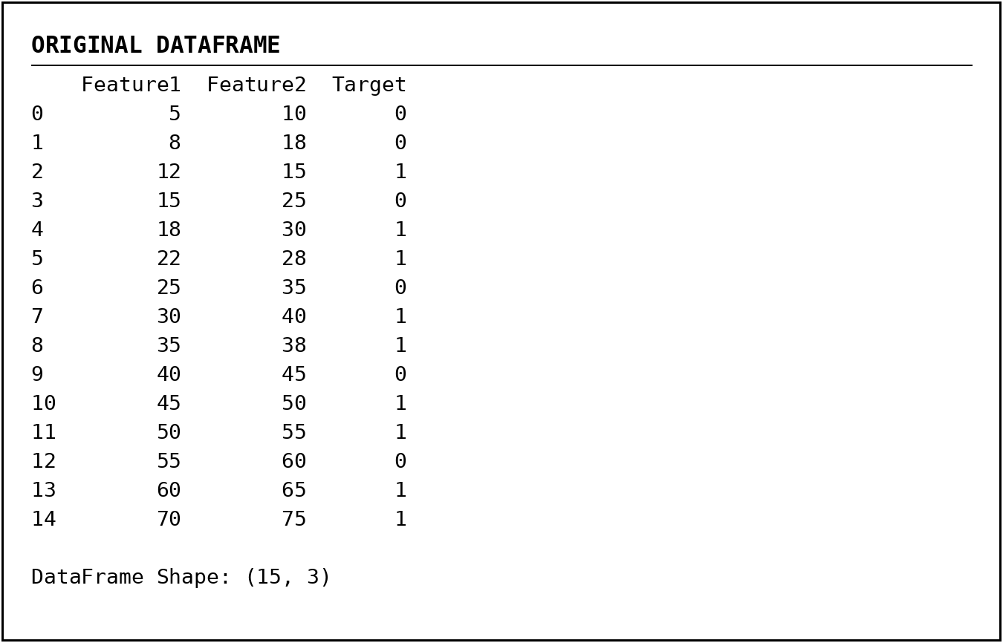  Screenshot 1: Original DataFrame  Figure 1.1 - Original DataFrame Explanation/Observation: The dictionary was converted into a DataFrame containing 15 observations and the three required columns: Feature1, Feature2, and Target.  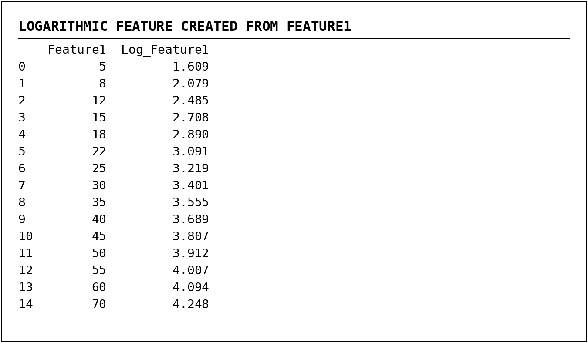  Screenshot 2: Logarithmic Feature  Figure 1.2 - Logarithmic Transformation of Feature1 Explanation/Observation: The natural logarithm of Feature1 was calculated using np.log(). The transformed values increase gradually and reduce the scale difference among larger values.

Student Reg. No: 26MML0031 Name: Makada Hasnain
Faculty: Dr Rajasekhara Babu M, Professor, School of CSE, Vellore Institute of Technology (VIT), Vellore
- | P a g e

2026 FALL SEMESTER

Programming for Data Science (MACSE502) Lab Record Practice Program
Date: 30/07/2026 Week No.: 4 Program S. No. 7
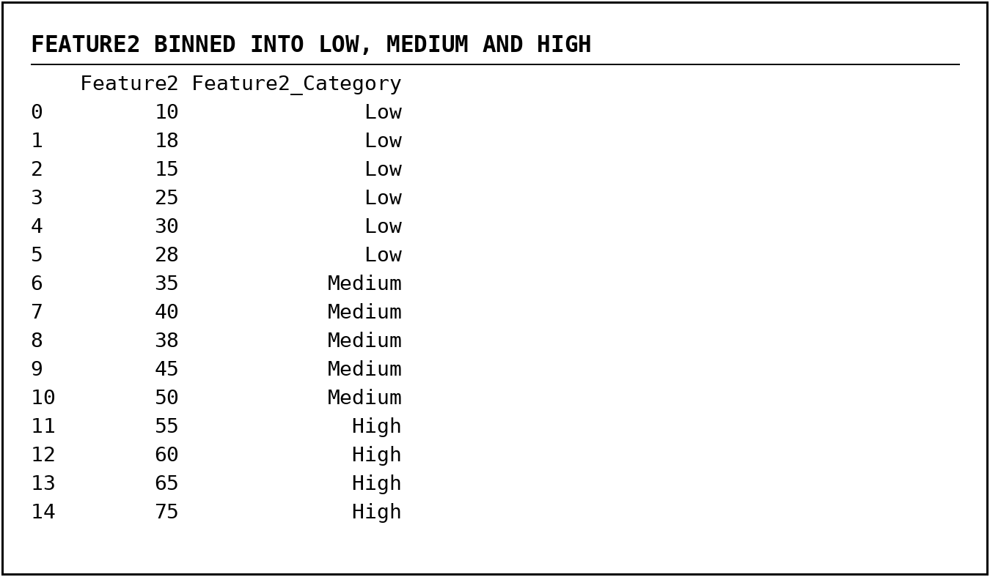
Screenshot 3: Feature2 Binning

Figure 1.3 - Feature2 Categorized as Low, Medium, and High Explanation/Observation: The pd.cut() function divided Feature2 into three equal-width categories. The output contains 6 Low, 5 Medium, and 4 High observations.

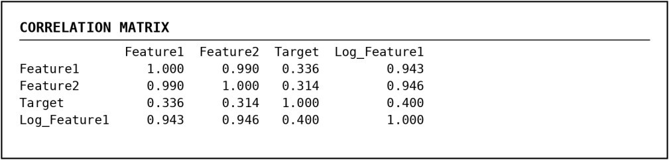
Screenshot 4: Correlation Matrix

Figure 1.4 - Correlation Matrix of Numerical Features Explanation/Observation: Feature1 and Feature2 have a very strong positive correlation of approximately 0.990. Log_Feature1 also has strong positive relationships with both original features.

Student Reg. No: 26MML0031 Name: Makada Hasnain
Faculty: Dr Rajasekhara Babu M, Professor, School of CSE, Vellore Institute of Technology (VIT), Vellore
- | P a g e

2026 FALL SEMESTER
Programming for Data Science (MACSE502) Lab Record Practice Program
Date: 30/07/2026 Week No.: 4 Program S. No.
7 Screenshot 5: Category Count and Pattern Interpretation

Figure 1.5 - Category Counts and Console Interpretation Explanation/Observation: The category distribution and calculated correlation confirm an increasing relationship between Feature1 and Feature2. Target classes overlap, so the features do not completely separate the two classes.

Screenshot 6: Scatter Plot

Conclusions
Figure 1.6 - Feature1 versus Feature2 Grouped by Target Explanation/Observation: The points follow a clear upward pattern, showing that Feature2 generally increases as Feature1 increases. Black squares represent Target = 1, while white circles represent Target = 0. The classes overlap, but Target = 1 occurs more frequently at medium and high feature values.

The feature engineering and correlation analysis exercise was completed successfully using Pandas, NumPy, and Matplotlib. A DataFrame was created from a locally defined Python dictionary. A logarithmic feature was generated from Feature1, Feature2 was categorized into Low, Medium, and

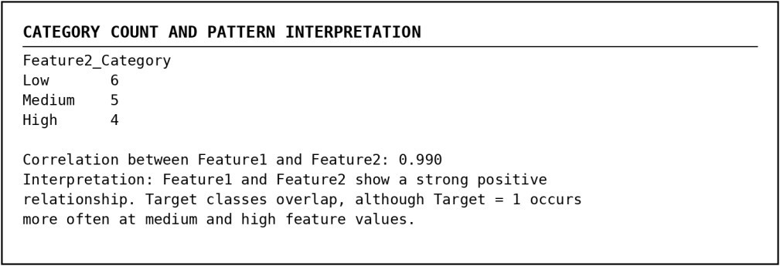
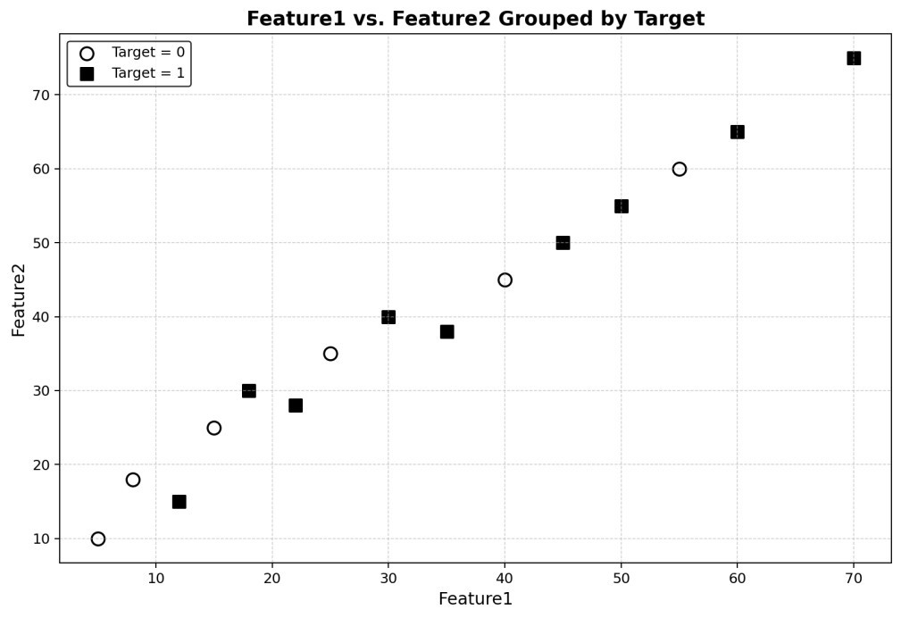
Student Reg. No: 26MML0031 Name: Makada Hasnain
Faculty: Dr Rajasekhara Babu M, Professor, School of CSE, Vellore Institute of Technology (VIT), Vellore
- | P a g e

2026 FALL SEMESTER

Programming for Data Science (MACSE502) Lab Record Practice Program
Date: 30/07/2026 Week No.: 4 Program S. No. 7
High groups, and a correlation matrix was calculated for the numerical variables. The correlation value of approximately 0.990 showed a very strong positive relationship between Feature1 and Feature2. The black-and-white scatter plot confirmed the upward trend and showed that the Target classes overlap, although Target = 1 appears more frequently at medium and high feature values. The exercise provided practical understanding of feature transformation, binning, correlation analysis, visualization, and
pattern interpretation.
References | - Pandas documentation for DataFrame creation, binning, category counting, and correlation analysis.  - NumPy documentation for logarithmic transformations.  - Matplotlib documentation for scatter plots, legends, labels, and plot formatting.  - Python Program (https://github.com/hasnainmakada-99/Data-Science-Codes/blob/main/WEEK%204/PRACTICE_PROGRAM.py)  - Programming for Data Science (MACSE502) class lecture notes (https://drive.google.com/file/d/1PqsD1tC9aCgGFZo7QIJblBu1pIjg4UBs  /view)

Student Reg. No: 26MML0031 Name: Makada Hasnain
Faculty: Dr Rajasekhara Babu M, Professor, School of CSE, Vellore Institute of Technology (VIT), Vellore
- | P a g e

Title | Employee Attrition Prediction Using Workforce Indicators
Problem Statement | A company wants to analyze workforce behavior and predict employee attrition. Create a DataFrame containing OvertimeHours, JobSatisfactionScore, SalaryLevel, TrainingHours, WorkLifeBalance, YearsAtCompany, PromotionCount, and AttritionStatus. Create Log_OvertimeHours, categorize JobSatisfactionScore as Disengaged, Satisfied, or Highly Engaged, generate a correlation matrix, create a treemap visualization of employee categories, and analyze workforce  trends to identify practical retention insights.
Objectives | - To create an employee workforce DataFrame from a predefined Python dictionary.  - To perform logarithmic transformation on employee overtime hours.  - To segment employees using job satisfaction scores.  - To encode attrition status for numerical analysis.  - To generate and interpret a correlation matrix of workforce indicators.  - To analyze attrition rates across employee engagement categories.  - To identify employees with high attrition risk using workforce conditions.  - To create a treemap visualization of employee categories.  - To derive retention insights related to workload, satisfaction, salary, training, promotion, and work-life balance.
Dataset URL Link / File | Predefined dictionary dataset used directly inside the Python program:  Table A: Overtime, Satisfaction, Salary and Training Indicators  Table B: Work-Life, Tenure, Promotion and Attrition Indicators
Dataset URL Link / File |  | Emp. | Work-Life Balance | Years at Company | Promotion Count | Attrition Status
Dataset URL Link / File |  | 1 | 5 | 10 | 3 | No
Dataset URL Link / File |  | 2 | 4 | 7 | 2 | No
Dataset URL Link / File |  | 3 | 3 | 5 | 1 | No
Dataset URL Link / File |  | 4 | 2 | 2 | 0 | Yes

Student Reg. No: 26MML0031 Name: Makada Hasnain
Emp. | Overtime Hours | Job Satisfaction Score | Salary Level | Training Hours
1 | 5 | 5 | 5 | 40
2 | 12 | 4 | 4 | 35
3 | 18 | 3 | 3 | 28
4 | 26 | 2 | 2 | 16
5 | 8 | 4 | 4 | 34
6 | 32 | 1 | 1 | 10
7 | 15 | 3 | 3 | 24
8 | 28 | 2 | 2 | 18
9 | 10 | 5 | 5 | 45
10 | 24 | 2 | 4 | 30
11 | 35 | 1 | 1 | 8
12 | 6 | 4 | 4 | 38
13 | 20 | 3 | 3 | 26
14 | 34 | 3 | 2 | 12
15 | 38 | 2 | 2 | 14

Faculty: Dr Rajasekhara Babu M, Professor, School of CSE, Vellore Institute of Technology (VIT), Vellore

 |  | 5 |  | 4 | 8 |  | 2 | No
 |  | 6 |  | 1 | 1 |  | 0 | Yes
 |  | 7 |  | 3 | 4 |  | 1 | No
 |  | 8 |  | 2 | 3 |  | 0 | Yes
 |  | 9 |  | 5 | 11 |  | 3 | No
 |  | 10 |  | 3 | 6 |  | 1 | No
 |  | 11 |  | 1 | 1 |  | 0 | Yes
 |  | 12 |  | 4 | 9 |  | 2 | No
 |  | 13 |  | 3 | 6 |  | 1 | No
 |  | 14 |  | 2 | 2 |  | 0 | Yes
 |  | 15 |  | 2 | 2 |  | 0 | Yes
 | No external CSV file, URL, database, or online dataset is required.
Functions Details | Sl.  No. |  | Function |  | Package | Description of function
Functions Details | 1 |  | pd.DataFrame(  ) |  | Pandas | Creates the workforce DataFrame from the predefined dictionary.
Functions Details | 2 |  | np.log() |  | NumPy | Calculates the natural logarithm of  OvertimeHours.
Functions Details | 3 |  | pd.cut() |  | Pandas | Categorizes job satisfaction and attrition risk into defined groups.
Functions Details | 4 |  | map() |  | Pandas | Converts AttritionStatus values from  Yes/No into 1/0.
Functions Details | 5 |  | corr() |  | Pandas | Generates the correlation matrix for  numerical workforce indicators.
Functions Details | 6 |  | groupby() |  | Pandas | Groups employee records by engagement  or attrition category.
Functions Details | 7 |  | agg() |  | Pandas | Calculates employee count, attrition count,  averages, and summaries.
Functions Details | 8 |  | mean() |  | Pandas | Calculates overall attrition rate and average  workforce indicators.
Functions Details | 9 |  | astype() |  | Pandas | Converts Boolean risk conditions into  integer risk points.
Functions Details | 10 |  | value_counts() |  | Pandas | Counts employees within each attrition-risk category.
Functions Details | 11 |  | Rectangle() |  | Matplotli  b | Creates proportional rectangles for the  treemap visualization.
Functions Details | 12 |  | savefig()/show () |  | Matplotli b | Saves and displays the employee-category treemap.
Steps/ Process/ Procedure/ Algorithm/ Flowchart/ Model | Step 1: Import Pandas, NumPy, Matplotlib, and Rectangle from matplotlib.patches.  Step 2: Create the workforce dataset locally in dictionary format. Step 3: Convert the dictionary into a DataFrame and assign employee numbers as the index.  Step 4: Create Log_OvertimeHours using the natural logarithm of OvertimeHours.  Step 5: Categorize JobSatisfactionScore as Disengaged, Satisfied, or Highly Engaged.  Step 6: Encode AttritionStatus as AttritionFlag using No = 0 and Yes = 1.

Step 7: Select numerical workforce indicators and generate the correlation matrix.
Step 8: Calculate the overall attrition rate and category-wise workforce summaries.
Step 9: Compare average workforce indicators for employees who stayed and employees who left.
Step 10: Create a rule-based risk score from overtime, satisfaction, salary, work-life balance, and promotion conditions.
Step 11: Create a black-background treemap showing employee-category size and attrition rate.
Step 12: Interpret workforce trends and recommend suitable employee-retention strategies.
Program | import pandas as pd import numpy as np  import matplotlib.pyplot as plt  from matplotlib.patches import Rectangle
 | def print_heading(title): print("\ n" + "=" * 100) print(title) print("=" * 100)
# 1. Workforce dataset stored locally as a Python dictionary. employee_data = {
"OvertimeHours": [5, 12, 18, 26, 8, 32, 15, 28, 10, 24, 35, 6,
20, 34, 38],
"JobSatisfactionScore": [5, 4, 3, 2, 4, 1, 3, 2, 5, 2, 1, 4, 3,
3, 2],
"SalaryLevel": [5, 4, 3, 2, 4, 1, 3, 2, 5, 4, 1, 4, 3, 2, 2],
"TrainingHours": [40, 35, 28, 16, 34, 10, 24, 18, 45, 30, 8, 38,
26, 12, 14],
"WorkLifeBalance": [5, 4, 3, 2, 4, 1, 3, 2, 5, 3, 1, 4, 3, 2, 2],
"YearsAtCompany": [10, 7, 5, 2, 8, 1, 4, 3, 11, 6, 1, 9, 6, 2,
2],
"PromotionCount": [3, 2, 1, 0, 2, 0, 1, 0, 3, 1, 0, 2, 1, 0, 0],
"AttritionStatus": [
"No", "No", "No", "Yes", "No", "Yes", "No", "Yes",
"No", "No", "Yes", "No", "No", "Yes", "Yes"
]
}
 | # 2. Create and display the DataFrame. df = pd.DataFrame(employee_data) df.index = range(1, len(df) + 1) df.index.name = "Employee"
 | print_heading("ORIGINAL WORKFORCE DATAFRAME") print(df.to_string()) print("\nDataFrame Shape:", df.shape)
# 3. Feature engineering and workforce segmentation. df["Log_OvertimeHours"] = np.log(df["OvertimeHours"]).round(3) df["EmployeeCategory"] = pd.cut(
df["JobSatisfactionScore"], bins=[0, 2, 3, 5],
labels=["Disengaged", "Satisfied", "Highly Engaged"], include_lowest=True
)
Student Reg. No: 26MML0031 Name: Makada Hasnain

df["AttritionFlag"] = df["AttritionStatus"].map({"No": 0, "Yes": 1})

print_heading("FEATURE ENGINEERING AND EMPLOYEE SEGMENTATION")
print(df[[
"OvertimeHours", "Log_OvertimeHours", "JobSatisfactionScore", "EmployeeCategory", "AttritionStatus"
]].to_string())

# 4. Correlation analysis. numeric_columns = [
"OvertimeHours", "JobSatisfactionScore", "SalaryLevel", "TrainingHours", "WorkLifeBalance", "YearsAtCompany", "PromotionCount", "Log_OvertimeHours", "AttritionFlag"
]
correlation_matrix = df[numeric_columns].corr()

print_heading("CORRELATION MATRIX") print(correlation_matrix.round(3).to_string())

# 5. Workforce trend analysis.
overall_attrition_rate = df["AttritionFlag"].mean() * 100 category_summary = (
df.groupby("EmployeeCategory", observed=False)
.agg(
EmployeeCount=("AttritionFlag", "size"), AttritionCount=("AttritionFlag", "sum"), AverageOvertime=("OvertimeHours", "mean"), AverageSalaryLevel=("SalaryLevel", "mean")
)
.reset_index()
)
category_summary["AttritionRatePercent"] = ( category_summary["AttritionCount"]
/ category_summary["EmployeeCount"] * 100
).round(2) category_summary["AverageOvertime"] = category_summary["AverageOvertime"].round(2) category_summary["AverageSalaryLevel"] =
category_summary["AverageSalaryLevel"].round(2)

status_summary = df.groupby("AttritionStatus")[[ "OvertimeHours", "JobSatisfactionScore", "SalaryLevel", "TrainingHours", "WorkLifeBalance", "YearsAtCompany", "PromotionCount"
]].mean().round(2)

print_heading("WORKFORCE TREND ANALYSIS") print("Overall Attrition Rate:
{:.2f}%".format(overall_attrition_rate)) print("\nEmployee Category Summary") print(category_summary.to_string(index=False))
print("\nAverage Workforce Indicators by Attrition Status") print(status_summary.to_string())

# 6. Rule-based attrition risk analysis. df["RiskScore"] = (
(df["OvertimeHours"] >= 25).astype(int)
+ (df["JobSatisfactionScore"] <= 2).astype(int)
+ (df["SalaryLevel"] <= 2).astype(int)
+ (df["WorkLifeBalance"] <= 2).astype(int)
+ (df["PromotionCount"] == 0).astype(int)
)
df["AttritionRisk"] = pd.cut(
df["RiskScore"], bins=[-1, 1, 4, 5], labels=["Low", "Medium", "High"]
)
Student Reg. No: 26MML0031 Name: Makada Hasnain

high_risk_employees = df[df["AttritionRisk"] == "High"][[ "OvertimeHours", "JobSatisfactionScore", "SalaryLevel", "WorkLifeBalance", "PromotionCount", "RiskScore", "AttritionRisk", "AttritionStatus"
]]

print_heading("ATTRITION RISK ANALYSIS") print("Risk Category Distribution")
print(df["AttritionRisk"].value_counts().sort_index().to_string()) print("\nHigh-Risk Employees") print(high_risk_employees.to_string())

# 7. Treemap visualization using proportional Matplotlib rectangles. total_employees = category_summary["EmployeeCount"].sum()
fig, ax = plt.subplots(figsize=(11, 6)) fig.patch.set_facecolor("black") ax.set_facecolor("black")
x_position = 0.0
grayscale_colors = ["#2F2F2F", "#555555", "#7A7A7A"]

for index, row in category_summary.iterrows(): width = row["EmployeeCount"] / total_employees ax.add_patch(Rectangle(
(x_position, 0), width, 1, facecolor=grayscale_colors[index], edgecolor="white",
linewidth=2
))
label = (
f'{row["EmployeeCategory"]}\n'
f'Employees: {int(row["EmployeeCount"])}\n' f'Attrition Rate: {row["AttritionRatePercent"]:.1f}%'
)
ax.text(
x_position + width / 2, 0.5, label, color="white", ha="center", va="center", fontsize=12, fontweight="bold"
)
x_position += width

ax.set_xlim(0, 1)
ax.set_ylim(0, 1) ax.axis("off") ax.set_title(
"Treemap of Employee Engagement Categories", color="white", fontsize=16, fontweight="bold", pad=18
)
plt.tight_layout() plt.savefig(
"hr_employee_category_treemap.png",
dpi=300, facecolor="black", bbox_inches="tight"
)
plt.show()
# 8. Final interpretation. attrition_correlations = (
correlation_matrix["AttritionFlag"]
.drop("AttritionFlag")
.sort_values(ascending=False)
)
print_heading("FINAL WORKFORCE INSIGHTS") print("Correlation of Workforce Indicators with Attrition") print(attrition_correlations.round(3).to_string()) print("\ nInterpretation:")
print(
"1. Higher overtime is associated with greater attrition risk.\n"
Student Reg. No: 26MML0031 Name: Makada Hasnain

"2. Lower job satisfaction, salary level, work-life balance, training,\n"
" tenure, and promotion opportunities are associated with attrition.\n"
"3. Disengaged employees show the highest attrition rate.\n" "4. Retention strategies should prioritize workload control,
employee\n"
" engagement, career growth, training, and work-life balance."
)
Output Snapshots With Explanation/ Observations | 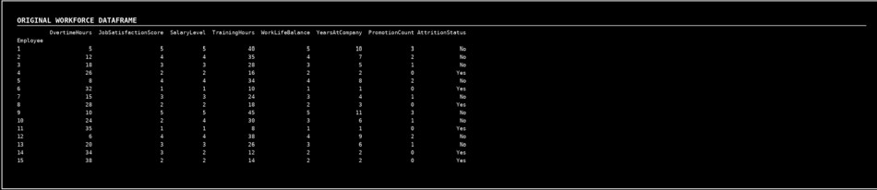  Screenshot 1: Original Workforce DataFrame
 | Figure 1.1 - Original Workforce DataFrame Explanation/Observation: The locally defined dictionary was converte into a DataFrame containing 15 employee records and all eight require workforce indicators.
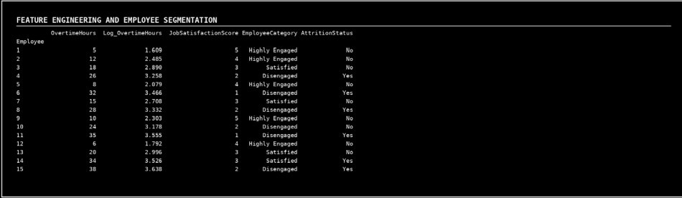
Screenshot 2: Feature Engineering and Employee Segmentation
 | Figure 1.2 - Logarithmic Overtime Feature and Employee Categories Explanation/Observation: Log_OvertimeHours was generated usin np.log(). JobSatisfactionScore was categorized as Disengaged, Satisfied, o Highly Engaged, and AttritionStatus was retained for comparison.
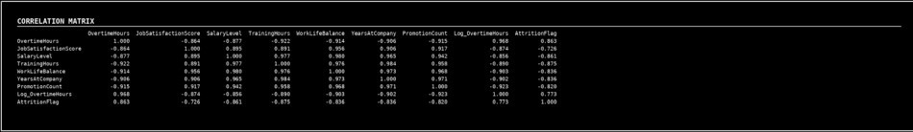
Screenshot 3: Correlation Matrix
 | Figure 1.3 - Correlation Matrix of Workforce Indicators Explanation/Observation: OvertimeHours has a strong positiv relationship with attrition, while satisfaction, salary, training, work-lif balance, tenure, and promotion indicators show negative relationships wit attrition.

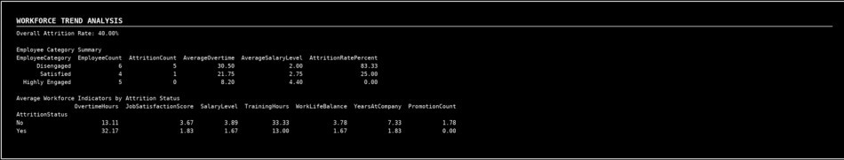
Screenshot 4: Workforce Trend Analysis

Figure 1.4 - Attrition Rate and Workforce Category Summary Explanation/Observation: The overall attrition rate is 40%. Disengage employees have the highest attrition rate and the highest average overtime while highly engaged employees show no attrition in the sample.

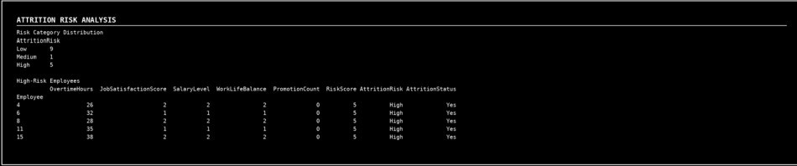
Screenshot 5: Attrition Risk Analysis

Figure 1.5 - Rule-Based Attrition Risk Distribution Explanation/Observation: Employees were assigned risk points based o overtime, satisfaction, salary, work-life balance, and promotion conditions Five employees were identified as high-risk, and all five have an observe attrition status of Yes.

Screenshot 6: Employee Category Treemap

Figure 1.6 - Treemap of Employee Engagement Categories Explanation/Observation: The treemap displays the relative size of each employee category. Each rectangle also reports the number of employees and the attrition rate for that category.

Screenshot 7: Final Workforce Insights

Figure 1.7 - Correlation-Based Workforce Interpretation

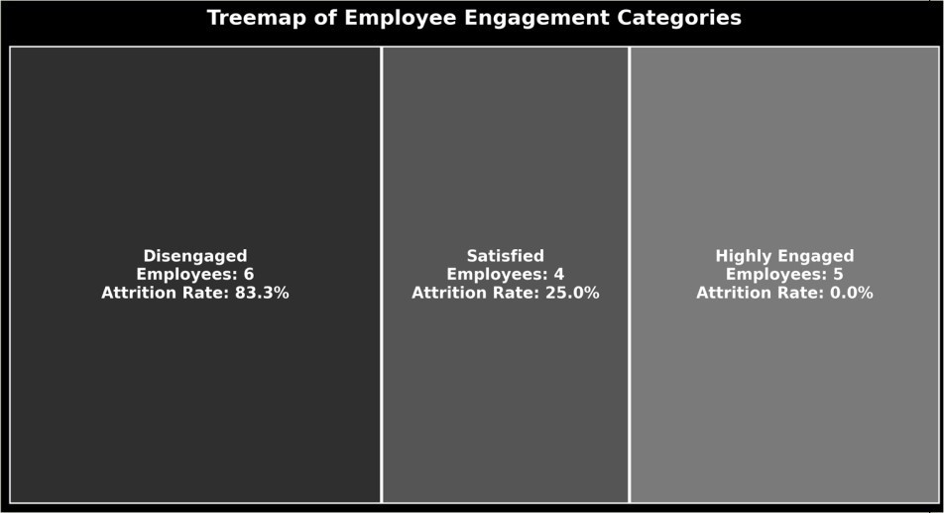
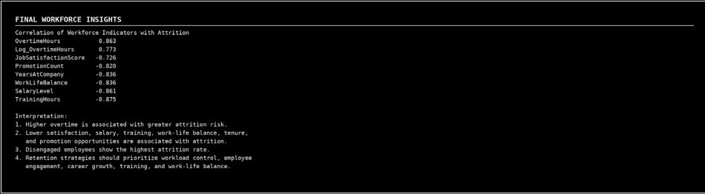

Conclusions
Explanation/Observation: The final analysis indicates that overtime is th strongest positive attrition indicator. Retention efforts should focus o workload control, engagement, compensation, training, career growth, an work-life balance.
The Human Resource Analytics exercise was completed successfully using Pandas, NumPy, and Matplotlib. A workforce DataFrame was created from a predefined Python dictionary, Log_OvertimeHours was generated, and employees were segmented using job satisfaction scores. The correlation matrix showed that higher overtime was positively associated with attrition, whereas job satisfaction, salary level, training, work-life balance, tenure, and promotion opportunities were negatively associated with attrition. The treemap highlighted the distribution of engagement categories, and the trend analysis showed that disengaged employees had the highest attrition rate. The rule-based risk analysis identified employees requiring immediate attention. These findings support retention strategies focused on workload reduction, employee

 | engagement, fair compensation, career progression, training opportunities, and improved work-life balance.
References | - Pandas documentation for DataFrame creation, categorization, grouping, aggregation, mapping, and correlation analysis.  - NumPy documentation for logarithmic transformation.  - Matplotlib documentation for figures, rectangles, text, and image export.  - Python program supplied with this exercise (https://github.com/hasnainmakada-99/Data-Science-Codes/blob/main/WEEK%204/EXERCISE_PROGRAM.py)  - Programming for Data Science (MACSE502) class lecture notes  (https://drive.google.com/file/d/1PqsD1tC9aCgGFZo7QIJblBu1pIjg4UB s/view)

Student Reg. No: 26MML0031 Name: Makada Hasnain

Title | Web Scraping and Data Collection
Problem Statement | Scrape data from a webpage and store it in a structured format like CSV or JSON format
Objectives | - To understand the concept of web scraping and data collection.  - To retrieve webpage content using the Requests library.  - To extract required information from HTML using BeautifulSoup.  - To organize the scraped data using Pandas DataFrame.  - To store the collected data in structured formats such as CSV and JSON.
Dataset URL Link / File | https://quotes.toscrape.com
Function Details
 | Sl. No. | Function | Package | Description of
 |  |  |  | Function
 | 1 | requests.get() | requests | Retrieves the
 |  |  |  | HTML content of a
 |  |  |  | webpage
 | 2 | BeautifulSoup() | bs4 | Parses the HTML
 |  |  |  | content of the
 |  |  |  | webpage
 | 3 | find_all() | BeautifulSoup | Finds all matching
 |  |  |  | HTML elements
 | 4 | find() | BeautifulSoup | Finds the first
 |  |  |  | matching HTML
 |  |  |  | element
 | 5 | DataFrame() | pandas | Converts collected
 |  |  |  | data into tabular
 |  |  |  | format
 | 6 | to_csv() | pandas | Stores data in CSV
 |  |  |  | format
 | 7 | json.dump() | json | Stores Python data
 |  |  |  | in JSON format
 | 8 | json.load() | json | Reads data from a
 |  |  |  | JSON file
Steps/ Process/ Procedure/ | - Import the required libraries: requests, BeautifulSoup, pandas and json.  - Specify the URL of the webpage to be scraped.

Algorithm/ Flowchart/ Model | - Send an HTTP GET request using requests.get().  - Parse the HTML content using BeautifulSoup.  - Locate the required HTML elements containing quotes, authors and tags.  - Extract the required data from the webpage.  - Store the extracted data in a Python list.  - Convert the collected data into a Pandas DataFrame.  - Save the structured data in CSV format using to_csv().  - Save the same data in JSON format using json.dump().  - Display the collected data to verify the output.
Program | import requests  from bs4 import BeautifulSoup import pandas as pd  import json  url = "https://quotes.toscrape.com/" response = requests.get(url)  print("Status Code:", response.status_code)  soup = BeautifulSoup(response.text, "html.parser") print("Website Title:", soup.title.text)  quotes = []  for item in soup.find_all("div", class_="quote"):  quote = item.find("span", class_="text").text author = item.find("small", class_="author").text  tags = [  tag.text  for tag in item.find_all("a", class_="tag")  ]  quotes.append({ "Quote": quote, "Author": author, "Tags": ", ".join(tags)  })  print("Number of quotes collected:", len(quotes))

df = pd.DataFrame(quotes) df
df.to_csv("quotes.csv", index=False) print("Data saved successfully in CSV format.")
with open("quotes.json", "w", encoding="utf-8") as file: json.dump(quotes, file, indent=4, ensure_ascii=False)

print("Data saved successfully in JSON format.") csv_data = pd.read_csv("quotes.csv")
csv_data all_quotes = [] page = 1 while True:
url = f"https://quotes.toscrape.com/page/{page}/"

response = requests.get(url)
soup = BeautifulSoup(response.text, "html.parser") items = soup.find_all("div", class_="quote")
if not items: break

for item in items:

quote = item.find("span", class_="text").text author = item.find("small", class_="author").text

tags = [
tag.text
for tag in item.find_all("a", class_="tag")
]
all_quotes.append({ "Quote": quote,

"Author": author, "Tags": ", ".join(tags)
})

page += 1

print("Total quotes collected:", len(all_quotes)) df = pd.DataFrame(all_quotes)
df

df.to_csv("quotes_dataset.csv", index=False)

with open("quotes_dataset.json", "w", encoding="utf-8") as file: json.dump(all_quotes, file, indent=4, ensure_ascii=False)

print("CSV and JSON files created successfully.")
Output Snapshots With Explanation/ Observations | The required libraries requests, BeautifulSoup, pandas and json are imported for web scraping, HTML parsing, data organization and structured data storage.  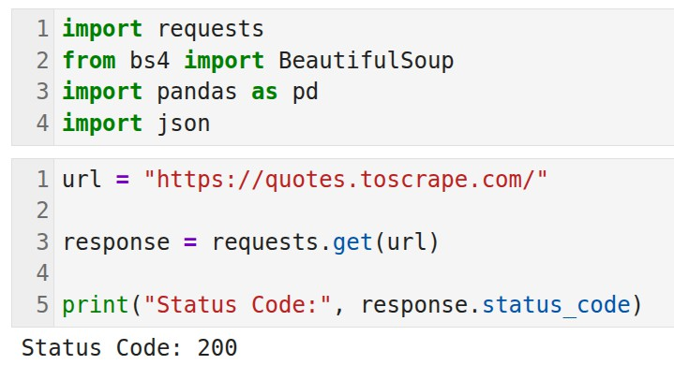  Fig. 1.1: Importing Required Python Libraries

The webpage https://quotes.toscrape.com/ is accessed using requests.get(). The status code 200 confirms that the webpage was successfully retrieved.

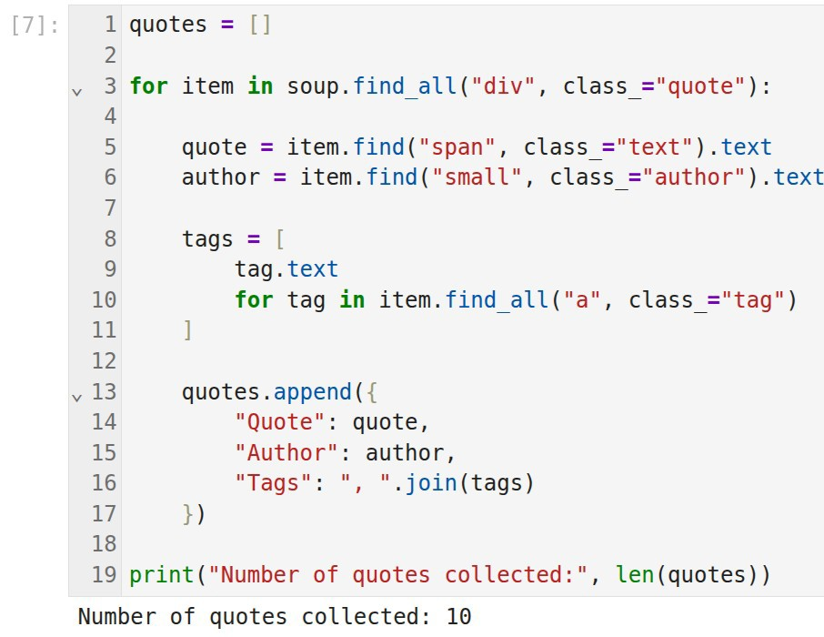
Fig. 1.2: Accessing the Webpage

The HTML content of the webpage is parsed using BeautifulSoup. The webpage title confirms that the correct page has been successfully loaded.

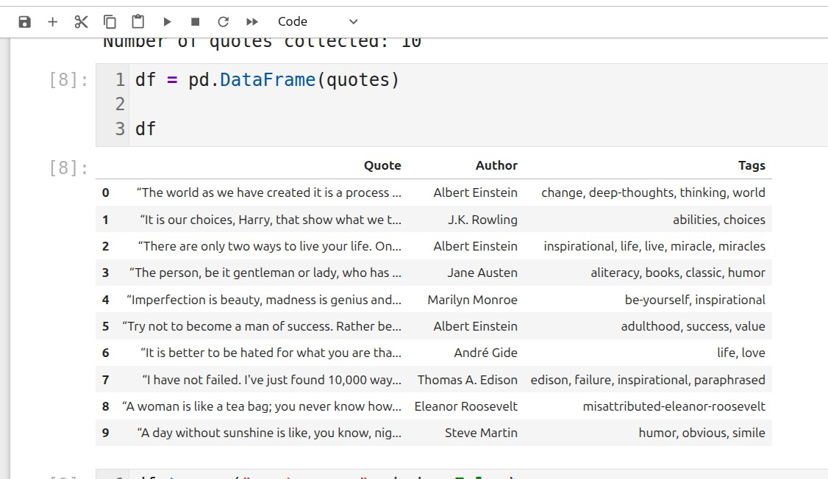
Fig. 1.3: Parsing the HTML and displaying the dataset Content

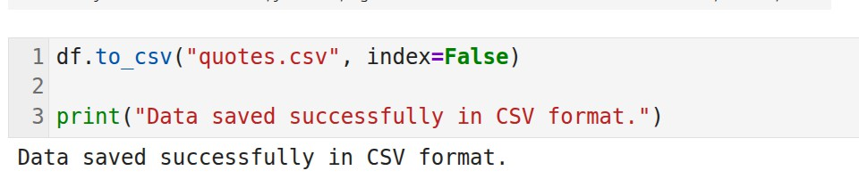
Fig. 1.4: Saving Data in CSV Format

The scraped data is successfully stored in CSV format using the pandas to_csv() function.

The scraped data is successfully stored in JSON format using the json.dump() function.

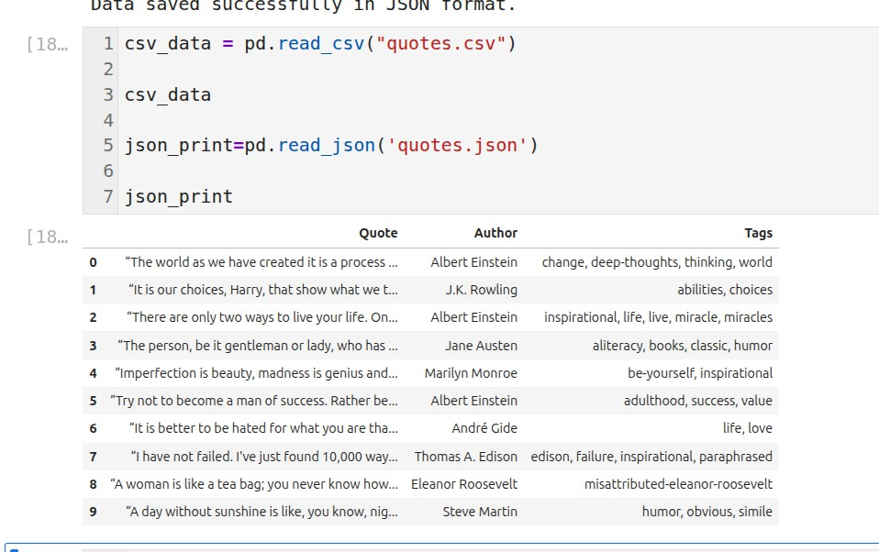
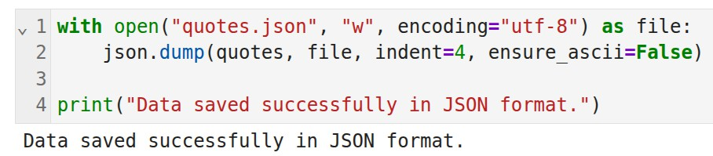
Fig. 1.5: Saving Data in JSON Format

Fig 1.6: Displaying the saved json and csv

The scraped data is successfully stored in JSON format using the json.dump() function.

The saved CSV file is read using pandas.read_csv() and displayed to verify that the data has been stored correctly.

The saved JSON file is read using json.load() and the stored records are displayed successfully, confirming correct JSON storage.
Conclusions | The experiment was successfully completed by scraping data from the given webpage using Python. The webpage content was retrieved using the requests library and parsed using BeautifulSoup. The required information such as quotes, authors, and tags was extracted and organized using a Pandas DataFrame. Finally, the collected data was successfully stored in structured CSV and JSON formats for further analysis and use.
References | - Michael Freeman and Joel Ross, Programming Skills for Data Science: Start Writing Code to Wrangle, Analyze, and Visualize Data with R, Addison-Wesley, 2018  - Python Program (Google Colab link /Githab link)  - Class lecture link

Title | Online Job Market Analytics
Problem Statement | A recruitment agency wants to analyze job opportunities posted on a dynamic job portal. Develop a Python application using Selenium to scrape job listings, extract Job Title, Company Name, Location and Salary (if available), store the collected data in a Pandas DataFrame, save the dataset as a CSV file, and visualize job demand by location.
Objectives | - To understand web scraping from a dynamic job portal using Selenium.  - To extract job title, company name, location and salary information from job listings.  - To organize and clean the collected data using a Pandas DataFrame.  - To save the structured job dataset in CSV format.  - To perform location-wise analysis and visualize job distribution using Matplotlib.
Dataset URL Link / File | Job Portal: https://www.naukri.com  Search role used: Data Scientist | Cities: Bangalore, Hyderabad, Pune, Chennai, Mumbai and Delhi
Functions Details | Sl.  No. | Function | Package | Description of function
Functions Details | 1 | Firefox() | selenium | Starts a Firefox browser session controlled by Selenium.
Functions Details | 2 | driver.get() | selenium | Opens the specified job-portal URL in the automated browser.
Functions Details | 3 | execute_script() | selenium | Executes JavaScript to scroll the dynamically loaded webpage.
Functions Details | 4 | find_elements() | selenium | Finds all matching job-card elements on the page.
Functions Details | 5 | find_element() | selenium | Finds a required field inside an individual job card.
Functions Details | 6 | time.sleep() | time | Pauses execution briefly to allow dynamic content to load.
Functions Details | 7 | DataFrame() | pandas | Converts the collected job records into tabular form.
Functions Details | 8 | drop_duplicates() | pandas | Removes duplicate job records from the DataFrame.
Functions Details | 9 | reset_index() | pandas | Resets row indexing after data cleaning.
Functions Details | 10 | to_csv() | pandas | Saves the structured job dataset as a CSV file.
Functions Details | 11 | value_counts() | pandas | Counts job records for each location for analysis.
Functions Details | 12 | bar()/savefig() | matplotlib | Creates and saves the location-wise job-demand bar chart.
Steps/ Process/ Procedure/ Algorithm/ Flowchart/ Model | - Import Selenium, Pandas, Matplotlib and supporting Python modules.  - Define the job role, location and maximum number of job listings to collect.  - Launch the browser using Selenium WebDriver and construct the Naukri search URL.  - Open the dynamic job-search page and allow sufficient time for the page to load.  - Scroll the webpage so that dynamically loaded job cards become available.  - Locate job-card elements using CSS selectors.  - Extract Job Title, Company Name, Location and Salary from each job card.  - Store the extracted records in a Python list and convert them into a Pandas DataFrame.  - Remove duplicate records and save the cleaned dataset as a CSV file.  - Repeat the search for Bangalore, Hyderabad, Pune, Chennai, Mumbai

and Delhi.
- Use value_counts() to prepare location-wise job analysis and create a bar chart.
- Save the visualization and multi-city CSV file, display the final summary and close the browser.
START -> Open Job Portal -> Scrape Listings -> DataFrame -> CSV
-> Location Analysis -> Bar Chart -> STOP
Program | import time  import pandas as pd  import matplotlib.pyplot as plt from selenium import webdriver  from selenium.webdriver.common.by import By  from selenium.webdriver.firefox.options import Options  from selenium.common.exceptions import NoSuchElementException  JOB_ROLE = "data scientist" LOCATION = "bangalore"  MAX_JOBS = 30  options = Options()  driver = webdriver.Firefox(options=options) driver.set_window_size(1400, 900)  def make_slug(text):  return "-".join(text.lower().strip().split())  def get_text(card, selectors, default="Not Available"): for selector in selectors:  try:  element = card.find_element(By.CSS_SELECTOR, selector) text = element.text.strip()  if text:  return text  except NoSuchElementException: pass  return default  job_slug = make_slug(JOB_ROLE) location_slug = make_slug(LOCATION)  url = f"https://www.naukri.com/{job_slug}-jobs-in-{location_slug}" print("Search URL:", url)  driver.get(url) time.sleep(5)  print("Page Title:", driver.title) print("Current URL:", driver.current_url)

for i in range(3): driver.execute_script("window.scrollTo(0,
document.body.scrollHeight);") time.sleep(2)
driver.execute_script("window.scrollTo(0, 0);")

cards = driver.find_elements(By.CSS_SELECTOR, "div.cust-job-tuple") print("Number of job cards found:", len(cards))

jobs = []
for card in cards[:MAX_JOBS]:
title = get_text(card, ["a.title", "[class*='title']"])
company = get_text(card, ["a.comp-name", ".comp-name"]) location = get_text(card, ["span.locWdth", ".locWdth",
"[class*='location']"])
salary = get_text(card, ["span.sal", ".sal", "[class*='salary']"], default="Not Disclosed")
jobs.append({
"Job Title": title,
"Company Name": company, "Location": location, "Salary": salary
})

print("Jobs scraped:", len(jobs)) df = pd.DataFrame(jobs)
df = df.drop_duplicates().reset_index(drop=True) print("Total unique jobs:", len(df))
print("Dataset Shape:", df.shape) print(df.head(10))
print("Salary Information:") print(df["Salary"].value_counts())

df.to_csv("job_market_data.csv", index=False) print("CSV file saved successfully.")

csv_data = pd.read_csv("job_market_data.csv") print(csv_data.head())

cities = ["bangalore", "hyderabad", "pune", "chennai", "mumbai", "delhi"]
all_jobs = []
for city in cities:
city_slug = make_slug(city)
url = f"https://www.naukri.com/{job_slug}-jobs-in-{city_slug}" print("Scraping:", city)

driver.get(url)

time.sleep(4)

city_cards = driver.find_elements(By.CSS_SELECTOR, "div.cust-job-tuple")
print("Jobs found:", len(city_cards))

for card in city_cards[:10]:
title = get_text(card, ["a.title", "[class*='title']"])
company = get_text(card, ["a.comp-name", ".comp-name"]) salary = get_text(card, ["span.sal", ".sal", "[class*='salary']"],
default="Not Disclosed") all_jobs.append({
"Job Title": title,
"Company Name": company, "Location": city.title(), "Salary": salary
})

city_df = pd.DataFrame(all_jobs)
city_df = city_df.drop_duplicates().reset_index(drop=True) print("Total jobs collected:", len(city_df))

location_analysis = city_df["Location"].value_counts().reset_index() location_analysis.columns = ["Location", "Number of Jobs"] print(location_analysis)

plt.figure(figsize=(10, 5))
plt.bar(location_analysis["Location"], location_analysis["Number of Jobs"])
plt.title("Data Scientist Job Demand by Location") plt.xlabel("Location")
plt.ylabel("Number of Job Listings") plt.xticks(rotation=45) plt.tight_layout()
plt.savefig("job_demand_by_location.png", dpi=300, bbox_inches="tight")
plt.show()
city_df.to_csv("job_market_multi_city.csv", index=False) print("Multi-city dataset saved successfully.")
print("ONLINE JOB MARKET ANALYTICS")
print("Job Role:", JOB_ROLE) print("Total Jobs Analyzed:", len(city_df))
print("Cities Analyzed:", len(location_analysis))

print(location_analysis.to_string(index=False))
driver.quit()
print("Browser closed successfully.")
Output Snapshots With Explanation/ Observations | 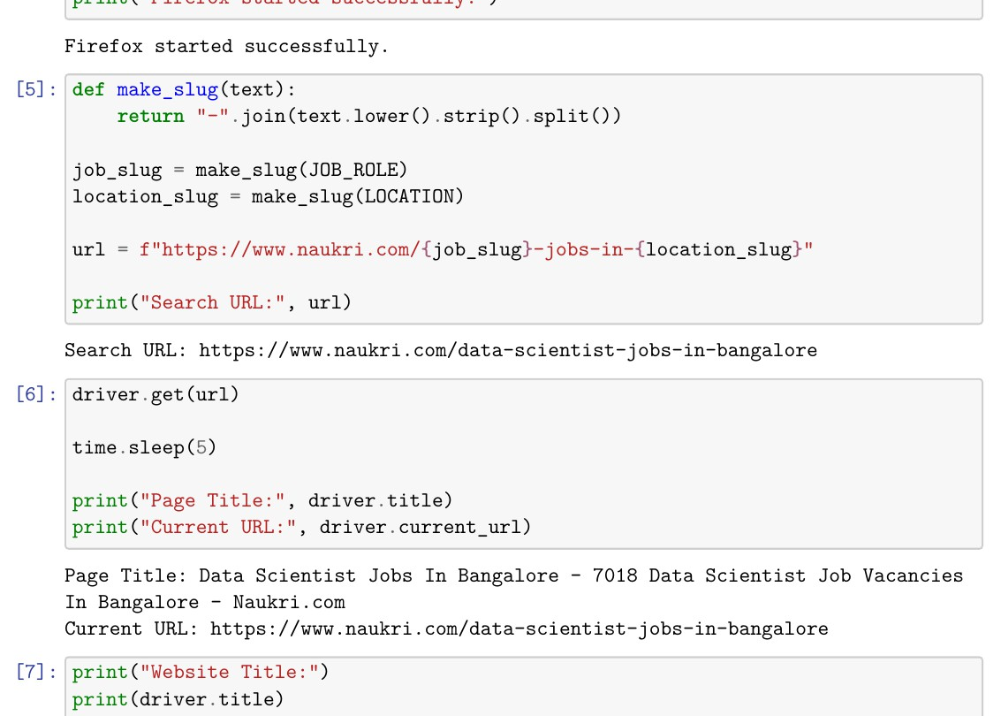  Fig. 1.1: Search URL and Job Portal Validation  The Selenium session generated the Naukri search URL for Data Scientist jobs in Bangalore and successfully retrieved the page title and current URL, confirming that the dynamic job portal was opened correctly.  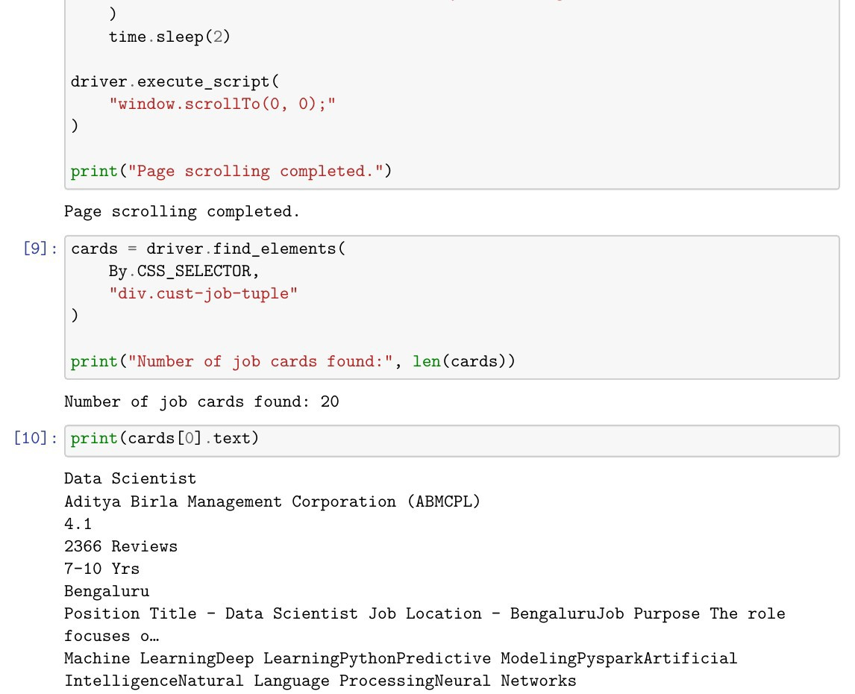  Fig. 1.2: Detection of Dynamic Job Cards  After scrolling the page, Selenium detected 20 job-card elements. The

first job card displays details such as job title, company, experience, location and associated skills.

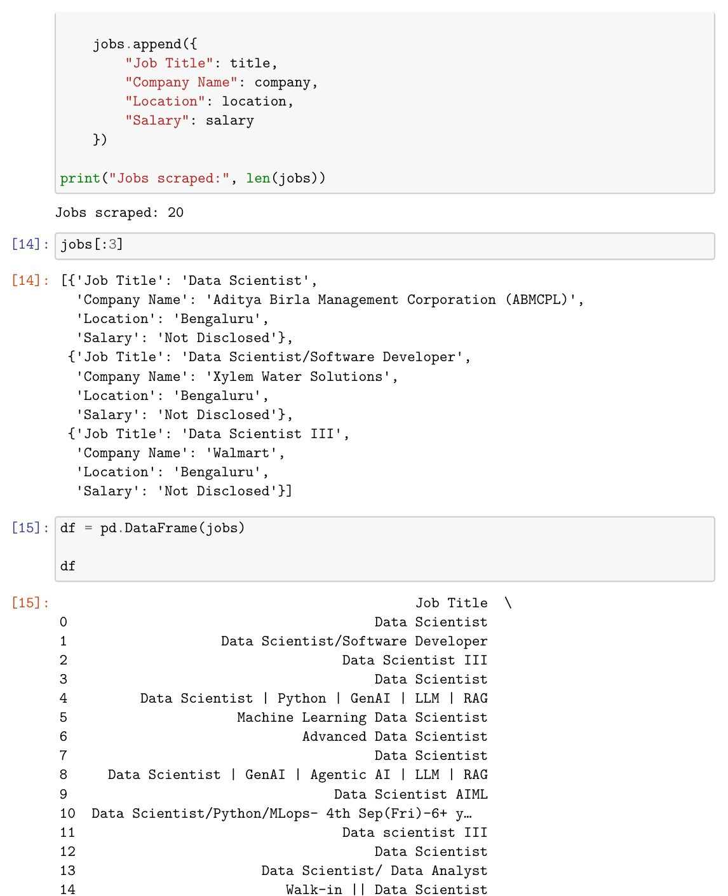
Fig. 1.3: Scraped Job Records and Pandas DataFrame
The scraper collected 20 listings and extracted the required Job Title, Company Name, Location and Salary fields. The records were then converted into a structured Pandas DataFrame.

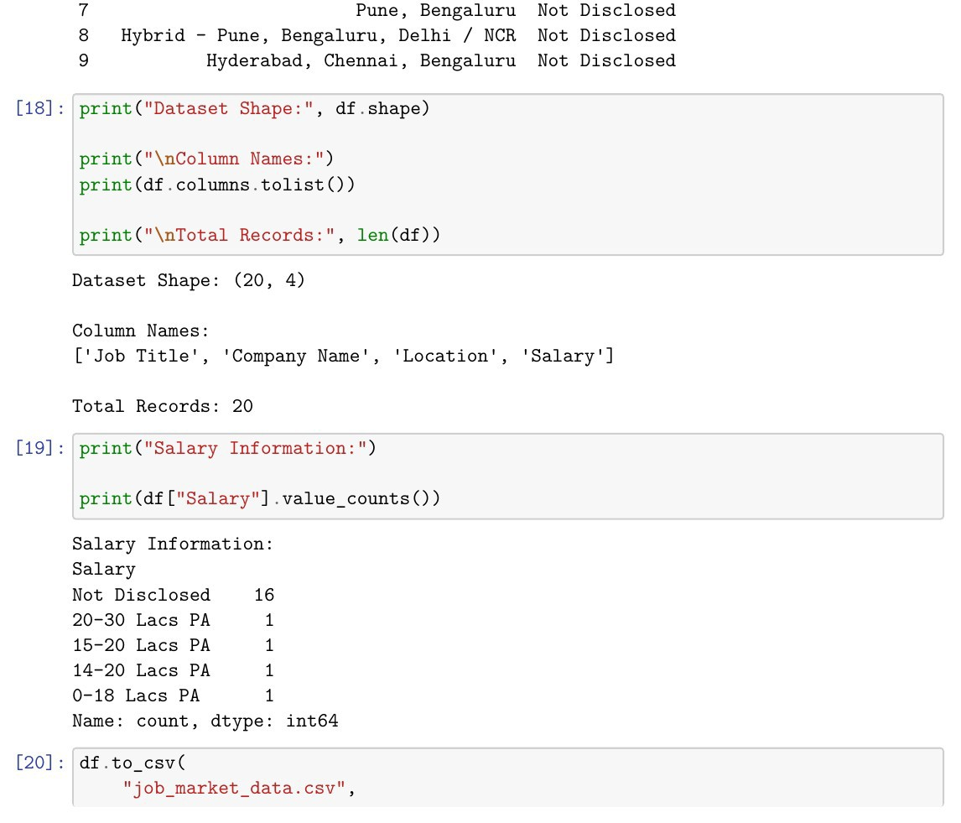
Fig. 1.4: Dataset Structure, Salary Availability and CSV Creation
The initial dataset contains 20 records and 4 required columns. Salary information was unavailable for most listings, while a few postings contained salary ranges. The cleaned DataFrame was saved successfully as job_market_data.csv.

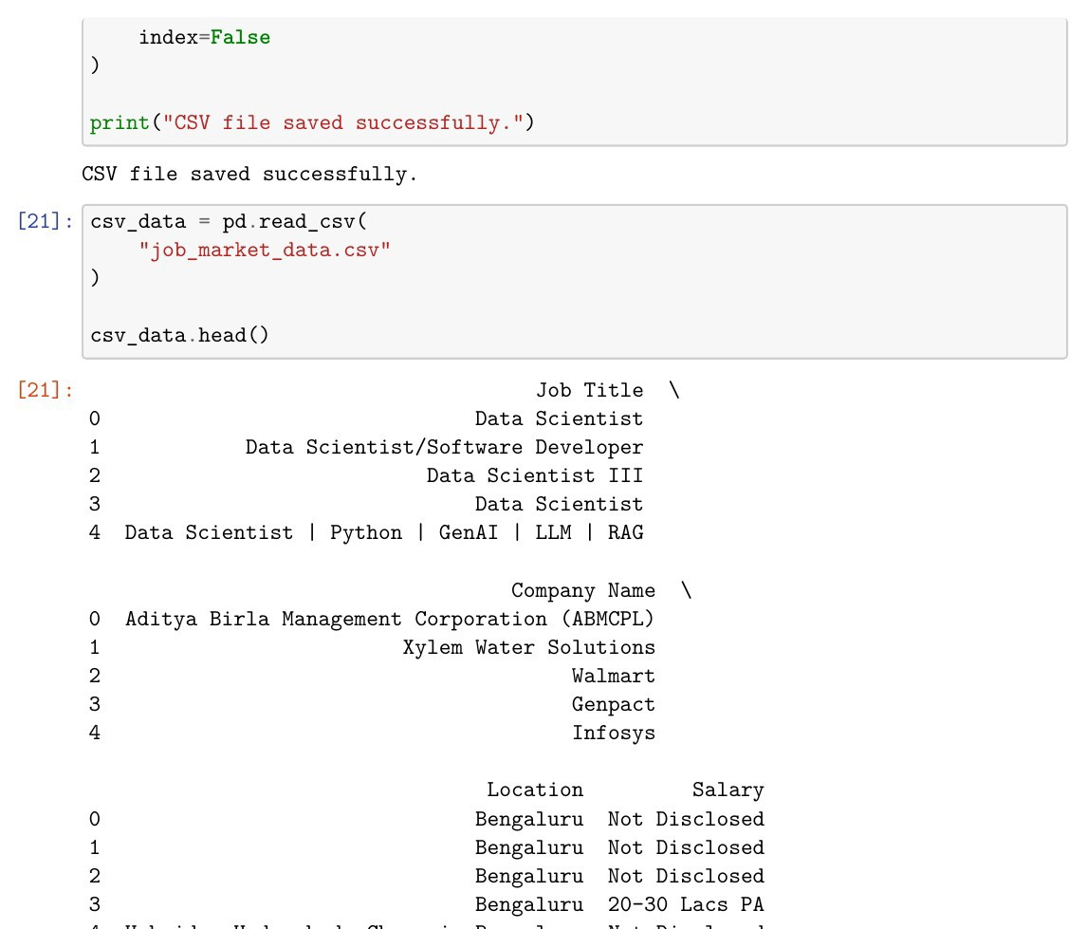
Fig. 1.5: Verification of the Saved CSV Dataset
The generated CSV file was read back using pandas.read_csv(), and the displayed rows confirm that the job-listing data was stored correctly in

structured form.

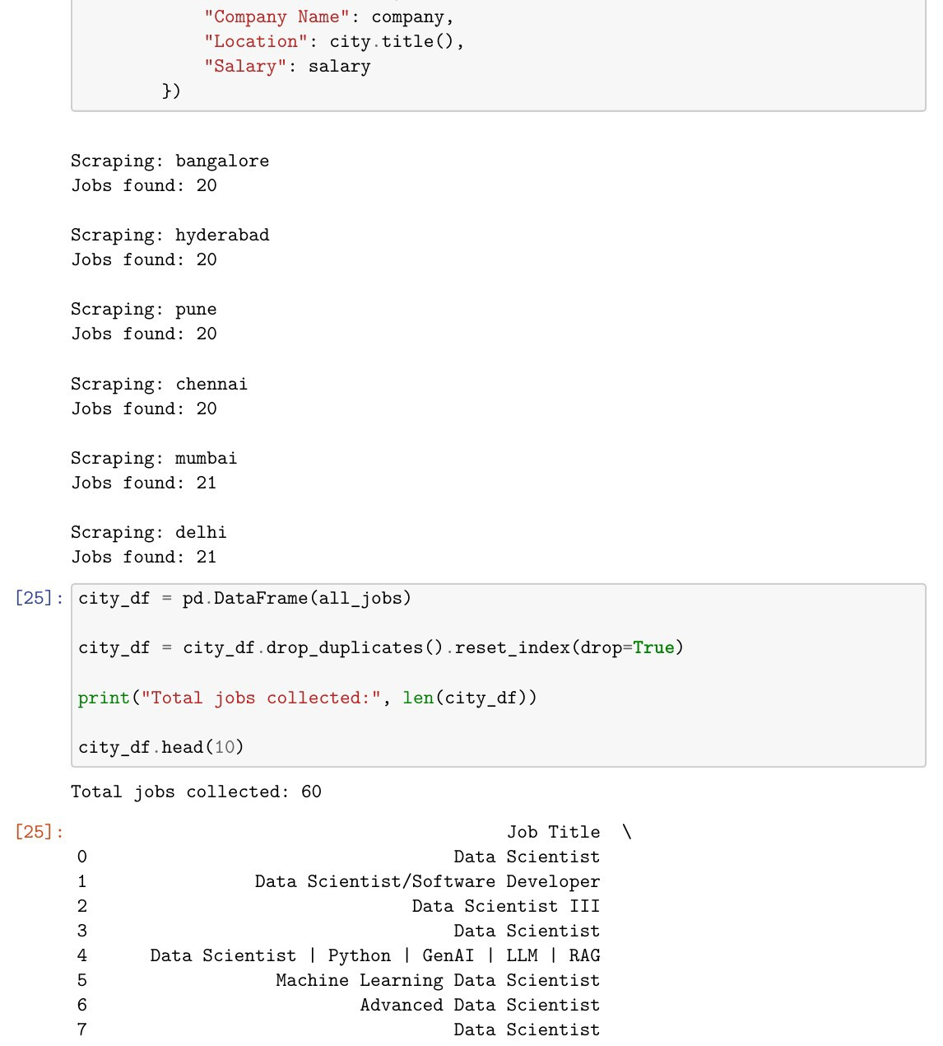
Fig. 1.6: Multi-City Job Data Collection
The same Data Scientist search was executed for Bangalore, Hyderabad, Pune, Chennai, Mumbai and Delhi. A controlled sample of 10 listings per city produced 60 records for location-wise analysis.

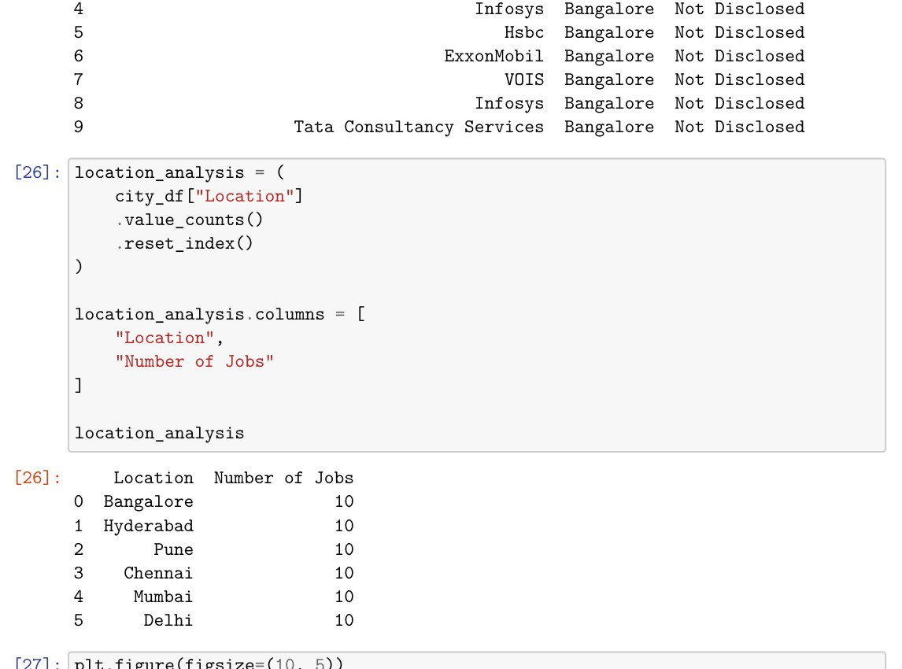
Fig. 1.7: Location-Wise Job Analysis
Pandas value_counts() produced the location-wise summary for the six-city job sample.

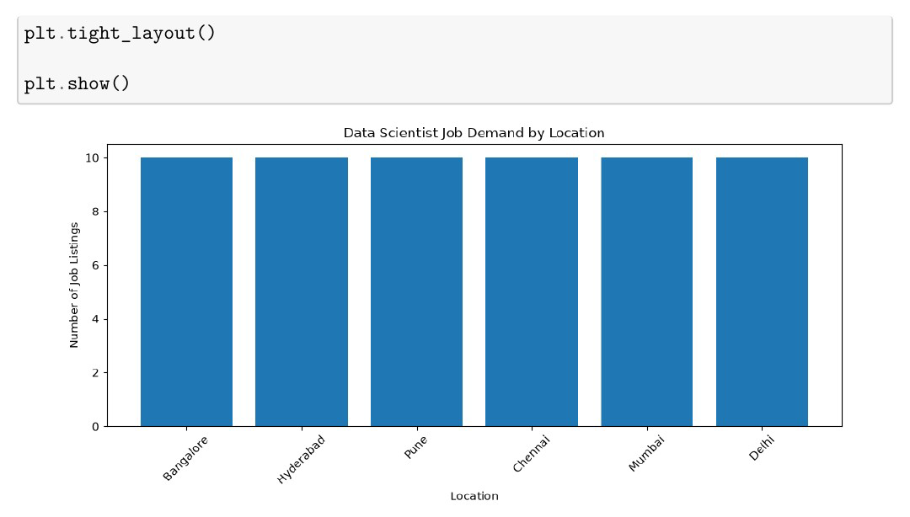
Fig. 1.8: Data Scientist Job Demand Visualization by Location
A Matplotlib bar chart visualizes the number of sampled job listings for each selected city. The graph provides a clear location-wise comparison of the collected job-market sample.

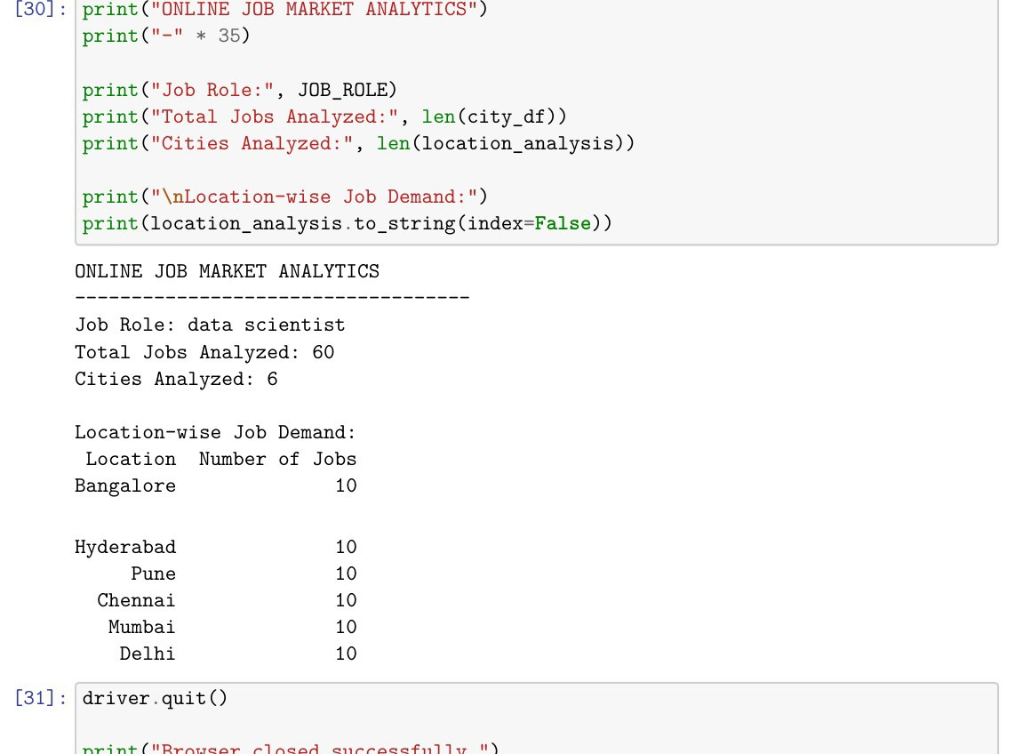
Fig. 1.9: Final Job Market Analytics Summary
The final output confirms that the multi-city dataset and graph were saved successfully. The analysis includes 60 sampled job records across 6 cities and displays the location-wise summary.
Conclusions | The exercise successfully demonstrated Selenium-based web scraping on a dynamic job portal. Job title, company name, location and available salary information were extracted from Naukri, organized in Pandas DataFrames, cleaned and stored as CSV files. Location-wise analysis was performed for six cities and visualized using a Matplotlib bar chart. Thus, the required job listings dataset, CSV output, location analysis and demand visualization were generated successfully.
References | - Michael Freeman and Joel Ross, Programming Skills for Data Science: Start Writing Code to Wrangle, Analyze, and Visualize Data with R, Addison-Wesley, 2018.  - Python Program (GitHub link): https://github.com/hasnainmakada-99/Data-Science-Codes/blob/main/Lab%20Codes/Week5-EP.ipynb  - Class lecture link: https://drive.google.com/file/d/1HjCacfaFs49XEnuM3idduuKB0Tgjb4xI  /view

Title | Interactive Bar Chart with Plotly
Problem Statement | Create an interactive bar chart showing the population of different cities.
Objectives | - To understand the creation of interactive data visualizations using Plotly.  - To organize city population data in a Pandas DataFrame.  - To create an interactive bar chart for comparing population across different cities.  - To sort and analyze population data to identify the highest, lowest, and average values.  - To save the interactive chart as an HTML file and the dataset as a CSV file.
Dataset URL Link / File | Dataset source: Manually defined in the Jupyter Notebook for this exercise; no external dataset URL is required.
Functions Details | Sl.  No. | Function | Package | Description of function
Functions Details | 1 | pd.DataFrame () | pandas | Creates a structured DataFrame from the city and population data.
Functions Details | 2 | px.bar() | plotly.ex press | Creates an interactive bar chart from the DataFrame.
Functions Details | 3 | update_traces(  ) | plotly | Updates trace properties such as the position of value labels on the bars.
Functions Details | 4 | update_layout () | plotly | Updates chart layout properties including axis titles.
Functions Details | 5 | show() | plotly | Displays the interactive Plotly figure in the Jupyter Notebook.
Functions Details | 6 | sort_values() | pandas | Sorts the DataFrame based on population values in ascending or descending order.
Functions Details | 7 | idxmax() | pandas | Returns the index of the row containing
City | Population (Lakhs)
Mumbai | 204
Delhi | 167
Bengaluru | 136
Hyderabad | 108
Chennai | 115
Kolkata | 149

 |  |  |  | the maximum population value.
 | 8 | idxmin() | pandas | Returns the index of the row containing the minimum population value.
 | 9 | mean() | pandas | Calculates the average population of all cities.
 | 10 | round() | Python | Rounds the calculated average population to the required decimal places.
 | 11 | write_html() | plotly | Saves the interactive Plotly chart as an HTML file.
 | 12 | to_csv() | pandas | Saves the DataFrame as a CSV file without the index column.
Steps/ Process/ Procedure/ Algorithm/ Flowchart/ Model | - Import the Pandas library and Plotly Express for data handling and interactive visualization.  - Create a dictionary containing the names of six Indian cities and their population values in lakhs.  - Convert the dictionary into a Pandas DataFrame and display the dataset.  - Check the dataset shape and print the city and population lists to verify the input data.  - Create an interactive bar chart using Plotly Express with City on the X-axis and Population (Lakhs) on the Y-axis.  - Display population values above the bars and provide appropriate chart and axis titles.  - Sort the DataFrame in descending order of population using sort_values().  - Create and display a second interactive bar chart using the sorted population data.  - Use idxmax() and idxmin() to identify the cities with the highest and lowest populations.  - Calculate the average population using mean() and round the result to two decimal places.  - Display the final population analysis summary in the notebook.  - Save the interactive Plotly chart as city_population_chart.html and save the dataset as city_population.csv.  Flow: START → Import Libraries → Create Dataset → DataFrame  → Verify Data → Interactive Bar Chart → Sort Data → Sorted Chart → Population Statistics → Save HTML/CSV → STOP
Program | import pandas as pd

import plotly.express as px

data = {
"City": [
"Mumbai",
"Delhi", "Bengaluru", "Hyderabad", "Chennai", "Kolkata"
],
"Population (Lakhs)": [ 204,
167,
136,
108,
115,
149
]
}

df = pd.DataFrame(data) df

print("Dataset Shape:", df.shape) print("\nCities:") print(df["City"].tolist()) print("\nPopulation:") print(df["Population (Lakhs)"].tolist())

fig = px.bar( df, x="City",
y="Population (Lakhs)", title="Population of Major Indian Cities", text="Population (Lakhs)"
)
fig.update_traces(textposition="outside") fig.update_layout(
xaxis_title="City", yaxis_title="Population (Lakhs)"
)
fig.show()

sorted_df = df.sort_values( by="Population (Lakhs)",

ascending=False
)
sorted_df

fig = px.bar( sorted_df, x="City",
y="Population (Lakhs)",
title="City-wise Population Analysis", text="Population (Lakhs)"
)
fig.update_traces(textposition="outside") fig.update_layout(
xaxis_title="City", yaxis_title="Population (Lakhs)"
)
fig.show()
highest = df.loc[
df["Population (Lakhs)"].idxmax()
]
print("City with Highest Population:") print(highest)
lowest = df.loc[
df["Population (Lakhs)"].idxmin()
]
print(
"Lowest Population:", lowest["City"],
"-",
lowest["Population (Lakhs)"], "Lakhs"
)

average_population = df["Population (Lakhs)"].mean() print(
"Average Population:", round(average_population, 2), "Lakhs"
)

print("CITY POPULATION ANALYSIS")
print("-" * 35)
print("Total Cities:", len(df)) print(

"Highest Population:",
df.loc[df["Population (Lakhs)"].idxmax(), "City"]
)
print(
"Lowest Population:",
df.loc[df["Population (Lakhs)"].idxmin(), "City"]
)
print(
"Average Population:", round(df["Population (Lakhs)"].mean(), 2), "Lakhs"
)

fig.write_html( "city_population_chart.html"
)
print("Interactive chart saved successfully.")
df.to_csv( "city_population.csv", index=False
)
print("Dataset saved successfully.")
Output Snapshots With Explanation/ Observations | The following output snapshots are taken from the completed Jupyter Notebook. Each image is inserted at full content width so that the dataset, charts, code cells, and output values remain readable and are not cut off.  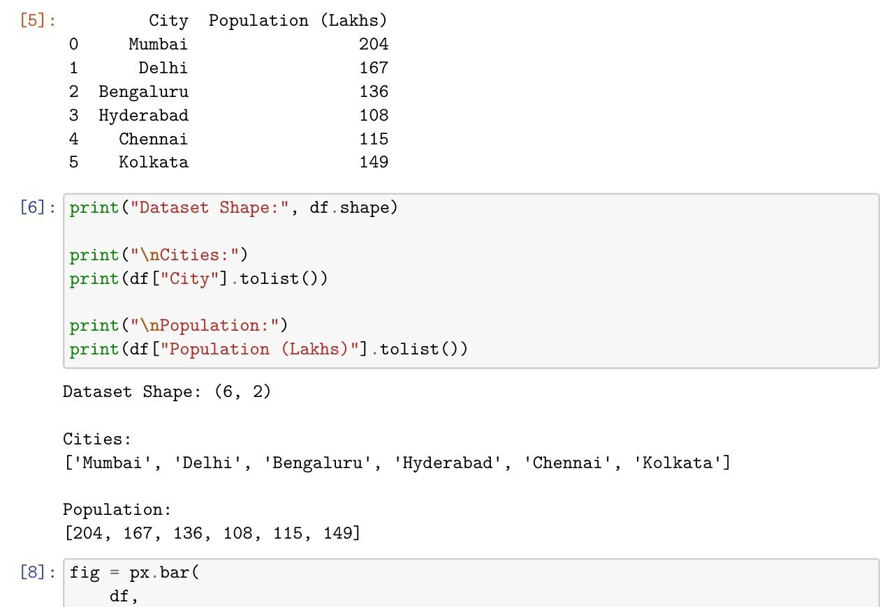  Fig. 1.1: Population Dataset and Dataset Structure

eir
Explanation/Observation: The DataFrame verifies 6 cities and th corresponding population values.

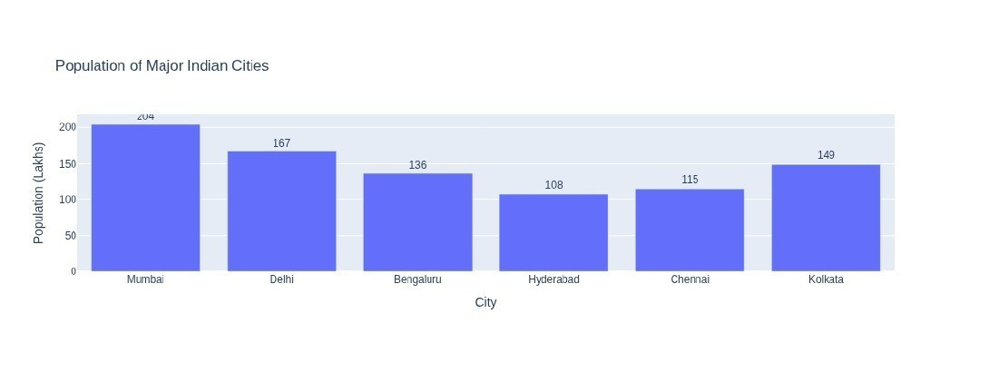
Fig. 1.2: Interactive Bar Chart of Major Indian Cities Explanation/Observation: Plotly Express generates an interactive bar chart for the original city order. The population values are displayed above the bars, with Mumbai showing the highest value of 204 lakhs in the given dataset.

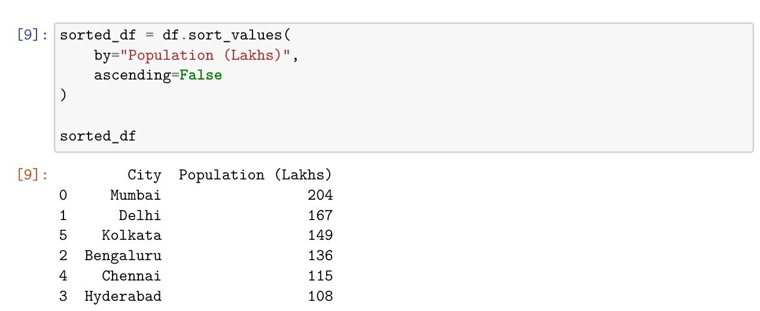
Fig. 1.3: Population Data Sorted in Descending Order Explanation/Observation: The DataFrame is sorted using sort_values() in descending order of population. The resulting order is Mumbai, Delhi, Kolkata, Bengaluru, Chennai, and Hyderabad.

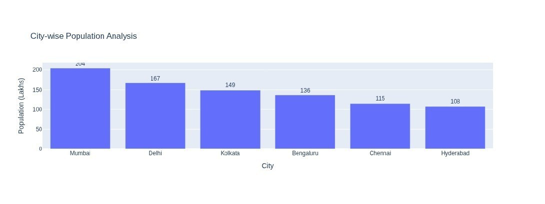
Fig. 1.4: City-wise Population Analysis after Sorting
Explanation/Observation: The sorted bar chart displays the cities from

highest to lowest population, making comparison and ranking easier.

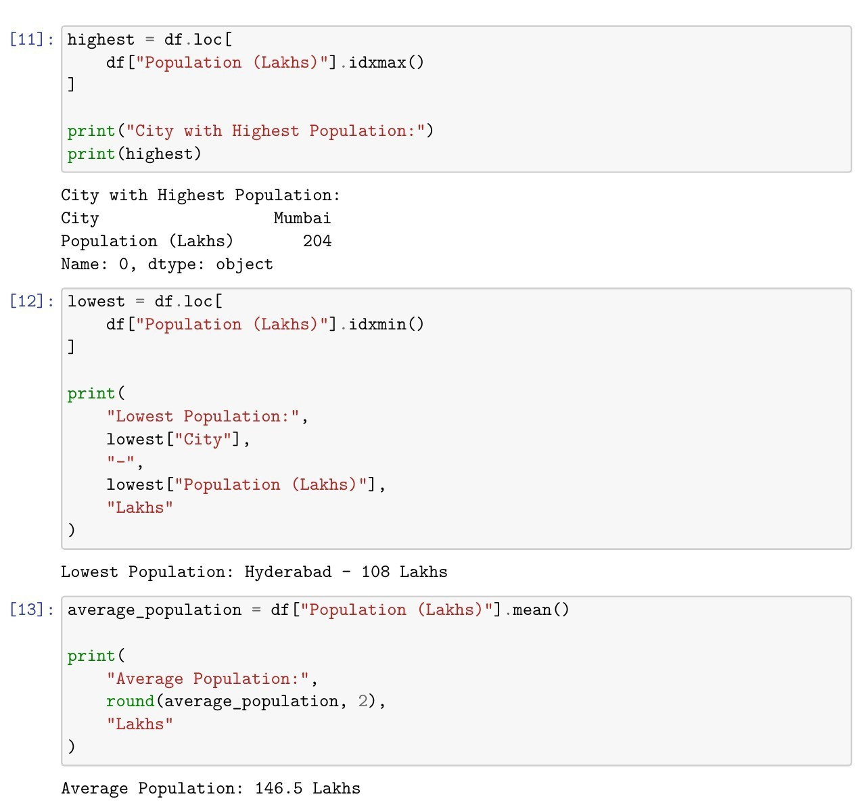
Fig. 1.5: Highest, Lowest, and Average Population Analysis Explanation/Observation: The program identifies Mumbai as the city with the highest population (204 lakhs), Hyderabad as the city with the lowest population (108 lakhs), and calculates the average population as
146.5 lakhs.

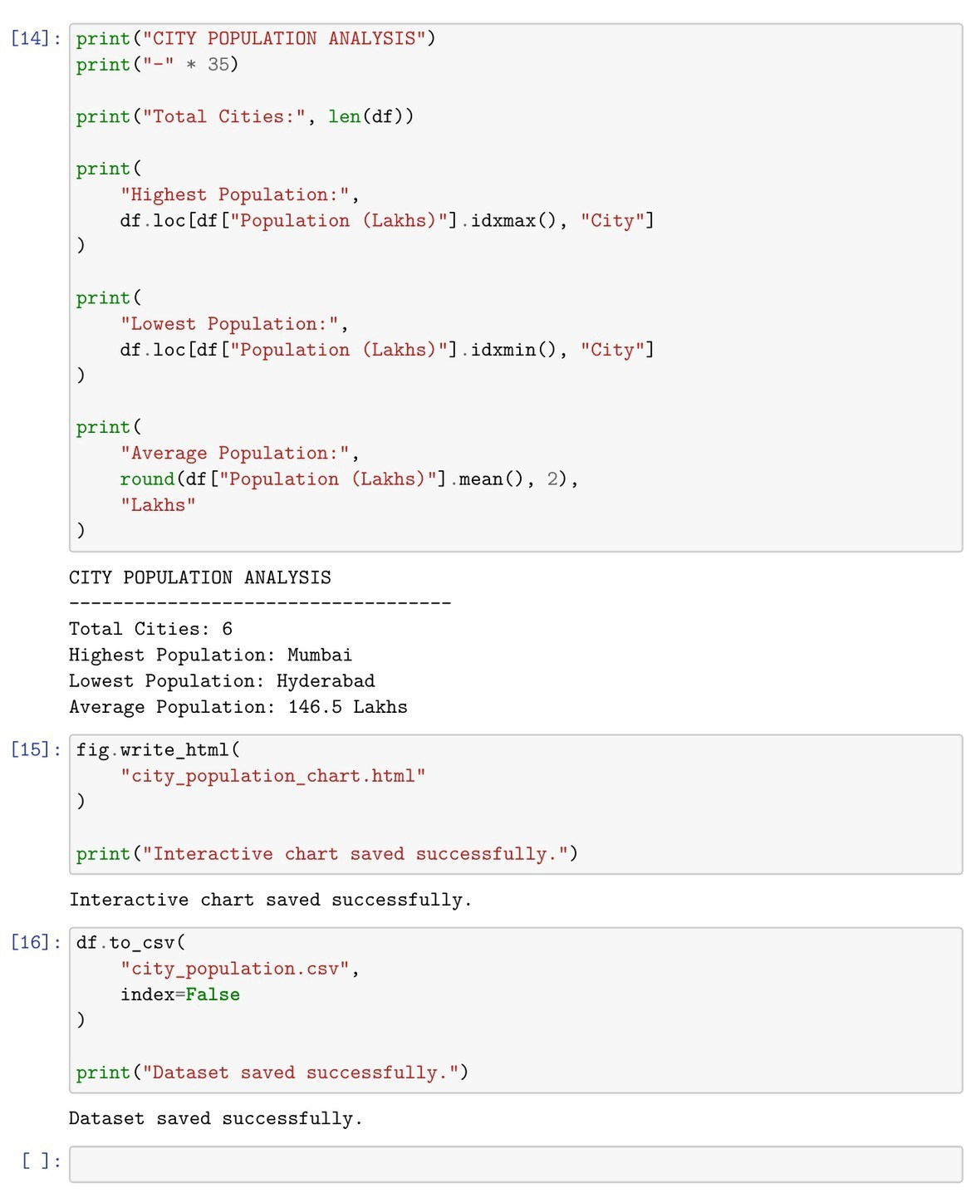
Fig. 1.6: Final Analysis Summary and File Saving Output Explanation/Observation: The final summary confirms 6 cities were analyzed, with Mumbai highest and Hyderabad lowest. The interactive chart and CSV dataset are saved successfully.
Conclusions | The experiment was successfully completed using Pandas and Plotly. The population data was organized in a DataFrame, visualized with interactive bar charts, and sorted for comparison. Mumbai had the highest population, Hyderabad the lowest, and the average population was 146.5 lakhs. The interactive chart was saved as HTML and the dataset as CSV.
References | - Michael Freeman and Joel Ross, Programming Skills for Data Science, Addison-Wesley, 2018.  - Python Program (GitHub link): https://github.com/hasnainmakada-99/Data-Science-Codes/blob/main/WEEK%206/Week-6-PP.ipynb  - Class lecture link: Open Lecture File

Title | Interactive Scatter Plot with Plotly
Problem Statement | Create an interactive scatter plot showing the relationship between house size and price.
Objectives | - To understand interactive scatter plot visualization using Plotly.  - To organize house size and house price data using a Pandas DataFrame.  - To visualize and interpret the relationship between house size and house price.  - To compute descriptive measures such as minimum, maximum, average, and correlation.  - To create a trendline for the relationship and save the interactive chart and dataset for further use.
Dataset URL Link / File | 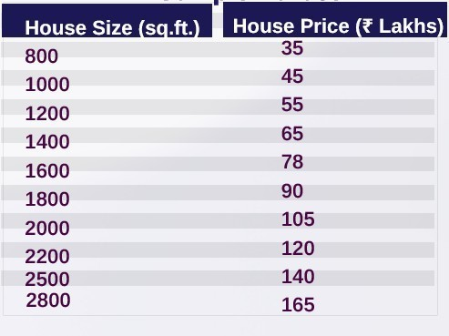  Dataset source: Manually defined in the Jupyter Notebook using the house-size and house-price values shown above; no external dataset URL is required.
Functions Details | Sl.  No. | Function | Package | Description of function
Functions Details | 1 | pd.DataFrame () | pandas | Creates a structured DataFrame from the house size and price data.
Functions Details | 2 | px.scatter() | plotly.ex press | Creates an interactive scatter plot from the DataFrame.
Functions Details | 3 | update_traces(  ) | plotly | Updates marker size and text-position properties of the plotted points.

 | 4 | update_layout () | plotly | Updates the chart layout and axis titles.
 | 5 | show() | plotly | Displays the interactive Plotly chart inside the Jupyter Notebook.
 | 6 | sort_values() | pandas | Sorts the dataset based on house size in ascending order.
 | 7 | idxmax() | pandas | Returns the index of the record with the maximum house price.
 | 8 | idxmin() | pandas | Returns the index of the record with the minimum house price.
 | 9 | mean() | pandas | Calculates the average house price and average house size.
 | 10 | corr() | pandas | Calculates the correlation between house size and house price.
 | 11 | write_html() | plotly | Saves the interactive Plotly scatter plot as an HTML file.
 | 12 | to_csv() | pandas | Saves the house-price DataFrame as a CSV file without the index column.
Steps/ Process/ Procedure/ Algorithm/ Flowchart/ Model | - Import Pandas and Plotly Express for tabular data handling and interactive visualization.  - Create a dictionary containing house sizes in square feet and corresponding house prices in lakhs.  - Convert the dictionary into a Pandas DataFrame and display all ten records.  - Verify the dataset shape and print the complete house-size and house-price lists.  - Create a basic interactive scatter plot with house size on the X-axis and house price on the Y-axis.  - Create an improved scatter plot with larger markers, value labels, title, and proper axis labels.  - Sort the DataFrame by house size in ascending order and display the sorted dataset.  - Use idxmax() and idxmin() to identify the most expensive and least expensive houses.  - Calculate the average house price and average house size using mean().  - Calculate the correlation between house size and price using corr() to measure the strength of their relationship.  - Create a scatter plot with an OLS trendline to visually represent the positive relationship between size and price.

12. Display the final house-price analysis and save the interactive chart as HTML and the dataset as CSV.
Flow: START → Import Libraries → Create Dataset → DataFrame
→ Verify Data → Scatter Plot → Enhanced Plot → Sort Data → Price Statistics → Average Values → Correlation → Trendline → Save HTML/CSV → STOP
Program | import pandas as pd
 | import plotly.express as px
 | data = {
 | "House Size (sq.ft.)": [
 | 800,
 | 1000,
 | 1200,
 | 1400,
 | 1600,
 | 1800,
 | 2000,
 | 2200,
 | 2500,
 | 2800
 | ],
 | "House Price (Lakhs)": [
 | 35,
 | 45,
 | 55,
 | 65,
 | 78,
 | 90,
 | 105,
 | 120,
 | 140,
 | 165
 | ]
 | }
 | df = pd.DataFrame(data)
 | df
 | print("Dataset Shape:", df.shape)
 | print("\nHouse Sizes:")
 | print(df["House Size (sq.ft.)"].tolist())
 | print("\nHouse Prices:")
 | print(df["House Price (Lakhs)"].tolist())

fig = px.scatter( df,
x="House Size (sq.ft.)", y="House Price (Lakhs)", title="House Size vs House Price"
)
fig.show()

fig = px.scatter( df,
x="House Size (sq.ft.)", y="House Price (Lakhs)",
title="Relationship Between House Size and Price", text="House Price (Lakhs)"
)
fig.update_traces( marker=dict(size=12), textposition="top center"
)
fig.update_layout( xaxis_title="House Size (sq.ft.)", yaxis_title="House Price (Lakhs)"
)
fig.show()

sorted_df = df.sort_values( by="House Size (sq.ft.)", ascending=True
)
sorted_df

highest = df.loc[
df["House Price (Lakhs)"].idxmax()
]
print("Most Expensive House:") print(highest)

lowest = df.loc[
df["House Price (Lakhs)"].idxmin()
]
print(
"Least Expensive House:", lowest["House Size (sq.ft.)"], "sq.ft. - ",
lowest["House Price (Lakhs)"],

"Lakhs"
)

average_price = df["House Price (Lakhs)"].mean() print(
"Average House Price:", round(average_price, 2), "Lakhs"
)

average_size = df["House Size (sq.ft.)"].mean() print(
"Average House Size:", round(average_size, 2), "sq.ft."
)

correlation = df[ "House Size (sq.ft.)"
].corr(
df["House Price (Lakhs)"]
)
print(
"Correlation between House Size and Price:", round(correlation, 3)
)

fig = px.scatter( df,
x="House Size (sq.ft.)", y="House Price (Lakhs)",
title="House Size vs Price with Trendline", trendline="ols"
)
fig.update_traces( marker=dict(size=12)
)
fig.update_layout( xaxis_title="House Size (sq.ft.)", yaxis_title="House Price (Lakhs)"
)
fig.show()

print("HOUSE PRICE ANALYSIS")
print("-" * 40)
print("Total Houses:", len(df))

print(
"Smallest House:",
df["House Size (sq.ft.)"].min(), "sq.ft."
)
print(
"Largest House:",
df["House Size (sq.ft.)"].max(), "sq.ft."
)
print(
"Lowest Price: ",
df["House Price (Lakhs)"].min(), "Lakhs"
)
print(
"Highest Price: ",
df["House Price (Lakhs)"].max(), "Lakhs"
)
print(
"Average Price: ",
round(df["House Price (Lakhs)"].mean(), 2), "Lakhs"
)
print(
"Correlation:", round(correlation, 3)
)
fig.write_html( "house_size_price_scatter.html"
)
print("Interactive scatter plot saved successfully.")
df.to_csv( "house_price_data.csv", index=False
)
print("Dataset saved successfully.")
Output | The following snapshots are taken from the completed Jupyter Notebook.
Snapshots | The images retain the complete visible code/output blocks from each
With | source page; only unused white margins were removed so no program
Explanation/ | output is cut off.
Observations

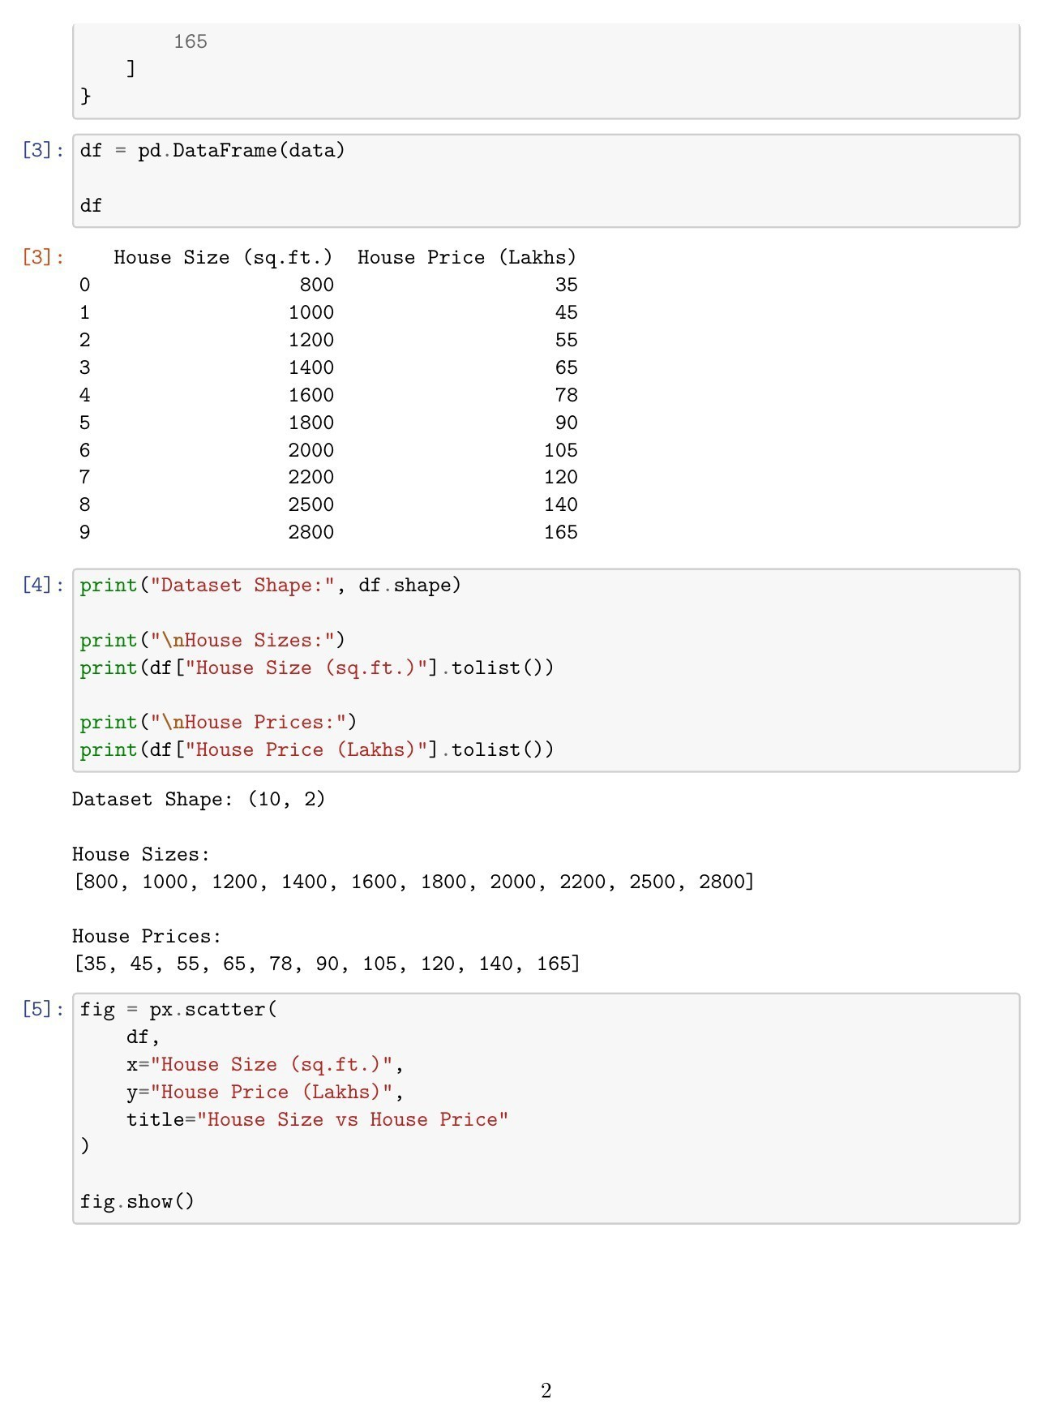
Fig. 1.1: DataFrame Creation, Dataset Verification, and Basic Scatter Plot Code

Explanation/Observation: The dataset is converted into a Pandas DataFrame with 10 rows and 2 columns. The complete house-size and house-price lists are verified, and the code for the initial interactive scatter plot is executed.

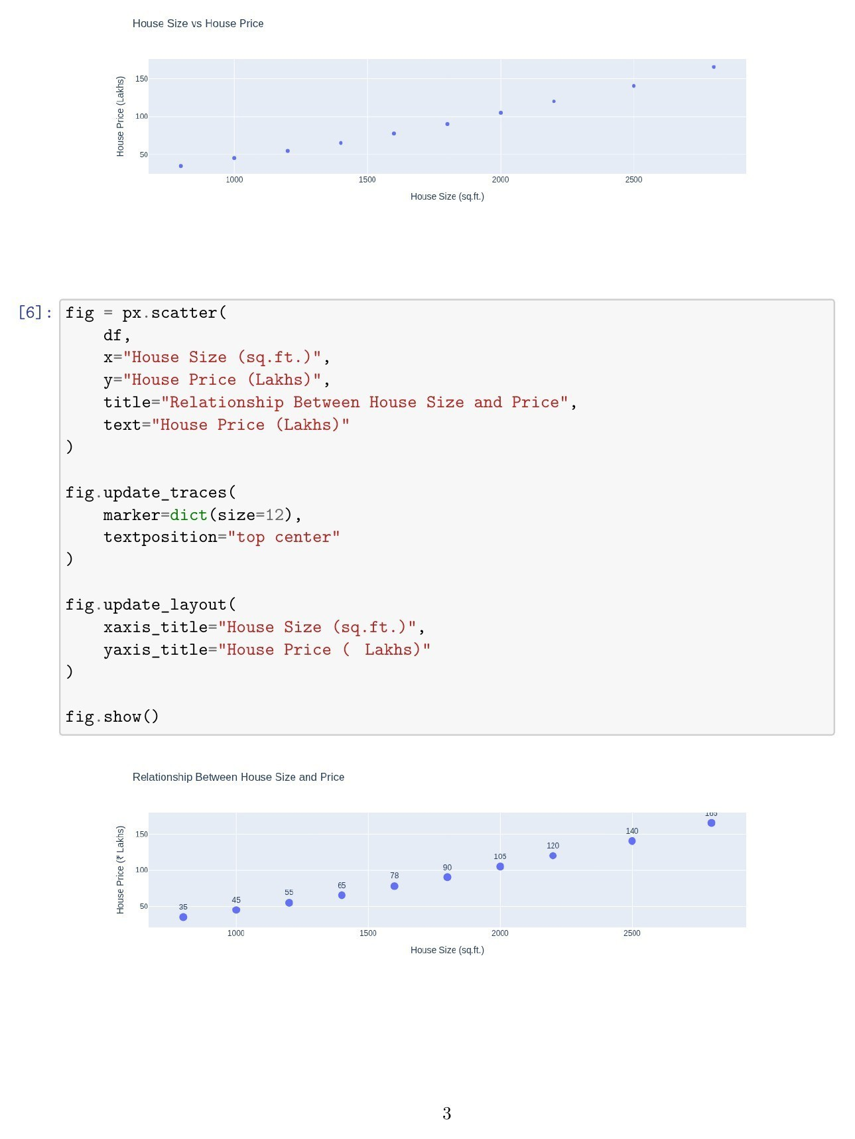
Fig. 1.2: Interactive and Enhanced Scatter Plots Explanation/Observation: The first scatter plot shows house size versus price. The enhanced Plotly chart adds larger markers and price labels, making the strong upward relationship between size and price visually clear.

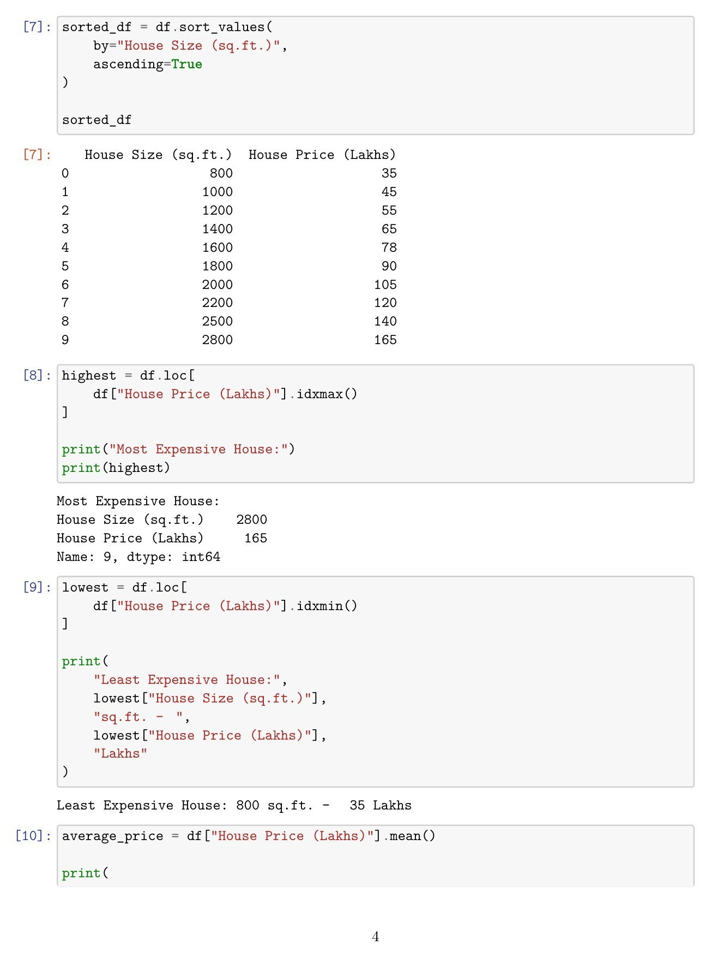
Fig. 1.3: Sorted Dataset and Extreme Price Analysis Explanation/Observation: The dataset is sorted by house size in ascending order. The program identifies the 2800 sq.ft. house priced at 165 lakhs as the most expensive and the 800 sq.ft. house priced at 35 lakhs as the least expensive.

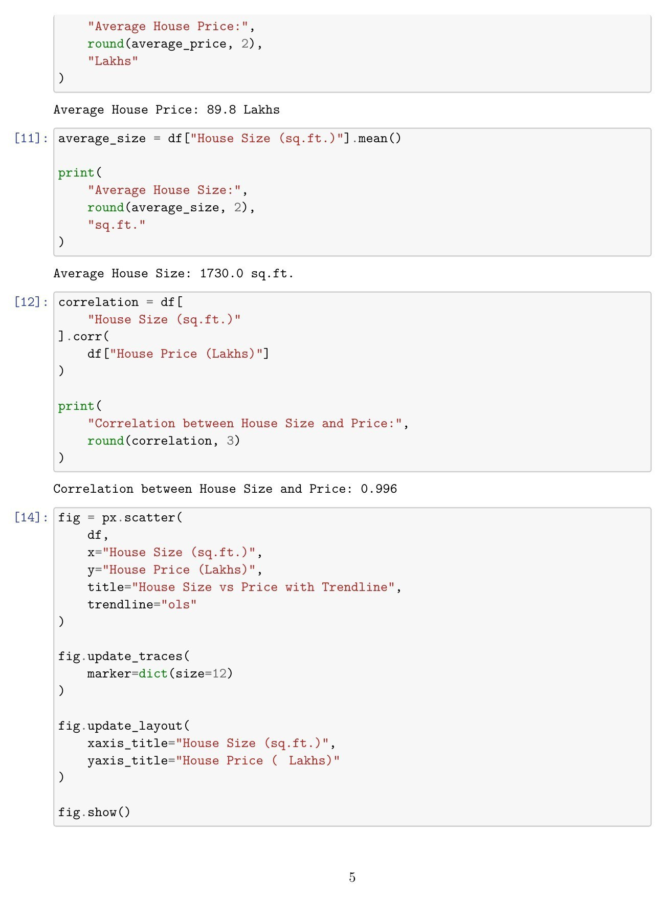
Fig. 1.4: Average Values, Correlation, and Trendline Program Explanation/Observation: The average house price is 89.8 lakhs and the average house size is 1730 sq.ft. The calculated correlation is 0.996, indicating a very strong positive relationship. The trendline scatter-plot code is also shown.

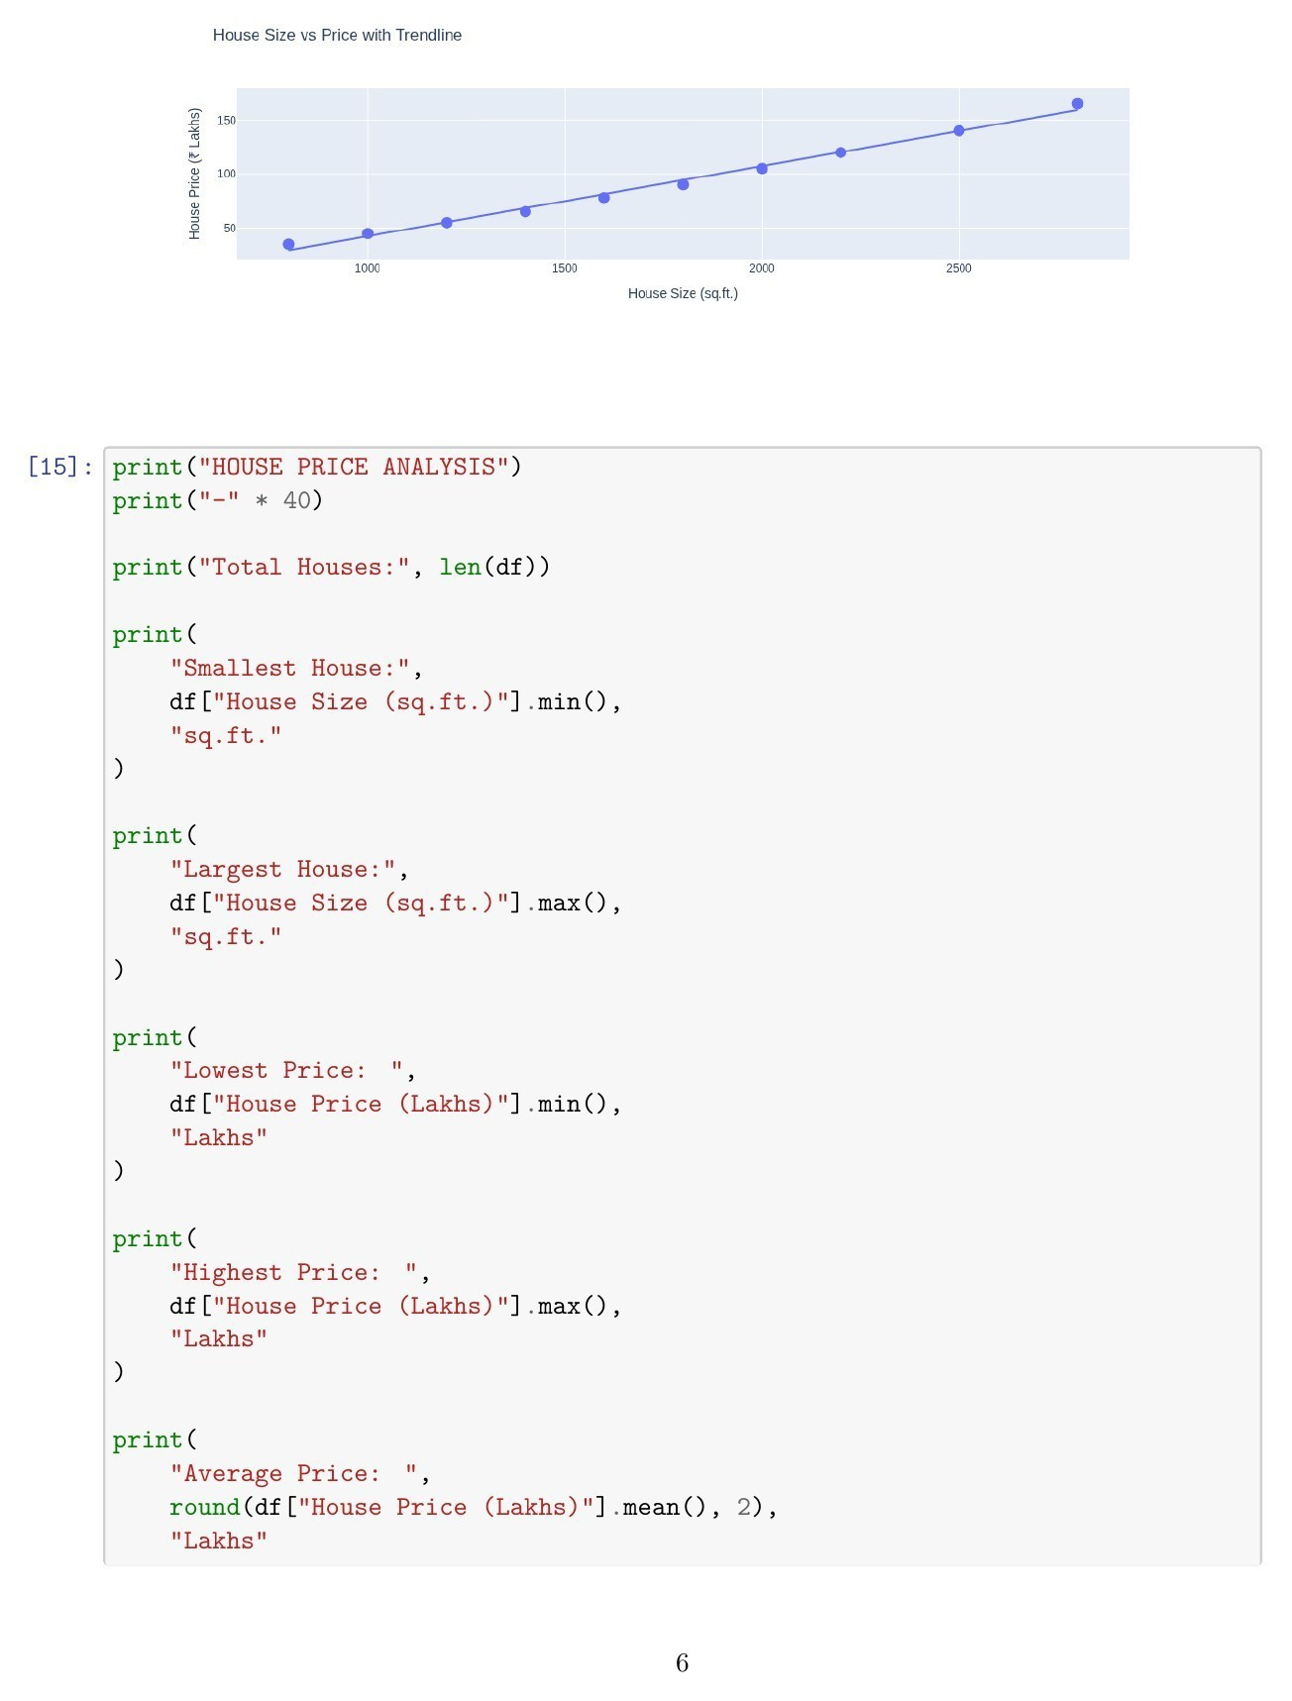
Fig. 1.5: Scatter Plot with OLS Trendline and Final Analysis Code Explanation/Observation: The Plotly scatter plot with an OLS trendline confirms that house price rises strongly with house size. The final analysis code computes the smallest/largest houses and lowest/highest/average prices.

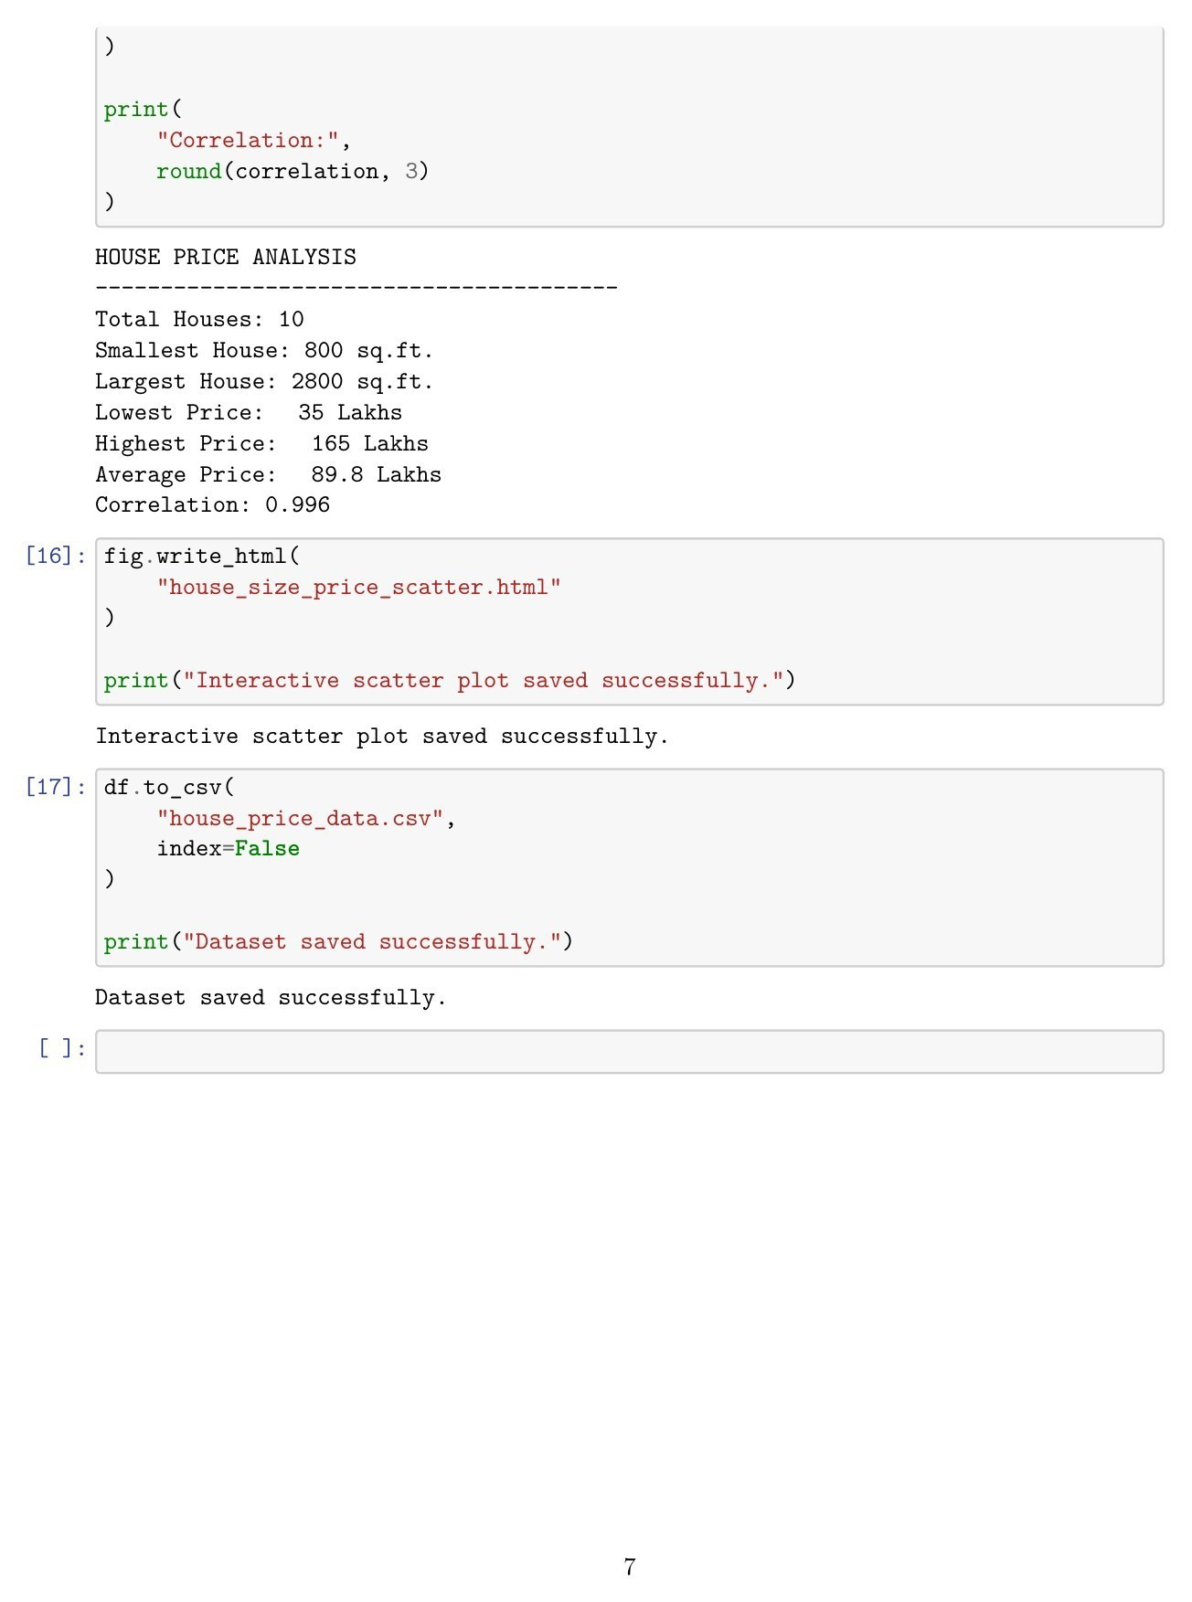
Fig. 1.6: Final House Price Analysis and File Saving Output Explanation/Observation: The final output confirms 10 houses, sizes from 800 to 2800 sq.ft., prices from 35 to 165 lakhs, an average price of
89.8 lakhs, and correlation of 0.996. The interactive HTML chart and CSV dataset are saved successfully.
Conclusions | The experiment was successfully completed using Pandas and Plotly. House size and price data were organized in a Pandas DataFrame and visualized through interactive scatter plots. The analysis found an average house size of 1730 sq.ft., an average price of 89.8 lakhs, and a correlation o 0.996, showing a very strong positive relationship between house size and price. An OLS trendline further confirmed this relationship. The interactive

f

 | chart and dataset were successfully saved as HTML and CSV files.
References | - Michael Freeman and Joel Ross, Programming Skills for Data Science: Start Writing Code to Wrangle, Analyze, and Visualize Data with R, Addison-Wesley, 2018.  - Python Program (GitHub link): https://github.com/hasnainmakada-99/Data-Science-Codes/blob/main/WEEK%206/Week-6-PP2.pdf  - Class lecture link: Open Lecture File

